CURRICULLUM VITAE

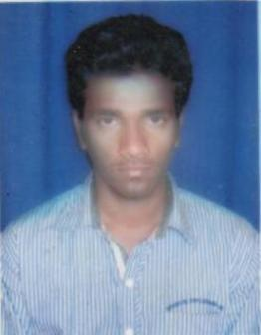 | GIRIJA SANKAR SAMANTRAY  Address for Communication:  Dwarka Mor,Delhi-110075  Mobile No: 8763991767  E-mail: girijasankarsamantray@gmail.com

Career Objective
To make contribution to the organization to the best of my ability and to develop new skills and share my knowledge while interacting with others and achieve new height.

Synopsis

- I have done my B.Tech(Mechanical Engg. ) at Eastern Academy of Science & Technology (EAST), Bhubaneswar with 6.71 CGPA .
- I have done +2 Science under CHSE, Odisha in 2012 with 62% marks.
- I have done HSC under BSE, Odisha in 2010 with 71% marks.
- Ability to rapidly build relationship and set up trust.
- Confident and determined.
- Ability to cope up with different situation.
- Quick Learner.

Academic Qualification

Degree / Qualification | Institute | Board /  University | Year | Aggregate  % / CGPA
B. Tech Mechanical Engineering | EAST | BPUT | 2012-2016 | 6.71 CGPA
+2 Science | Naidu +2 Science College | Council Of Higher Secondary Education | 2010-2012 | 62%
10th (Board) | Pratap Sasan High School | Board Of Secondary Education | 2010 | 71%

Computer Proficiency

- AutoCAD 2010 from CTTC
- MS Office

Projects Undertaken

Name of Institute / Organization | Project Title | Duration
EAST | HOVERCRAFT | 6 Month

Accolades

- Participated in Science Exhibition in school level.
- Participated in various cultural events.

Personal Details

- Father’s Name : Mr. Sachidananda Samantaray
- Mother’s Name : Mrs. Laxmipriya Samantaray
- Date of Birth : 18th JUNE 1995
- Gender : Male
- Blood Group : B+
- Languages known : English, Hindi & Odia
- Interests in : Listening music, internet browsing, Playing cricket

Declaration

I hereby, declare that the information furnished above is true to the best of my knowledge.

Place:
Date: Girija Sankar Samantray

