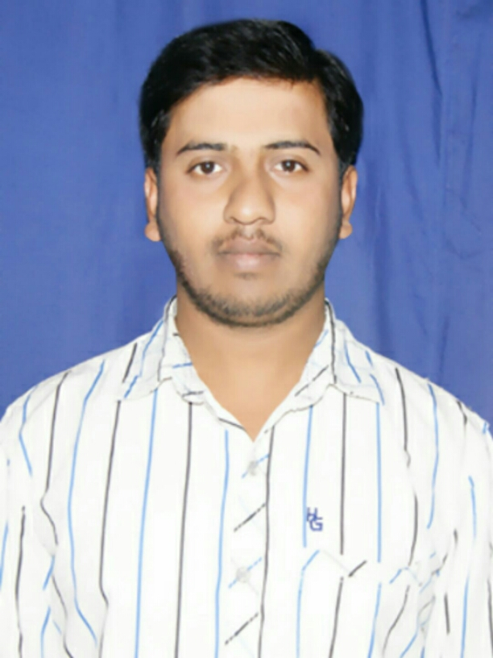
MURTHY Y N
Mobile: 9739948108
Email:murthyyn11@gmail.com
Address: #123,1st main road ,
jangamakote (p/v),
shidlaghatta taluk,
chikabalapur dist,
pincode :562102

CAREER OBJECTIVE:
I would like to have an opportunity to aim for a suitable position in your esteemed Organization to utilize my knowledge and to apply my skills with observing personal growth and aiding towards effective organizational progress.

EDUCATION BACKGROUND

Education | University | Specialization | Institute | Percentage  % | Year of Passing
B.E | Vishveshwaraya technology university | Mechanical | ACS College of Engineering | 57 | 2016
DIPLOMA | Department of Technical Education | Machine Tool Technology | S.J GOVT polytechnic | 64 | 2012
SSLC | Karnataka Secondary Education Examination Board |  | Sri Jyothi High School | 75.52 | 2007

TECHNICAL COMPETENCIES:

- Basic knowledge of CAD & CATIA V5.
- Basic MS Office Skills.
- Basic Knowledge of CIM and Automation Software..

SOFT SKILLS:
- Adaptable and Quick Learner.
- Optimistic.
- Capable of Working in Team.
- Have Good Intrapersonal Skills

Project Works Undertaken:
Engineering Project
Title: Vertical Axis Wind Mill
Objective: - “To Obtain Maximum Renewable Energy”

In this project, We Fabricated a Double stage vertical axis wind turbine to produce electricity by utilizing cross winds and vehicular movements in highways.

Diploma Project
Title: Hydraulic Arm
In this project, we Fabricated a pick and place robotic hydraulic arm which has vast application in automobile industries.
.

PERSONAL INFORMATION:
- Name : MURTHY Y N
- Gender : Male
- DOB : 17 JAN1992
- Languages known : English ,Kannada ,Hindi,Telugu

DECLARATION:
I here by declare that all the information given above is correct to best of my knowledge.

MURTHY Y N

