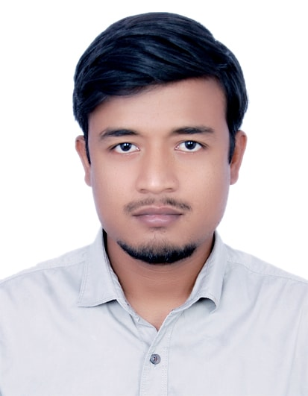

Shivendra Kumar E-mail shivorshivendra@gmail.com
Contact No. 9199225507

Present Addres

CAREER OBJECTIVE
To work for an organization like yours which provides me the opportunity to improve my skills and knowledge to growth along with organization objectives.

PROFESSIONAL AND ACADEMIC CREDENTIALS

Qualification | Board/University | Year | Percentage
B.tech (Mechanical) | Dr. K. N. Modi Institute Of Engineering And Technology | 2014-2018 | 67.42
Intermediate | Jawahar navodaya | 2012 | 77.4
High School | G D Mother International School | 2010 | 8(CGPA)

SUMMER TRAINING AND EXPERENTIAL LEARNING

- Software training in CADMECH
- Software :- AUTOCAD ,SOLIDWORKS and GD&T

- Summer training in RAIL WHEEL PLANT, BELA
- Duration :- 4 Weeks

INDUSTRIAL VISITS

- PRADESHIK COOPERATIVE DAIRY FEDERATION : PARAG MILK, MEERUT

- YAKULT DANONE PVT LTD, SONEPAT

TECHNICAL SKILLS

- CAD and CAE Softwares :- AutoCAD, Solidworks And GD&T

PROJECT
“ To design a solar e-rickshaw which would be motor driven using electrical energy as well as solar energy simultaneously to empower renewable energy in the field of automobile”
- To utilise abundantly available solar power
- To reduce the use of fossil fuel
- Ecofriendly nature
- High future prospect in renewable energy field
- To make cost effective not only for consumer but also for the owners
- To provide much safety compare to other fuel operating vehicle which have chances of explosion
POSITION : overall Coordinator of project (with my team member)

EXTRA CURRICULARS

- Participated in one week workshop on AUTONOMOUS ROBOTICS at IIT Delhi
- Active Participation And won in Mechanical Society Events in College
- Co-ordinator of Mechanical Society (EXODIA)
- Active Participation in workshops on HIDP done by ADVAIT FOUNDATION in College

PERSONAL DETAILS

- Father’s Name :- RAM BABU PRASAD
- Permanent Address :- VIKASH ENGG. WORKS, TILAK MAIDAN ROAD, MUZAFFARPUR - 842001
- Date of Birth :- Feb 23, 1995
- Marital Status :- Single
- Language Known :- English and Hindi
- Nationality :- Indian
- Hobbies :- Playing Cricket and Kabaddi , Watching Trending Videos on YouTube ,Watching Movies, listening songs.

DECLARATION

I do hereby declare that the above information is true to the best of my knowledge.

Place: MODINAGAR SHIVENDRA KUMAR
Date: (Signature)

