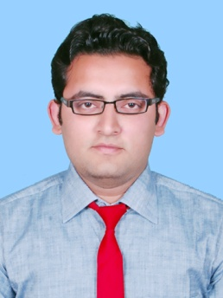
Rohit Verma
Rohit.rvd.verma15@gmail.com
Home phone: +918755696220
Objective:
With the chop of my college education as bachelor of Technology in mechanical Engineering. I am speaking in my capacity as a mechanical Engineer, I am planning to wrest my skills and ability to scoop up a challenging and demanding job in the core field of mechanical engineering. Where my skills and abilities culminate to contribute challenging job accomplishment. To carve myself as an indispensable employee for the organization's personnel and personal growth
Education:
- GATE 2017 Qualified Mark Obtained 45.2 AIR 14,593. Gate Scored Card 479.
- Aug 2010- 2014 ~ B tech in mechanical engineering from excel group of institution, mathura formerly
UPTU with 69%.
- June 2009 ~ higher secondry by ISC board from gagan public school, agra road, aligarh.
- June 2007 ~ high school by CBSC board from sarswati vidya mandir, Aligarh .

Working Experience :

- 1 Year Experience in workshop of Ashok Auto Sales (Tata Motors) as Floor Incharge & Service Advisor (Heavy & Light Commercial Vehicle) from March-2015 to March-2016 in Aligarh.

Trainings:
- June 2012-july 2012 ~ Summer tarining from usher pawer plant ,Mathura. This power plant was combined
cycle power plant. Which is in operation with Brayton Cycle as topping cycle and Rankine
cycle as bottoming cycle. Successfully completed With Certificate of excellent performance
during training.
- June 2013-july 2013~ summer training from tata motor ,Aligarh. in this company i learn about the overall
mechanical process of inner level parts of the vehicle as well as inter communicaition system
among various components of the engine.
- July 2012-aug2012~ PRO-E from cadd centre training training services, aligarh.

Hobbies:

- News,politics, automobile, body building.

Personal:
- Father name = Mahesh verma
- Mother name = Manju verma
- Date of Birth = 01/10/1992
- Marital Status = Single
- Language Known = Hindi & English
- Address = mahesh kumar rituraj singh, near shiboo kachodi wale,
shahpara, aligarh. 202001

I hereby declare that above mentioned Information is true to the Best of my Knowledge and belief

28/03/2017 Rohit verma

