CHANDAN SINGH

DIPLOMA (Mechanical Engineering)

Mobile:9803704582 ~ Email: Chandanrana000@gmail.com

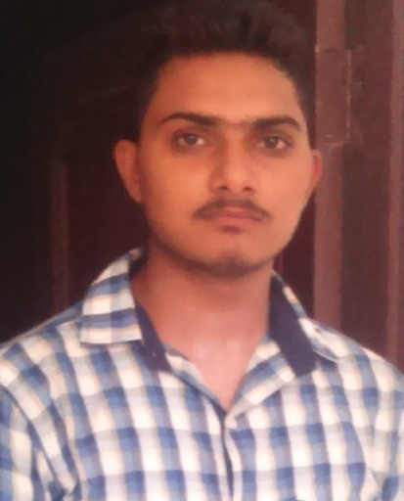

CAREER OBJECTIVE:

To have a growth Oriented and Challenging career, where I can contribute my knowledge and skills to the organization and enhance my experience through continuous learning and Teamwork.

EDUCATION

- Matriculation ­ Year 2010 from U.P Board
- 10+2 ­ Year 2012 from U.P Board
- Diploma ­ Year (2011 – 2014)

from Neelkanth Institute of Engineering and Technology, Meerut.
(An Institute established in the year 2002 & affiliated to Board of Technical Education, U.P

OTHER SKILLSET

Industrial Work Experience –

- Persently working as an Junior Engineer in “FORGE SHOP Production Department” since Sept. 1, 2014 at “HIGHWAY INDUSTRIES LTD”(HERO GROUP) Focal Point, Ludhiana.

Company´s Overview –

Highway Industries Limited ventured into the world of business in the year 1971 as a manufacture of cold forged components like free wheels foe Bi-Cycles. Its products were a global hit as within a very short span of time, it is has been able to bag a large number of highly reputed customers from Europe and USA apart from the domestic market. Highway produces millions of hot and cold forged and precision machined components like Crank shafts, Connecting Rod, Kick Starter Spindle , Arm Assembly for 2 wheelers, Flange axle, variety of Shafts and Flanges, Sleeves for 4 wheelers, Crank, Piston, C-Block for white goods industries.

Consistency and tenacious adherence to the Quality-Precision factor has mapped in internal clients. Being an ISO/TS:16949 certified Company, modern management systems are in place, further adding ISO:14001 and OHSAS:18001certifications. Quantifying qualitative parameters with a zero tolerance approach, Highway Industries Ltd. Raises the bar for its own level of perfection, an art thet keeps it on the edge that keeps it ahead of the competition.
Main clients are Hero Moto Corp Ltd, Magna Powertrains, Sono Koyo steering Ltd, Multimetic, GKN group, L.G.

Job Responsibilities –

- Planning, determining, coordinating and controlling the processes related to the production & Quality.
- Currently managing a team of almost 100 persons.
- Handling all documents of production, rejection sheet, tool life and knowledge of document FMEA, MSA APQP, PPAP, SPC, OEE.
- Maintain all documents of IATF-16949:2016 & as per according to Customer demand.
- Responsible for all the issues related Quality.
- Maintain production by using E.R.P SYSTEM.
- Responsible for all the issues related to productivity he man power management.
- Daily work management and supervision for machining process.
- Elimination of Muda in the line.
- To improve process by using SPC studies.
- Awareness about QUALITY TOOLS, FMEA, and Control Plan, 8D / CAPA, Pareto Charts, etc.
- Contribution in 5S, Kaizen and Manufacturing.

Industrial training Experience –

- Company´s Name : - AIML Group
- Duration : - 28 Days
- Address : - Rajpura, Punjab

SOFTWARE KNOWLEDGE

- ERP System.
- MS Office ( MS–Excel, MS–Word, MS–Power Point )
- Operating Systems ( Windows 7, Windows 8, etc.)

PROFESSIONAL OVERVIEW

- Ability to rapidly build relationship and set up Trust.
- Self motivated professional always ready to learn.
- Confident and Determined.
- Served as a Co-ordinator and Organiser in various college events.

HOBBIES

- Playing games like volleyball & Cricket
- Listening Songs

PERSONAL VITAE

- Father’s Name :Shri. Pawan singh
- Permanent :Vill+Post –Bhaila, Tehsil –Deoband, Distt –Saharanpur, Pin -247554
- Date of Birth :10ͭ ͪ Oct, 1995
- Se :Male
- Languages known :English, Hindi & Punjabi
- Marital Status :Single
- Nationali :Indian
- Category :Gen

Date:...................

(Chandan Singh)
Place:....................

