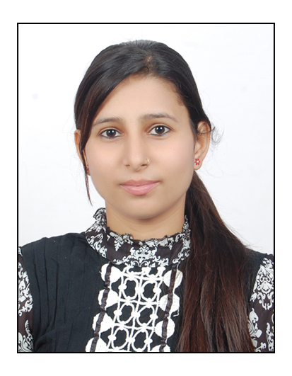
Neha Pandey
Shardha colony, tcp
Tekanpur, Gwalior, Mp.

E-mail Id:nehapandit35@gmail.com Mobile No.:9926164396

Objective:

To utilize my core technical competencies and act as a solution finder for individual and organization growth.

Academic Profile:
Qualification :Bachelors of Engineering (2012-2015).
Discipline :Mechanical engineering..

Education:
EXAMINATION | YEAR OF PASSING | INSTITUTE | BOARD/UNIV. | PERCENTAGE
B.E. | 2012-15 | Samrat Ashok Technological Institute of Vidisha. | R.G.P.V. | 7.00(CGPA)
Diploma | 2012 | B.S.F Polytechnic, Gwalior | R.G.P.V. | 67.67
High School(Class 10th) | 2009 | B.S.F Sr. SecSchool. | CBSE | 51

Experience:
.
- Worked as a Business analyst in ways2capital.

Projects:

- Name : Automatic solar operating window glass cleaner.
- Role:Designing and testing.
- Team :4 members.
- Deliverable: It isusedin a high-rise buildingsfor cleaning windows.

Technical Skills:
- Language : Auto Cad
- Subject :Industrial Engineering.

Training:

Title:Disel Loco Shed, BHEL.
BharatHeavy ElectricalLimited

KeyPoints:
- In BHEL to make a locomotives and Power transformers.
- In case of Diesel Loco Shed provides assembly of goods and passengers.

Achievements:

- Participate in debate competition organised by vikrant group of technological.
- Participate in state level athelitics running.
- Participate in dance\song in school several time.

Strengths:

- Committed, focused and capable of handling adverse situation.
- Motivated self-starter with a strong desire to learn and excel.
- Smart Working.
- Result Oriented.
- Enthusiastic to learn new skills.
- Can easily adapt according to situation.

Personal Information:

Father’s Name :Mr. HeeraBallabh Pandey.
Mother’s Name:Mrs. HemaPaney.
Date of birth: 24/04/1993
Hobbies :Interested in travelling and meeting new people, Acting, Helping others.

Declaration:

I consider myself familiar with Mechanical Engineering Aspects. I am also confident of my ability to work in a team. I hereby declare that the information furnished above is true to the best of my knowledge.

Date : 26-09-2015
Place :Tekanpur,Gwalior.(475005) Neha Pandey.

