Curriculum Vitae
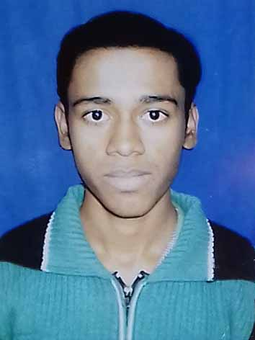

DINESH PAL
VILL: GOALJAN
P.O : GOALJAN,
P.S : BERHAMPORE,
DIST: MURSHIDZBAD,(W.B)
PIN : 742187,

Mob: +918372012375,

E-mail:d.dineshpal2012@gmail.com

Objective:
Electrical Engineering, which will not only provide opportunities for constant growth but also helps to enhance my Knowledge, Skills, Strengths & Abilities further. Thereby adding value to self and in turn to the organisation and to effectively contribute towards achieving the goals of the organisation.

Academic Qualifications:

Examination | Year | Board | Institute | Total Marks | Marks Obtained | Percentage
Madhyamik | 2010 | W.B.B.S.E. | Goaljan Refugee High School | 800 | 592 | 74%
Higher Secondary | 2012 | W.B.C.H.S.E. | Goaljan Refugee High School | 500 | 295 | 59%

COLLEGE: Murshidabad Institute of Technology
COURSE: Diploma
DEPARTMENT: Electrical Engineering
BOARD: WEST BENGAL STATE COUNCIL OF TECHNICAL EDUCATION
YEAR OF PASS: 2016

SEMESTER | 1st | 2nd | 3rd | 4th | 5th | 6th
PERCENTAGE  (%)  OF MARKS | 75 | 83.9 | 76.2 | 64.9 | 67.4 | 76.6

Technical Skills:
- Subject Interest : Electrical Machine.

- Computer Proficiency : Basic computer knowledge & fundamental.

Experience Details:
Company Name : Essline Engineers & Consultant Pvt. Ltd.
Duration :Since 5th july,2016.(to be continue)
Designation : Line Operator
Personal Details:

Father’s Name: ATUL PROSAD PAL

Date of Birth: 18/07/1995

Marital Status: Single

Sex: Male

Nationality: Indian

Religion: Hindu

Caste : O.B.C. B

Communication language:

English, Hindi & Bengali.

Hobbies:

Playing Cricket & Reading Newspaper

Declaration:

I, hereby, declare that the above mentioned informations true up to my knowledge & I’ll bear the responsibility for the correctness of the above mentioned particulars.

Place :Murshidabad
Signature

(DINESH PAL)

