CURRICULUM-VITAE

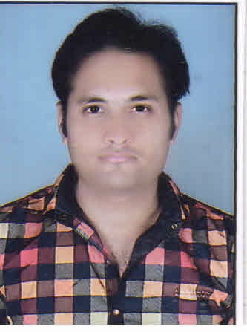NAVEEN SHARMA
MECHANICAL ENGINEER

Contact Details:
Address : H.No. 426,
Prem Nagar , Ward no-09, Mandideep ,
Dist-Raisen Bhopal (M.P.), Pin- 462046
Email Id: snaveen738944@gmail.com
Mobile No: +91- 7389440272
+91-9111354835
Career Objective:

To have a growth oriented and challenging career, where I can contribute my knowledge and skills to the organization and enhance my experience through continuous learning and teamwork.

Educational Qualifications:
Examination | Discipline/  Specialization | School/college | Board/  University | Year of Passing | Marks Obtained
B.E | Mechanical Engineering | Girdhar group of Institutions Bhopal. | RGPV (Bhopal) | 2016 | 73.3%
Higher Secondary | Science (Maths) | Vivek Jagrati H.S. School,Mandideep | M.P.B.S.E (Bhopal) | 2012 | 69.3%
SSLC | Science, Maths | Vivek Jagrati H.S. School,Mandideep | M.P.B.S.E (Bhopal) | 2010 | 69.4%

Training and Workshop Undergone:

Implant training:
∙ Organization : Steel Authority of India Limited (SAIL) , Bhilai (C.G.).
∙ Duration : 4 Weeks
∙ Knowledge Gained : Learnt about Coke oven .

Workshop:.

- Participated and has achieved 2 days Robotics workshop held at college campus (via PRO Group and Alcheringa, IIT Guwahati).
Skills & knowledge:
- Autocad 2D & 3D , MS Excel.
- 3D printing refers to processes in which material is joined or solidified under computer control to create a three-dimensional object, with material being added together (such as liquid molecules or powder grains being fused together). 3D printing is used in both rapid prototyping and additive manufacturing (AM)

Project Undertaken:
- Major Project:
Rocker-bogie suspension system .
Design- The rocker-bogie design has no springs or stub axles for each wheel, allowing the rover to climb over obstacles, such as rocks, that are up to twice the wheel's diameter in size while keeping all six wheels on the ground.

Interested Area:

- Manufacturing Technology/Production Engineering.
- Quality Control.
- Automobile Engineering.

Strengths;

1. Problem solving abilities.
2. Punctual, Optimistic.
3. Quick learner.
4. Good time management skills.
5. Positive Attitude.
6. Co-operative and keen observer.

Extra- curricular Activities:
- Participated in District level Surya Namaskar event at School level.
- Active Blood Doner

Assets & Hobbies:
- Watching Movies.
- Listen music.
3333333
Personal Profile:
Name : Naveen Sharma
Date of Birth : 01 Jan.1994
Marital Status : Single
Nationality : Indian
Languages known : English, Hindi (Read and Write)

Declaration:

I hereby declare that the above-mentioned information is correct up to my knowledge and I bear the responsibility for the correctness of the above mentioned particulars.

Place: Bhopal
Date: ( NAVEEN SHARMA )

