CURRICULUM VITAE
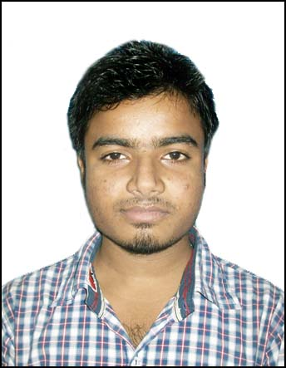
ANUJ KUMAR BHAKAT
kumar.anuj1992@gmail.com
.
Contact no:-9206968902

Career Objective:

To secure a challenging position where I can effectively contribute my skills as an Engineer, possessing competent Technical Skills.

Work Experience:

Organisation | Designation | Duration
Lumax Autotechnologies Ltd | Trainee Engineer | 19th jan 2016 - till date

Job Responsibilities:

1. Involved in KAI-ZEN activities.
2. Quality circle activities.
3. Promotion of safety practices.
4. Updating & maintaining of production relevant documents like PLB, PPMS, SMP, JISHU HOZEN sheets and documents files.
5. Operating injection molding machines for ABS, PP,PPGF
6. Setting up Standardized work flow, Control & process flow charts.
7. Knowledge of 5S.
8. Involved in KYT activities.
9. Manpower allocation & completing production targets.

Educational Qualifications:

Examination | Discipline/  Specialization | School/college | Board/  University | Year of Passing | Aggregate  %/CGPA
B.TECH | Electrical Engineering | DIET,W.B | WBUT | 2014 | 7.9
12th | Computer Science | AECS-1,Jaduguda | C.B.S.E. | 2010 | 62.3%
10th | Science | AECS-1,Jaduguda | C.B.S.E. | 2008 | 78.2%

Computer Skills:
Languages : C, C++.

Hobbies:
- Internet surfing
- Listening songs
Trainings / Projects Undertaken:

Name of Institute / Organization | Project Title | Duration
UCIL | DISTRIBUTION | 30 DAYS
ARDENT COMPUTECH PVT. LTD. | PROGRAMS OF PROGRAMMABLE LOGIC CONTROLLER | 1 MONTH
ARDENT COMPUTECH PVT. LTD. | ONLINE JOB PORTAL BY USING ASP.NET WITH C# | 1 MONTH
DUMKAL INSTITUTE OF ENGINEERING & TECHNOLOGY | WATER PUMP CONTROLLER FOR RESERVOIR LEVEL CONTROL | 1 YEAR

Personal Profile:
Name : Anuj Kumar Bhakat
Father’s Name : BrihaspatiBhakat
Sex : Male
Marital Status : Single
Nationality : Indian
Hobbies : Internet surfing, listening music
Permanent Address : HNO-62, Vill-Gopalpur,P.O-Asanboni, P.S-Jadugoda , Jharkhand
Phone No : 9206968902
Date of Birth : 25-11-1992

Declaration:
I hereby declare that the above-mentioned information is correct up to my knowledge and I bear the responsibility for the correctness of the above-mentioned particulars.

Dated:-21/02/2017
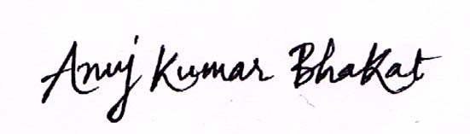

Signature

