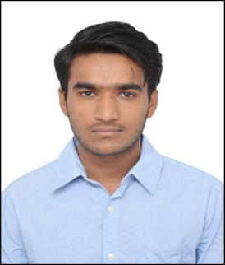
CURRICULUM VITAE

MD. IBRAHIM BABA
Mechanical Engineer
E-mail: mdibrahimbaba@gmail.com
Phone No: +918147983806

CAREER OBJECTIVE

To become an excellent career oriented professional by hard working, dedication, sincerity and loyalty which will help to achieve personal as well as organizational growth with a perfect blend of performance and passion for learning.

ACADEMIC CREDENTIALS

- Bachelor of engineering from Visveswarayya Technological University, Belgavi with Aggregate of 71% in 2017.

- Diploma in Mechanical Engineering from Board of Technical education, Bangalore with Aggregate of 67.42% in 2014.

COMPUTER PROFICIENCY

- Tools used: CAED, CAMD, ANSYS, AUTOCAD, CATIA, SOLID EDGE.
- Certification:
  - PROFESSIONAL IN PRODUCT DESIGN.
  - IT ESSENTIALS in PC HARDWARE AND SOFTWARE.
  - ADVENCED DIPLOMA IN FIRE AND SAFETY MANAGEMENT.
- Operating systems: Windows XP, Windows-10, Windows-8.1, Windows-
7, Windows- Vista.

EXTRA CURRICULAR ACTIVITIES

- Participated in BLUEBOTZ, a two-day advance Workshop on Advance Robotics recognised by SCIENCE PARK Korea in association with MSRDS-UG and AIESEC IIT DELHI held at CMRIT Bengaluru.
- Participated as Volunteer in STATE LEVEL PROJECT EXIBITION AND COMPETITION at SRISHTI 2016.

PROJECT DONE IN ENGINEERING

- FRICTION STIR WELDING:

Dissimilar welding which includes joining of different series of aluminum alloys and we checked the mechanical properties of this type of welding with normal welding.

PROJECT DONE IN DIPLOMA

  - PRODUCING ELECTRICITY THROUGH FOOTSTEPS:

A Staircase system which converts mechanical energy into electrical energy, created using spring system.

PERSONAL SKILLS

- Honesty and humble to my Work.
- Eagerness to complete a particular work as early as possible.
- Well determined and dedicated towards my aim.
- Talking initiative and quick learner.

PERSONAL DETAILS
- Date of Birth | : | 30th JULY 1994
- Gender | : | Male
- Nationality | : | Indian
- Languages known | : | English, Urdu, Hindi, Kannada.
- Hobbies | : | Bike riding, horse riding, car driving.
- Marital status | : | Unmarried.
- Passport No | : | P9803047.

