DEVANSH INDUSTRIES

PLOT NO – 54, AVON COMPLEX, SECTOR – 55, FARIDABAD HARYANA - 121004

Has been assessed and confirm to:

CERTIFIED BY : ISO 9001:2015

For the following activities

Manufacturing :-

TRAUB MACHINES & COMPONENTS

AND

PRECISION TURNED COMPONENTS

GSTIN : 06KHHPS7467H1ZJ
ISO CERTIFICATE NO. : 22EQHD08
UDHYAM REGISTRATION NO. : UDYAM -HR-03-0026587

DEVANSH INDUSTRIES
PLOT NO – 54, AVON COMPLEX, SECTOR – 55, FARIDABAD
HARYANA - 121004

CONTACT NO – 9354252725 (KAILASH SINGH)
7683066425 (TEJPAL SINGH)

EMAIL ID : devanshindustries21@gmail.com

ABOUT US

DEVANSH INDUSTRIES is registered by

The directors are manufactures Traub machines and precision turned components and have vast Experience in this field

The company is situated in Sector-55, Faridabad with a covered area of 3500 Sq. Feet.

WHAT WE DO

We Leading Manufacturer of Traub machines and Components on Traub machines and CNC machines.

Within house CNC Turning, Milling, Drilling, Tapping, DRO Machine, Automatic Bendsaw & other secondary operations.

HOW WE WORK?

DEVANSH INDUSTRIES has satisfied customers by system of total quality

management.

Exceeding customer's expectation through quality and service

QUALITY POLICY :

ENHANCING CUSTOMERS SATISFACTION THROUGH

MANUFACTURING & SUPPLY OF PRODUCTS TIMELY

CUSTOMER REQUIREMENTS, WHILE CONTINOUSLY

IMPROVING THE EFFECTIVENESS OF QUALITY

QUALITY MANAGEMENT SYSTEM

QUALITY OBJECTIVES:

i. REDUCE CUSTOMER COMPLAINTS & REJECTION

ii. REDUCE INTERNAL REJECTIONS.

iii. ON TIME DELIVERY TO CUSTOMERS

HOW WE ENSURE QUALITY?

"Quality is a way of life at DEVANSH INDUSTRIES" & timely delivery is our aim.
Our quality assurance department is equipped with lab and requisite
measuring instruments as given below:

LIST OF METROLOGICAL INSTRUMENTS

SERIAL NO DESCRIPTION
- SURFACE PLATE 12"x18"
- HEIGHT GAUGE
- DIGITAL VERNIER
- DIAL GAUGES
- MIOCROMETER (0-25MM)
- MICROMETER (25-50MM)
- MICROMETER (50-75MM)
- MICROMETER (75-100MM)
- VERNIER 6”
- VERNIER 12”

Periodic calibration of measuring instruments and gauges is done as per
final inspection.
All dispatches are accompanied by PDI reports.
Actions are taken immediately through CAPA and informed to customer to remove the concerns pointed out by customers.
We ensure quality throughout the manufacturing cycle of the product starting from receipt of raw materials/components, during processing and till
final inspection.
All dispatches are accompanied by PDI reports. Actions are taken immediately through CAPA and informed to customer to remove the concerns pointed out by customers.

DIAL INDICATOR MICROMETER
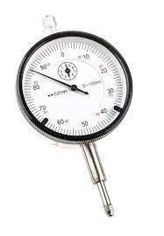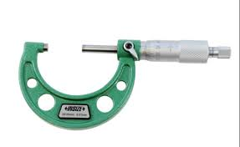

HEIGHT GUAGE DIGITAL VERNIER
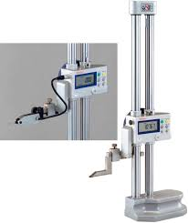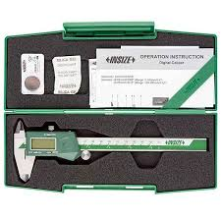

SURFACE PLATE

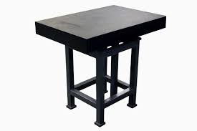
LIST OF MACHINERY :-

S.NO DESCRIPTION

1. CNC TURNING MACHINE ( 6” ) 1 NOS.

2. CNC TURNING MACHINE ( 8” ) 1 NOS.

3. TRAUB MACHINE A25 4 NOS.

4. TRAUB MACHINE A32 4 NOS.

5. LATHE (6 FEET) 2 NOS.

6. SURFACE GRINDER (9" *18") 1 NOS.

7. PRECISION DRILLING MACHINE (1" & ½”) 2 NOS.

8. EICHER GENERATOR (20 KVA) 1 NOS.

9. TAPPING ADDA 1 NOS.

10. M1TR (WITH DRO) MACHINE 1 NOS.

10 MILLING MACHINE 1 NOS.

11 COLLET ADDA A25 2 NOS.

12 VERTICAL MILLING MACHINE 1 NOS

CNC TURNING WORKING

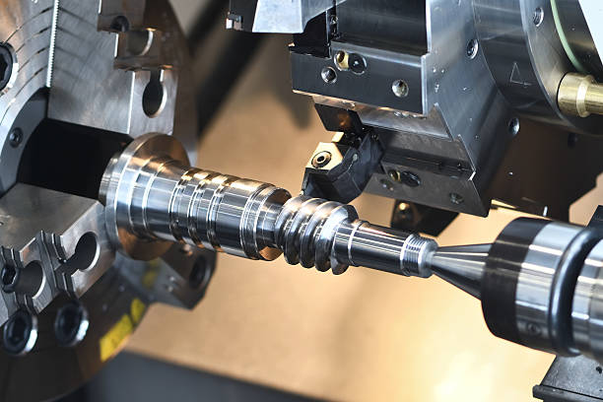

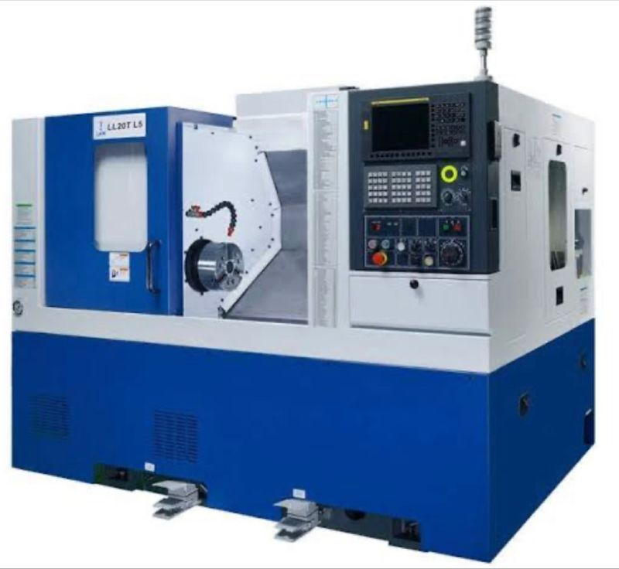

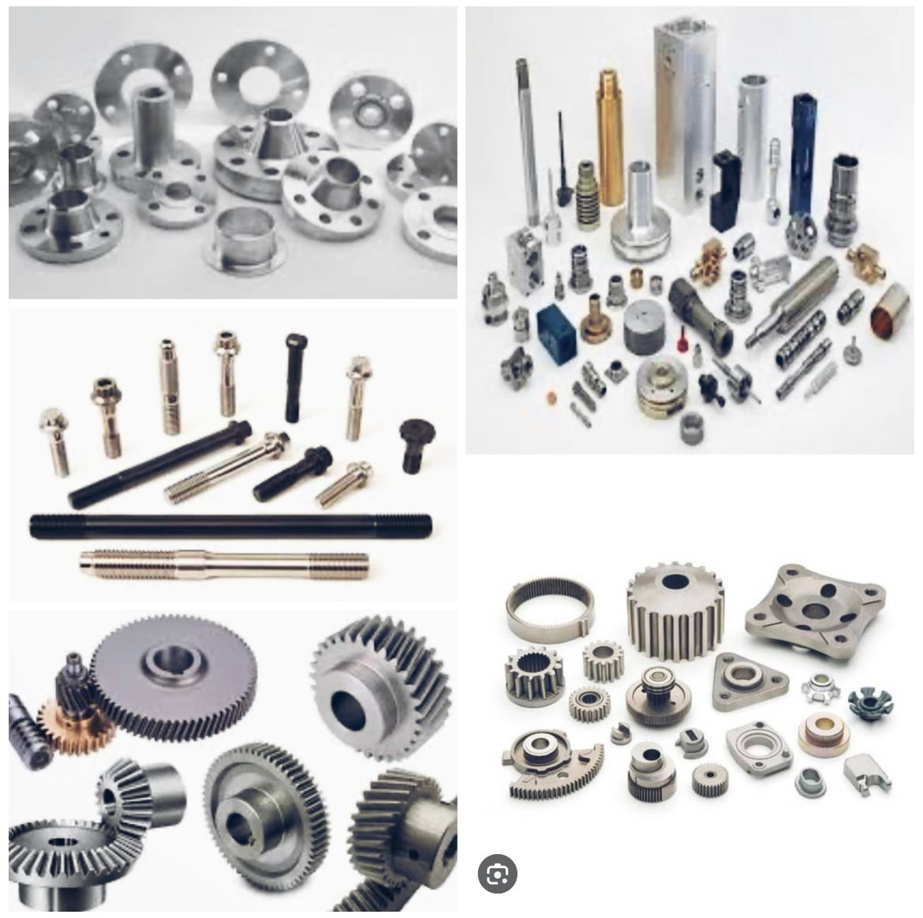

COMPONENTS/MACHINES IMAGES
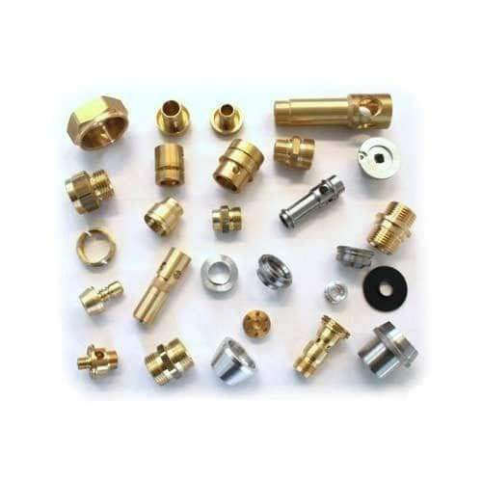

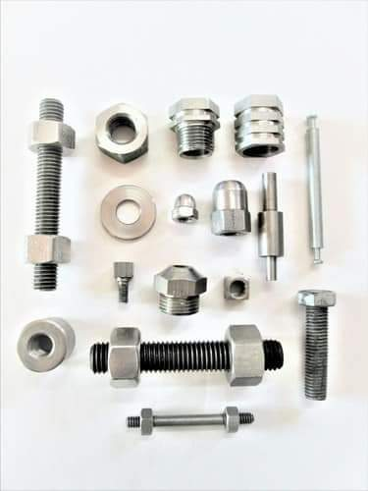

TRAUB MACHINE SPARES
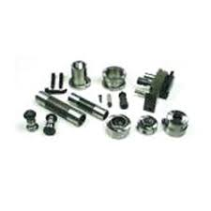

TRAUB CLUTCH

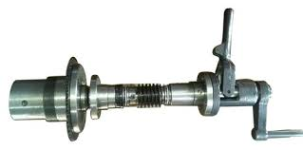

TRANSMISSION PARTS
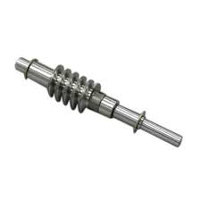

PRECISION TURNED COMPONENTS
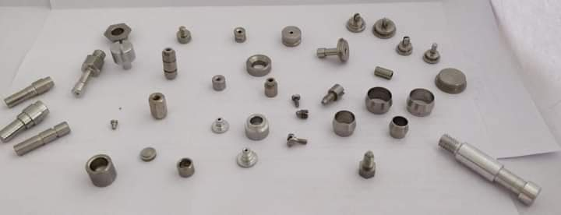

HYDROLIC FITTINGS
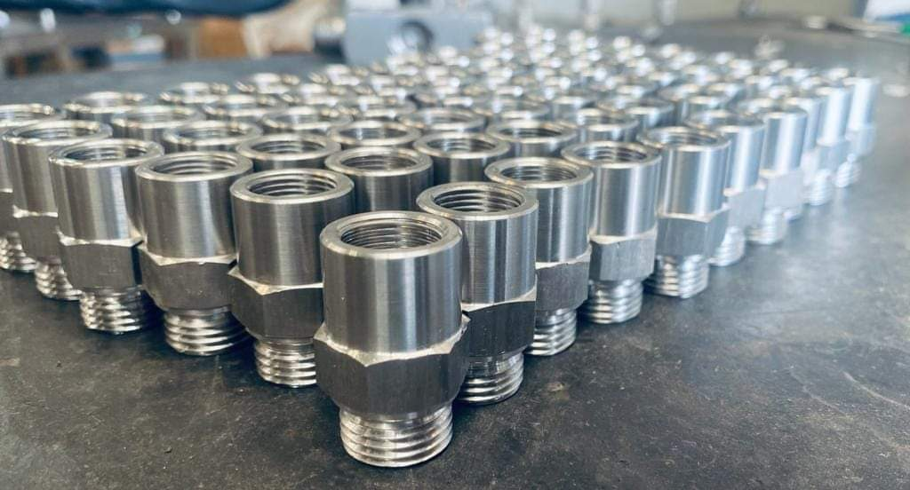

TRAUB MACHINE WORKING
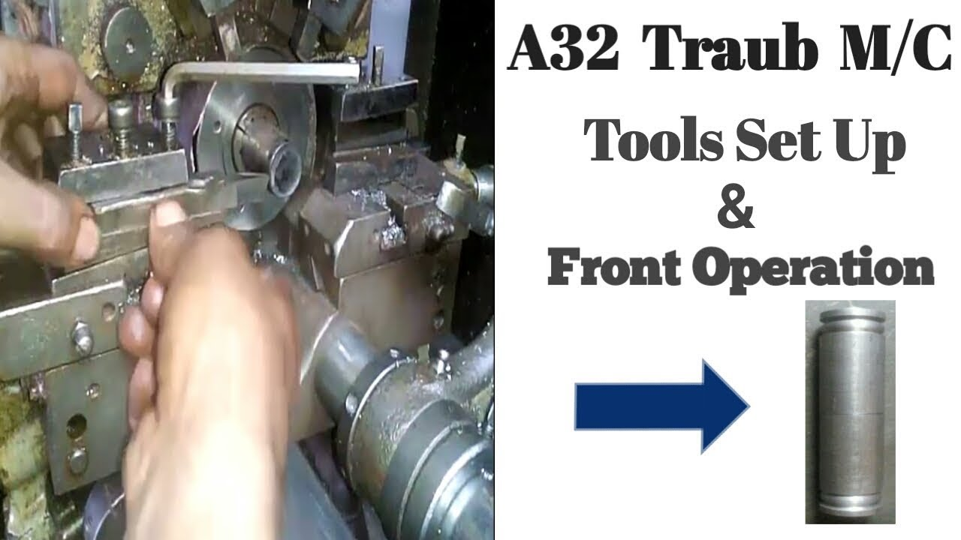

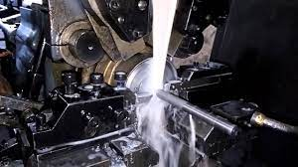

TRAUB MACHINE COLLET ADDA
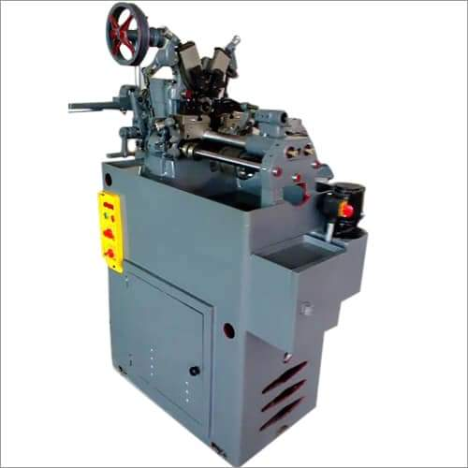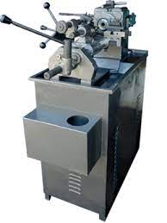

TAPPING ADDA MACHINE MILLING MACHINE
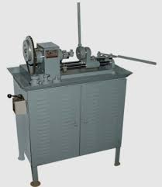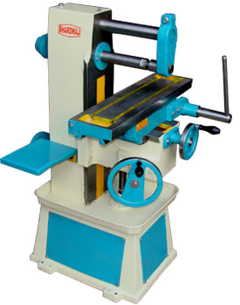

DRO MACHINE SURFACE GRINDING MACHINE
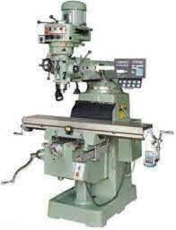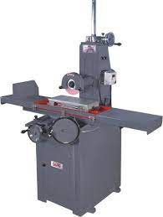

LATHE MACHINE DRILLING MACHINE
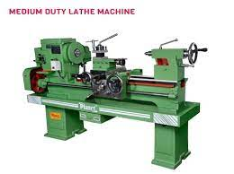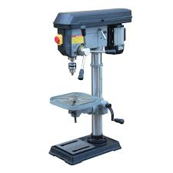

POWER BENDSAW
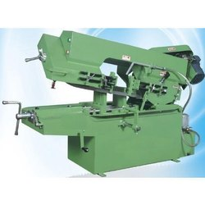

VERTICAL MILLING MACHINE A32 TRAUB WITH DOUBLE STAND

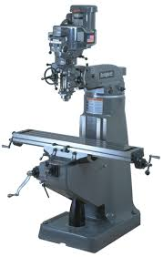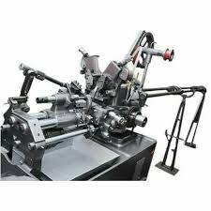

LIST OF MAJOR REGULAR CUSTOMERS…

1. M\S BHAVNISH METAL INDIA PVT. LTD.
2. M\S MADNANI ENGINEERING WORKS
3. M\S S.S TOOLS
4. M\S GLOBAL ENGG. WORKS
5. M\S FARIDABAD CONTROL & ELECTRICALS PVT LTD

PRIME MOTIVE :-
Our goal is to provide high quality service and products with total customer satisfaction in time.

Emphasis on standard & implied needs of customers.

To create long lasting business relationship for mutual benefits & strategic advantages.

To provide proper training to the employee.

WE DRAW OUR STRENGTH FROM :-
TECHNICALLY QUALIFIED AND EXPERIENCED MANAGEMENT
DEDICATED WORK FORCE
IN HOUSE FACILITY OF ALL PRODUCTION OPERATIONS SPECIAL EMPHASIS ON QUALITY AND PERFECTION
TIMELY COMPLETION OF DELIVERY SCHEDULE OUR POSITIVE ATTITUDE
OUR WILLINGNESS TO WORK WITH MODERN CONCEPTS

OUR EXPERTISE
COMMITMENTS TO CLIENTS TO FUNCTION WITH INTEGRITY AND COMPLETE TRANSP

. For DEVANSH INDUSTRIES

M. Director (KAILASH SINGH)

THANK YOU

DEVANSH INDUSTRIES
ISO 9001:2015

