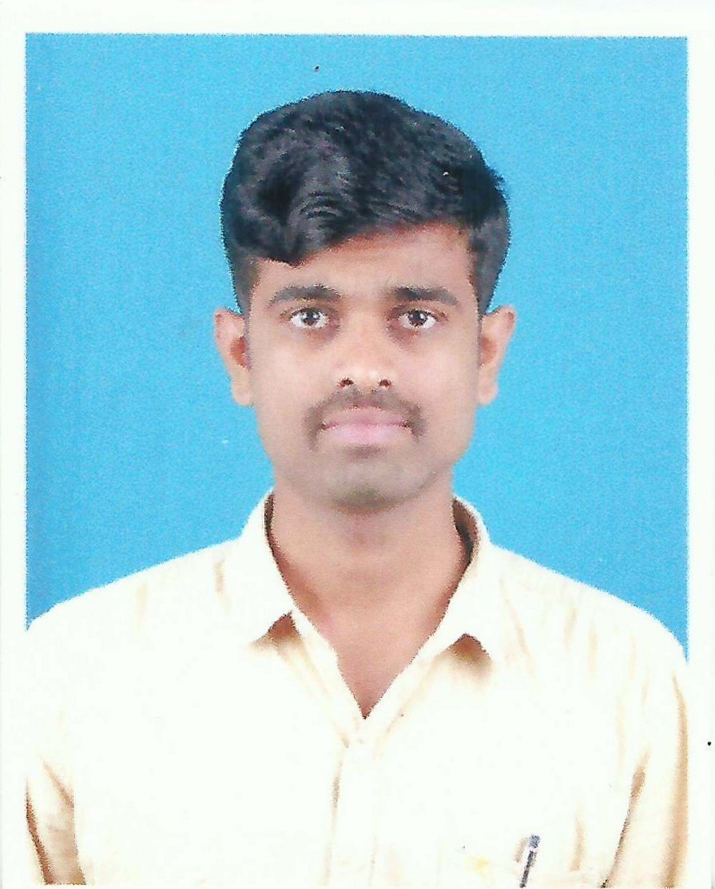

Mr.Prathap S Banigol

#444, 1st Main, 1st Cross
Kereangala, Kamalanagar
Bengaluru-560079
Karnataka, India
Ph : 8904894073

Email :
ssbanigol@gmail.com

Linkedin :
https://www.linkedin.com/in/prathap-banigol-212724144

Dear Sir\Madam.

To have a growth oriented and challenging career, where I can contribute my knowledge and skills to the organization and enhance my experience through continuous learning and teamwork.
Please take a look at my attached resume for a detailed look at my skills and experience. Here's a snapshot of what I have to offer:

- Done intern in Lakshmi components Pvt. Ltd.-Hosakote, Bengaluru.
- 1st Rank holder in Tool Engineering from VTU during 2015-2017.
- MTech in Tool Engineering from RV College, Bengaluru Under VTU, Belgaum, Karnataka, India.
- Bachelor of Engineering degree in Mechanical Engineering from BTLIT, Bengaluru under VTU, Belgaum, Karnataka, India.
- Carried project in HAL, Bengaluru and M.K. Industries, Bengaluru.
- Participated in Student Project Program during 2014-2015 held by KSCST, IISC, Bengaluru-560012.
- Software known: UG-NX 9.0, Auto CAD, Solid Edge V-19.
- Microsoft Office.

The attached resume details my extensive experience and training as a
Intern & Project trainee. And I am looking forward to discuss how I can
contribute my strengths at your company. I appreciate your taking the time
to review my credentials and experience.

Thank you for your consideration.

Sincerely,
PRATHAP S BANIGOL

Prathap S Banigol | Ph- +91 8904894073| ssbanigol@gmail.com

DETAILS
Mr. Prathap S Banigol

EXPERIENCE

June 2016-July 2017 Lakshmi Components Pvt. Ltd.Bengaluru
#444, 1st Main, 1st Cross
Kereangala, Kamalanagar
Bengaluru-560079
Karnataka, India
Ph : 8904894073
Email: ssbanigol @gmail.com

DOB: 27-March-1993

EDUCATION
- SSLC-79%
- PUC-64%
- BE-Mechanical-71%
- MTech-Tool Engineering-80%

AREA OF INTEREST
- Design field.
- Quality field.
- Manufacturing Technology.
- Production Engineer.

SKILLS
Decisive Thinker
Collaborative
Discrete And Ethical

PERSONAL PROFILE
- Hobbies: Reading Books, Gardening,
Attending Workshops, Calligraphy.
- Languages adept in : English, Hindi
Kannada.
- Good Listener, Willingness to Learn
- Self Motivated.
Lakshmi Components Pvt. Ltd. is a solutions provider for the sheet metal needs with experience and the knowledge base to provide with services ranging from Conceptualization, Product Design, Tool Development, Fabrication and Assembly operations. Be it small-sized high-volume stampings or large metal enclosures the setup can cater to all the stamping requirements. LCPL have major experience in services to the electrical and power sector for enclosures for UPS, battery shrouds, racks for CPU, Networks and Server equipment and high precision connectors for telecommunication appliances.
Accomplishments:
- Under gone as Intern and Project Trainee
- Project- Design, Analysis & Manufacturing of a Compound Press Tool for Rib.
- Cost estimation of Mold for New product.
- Customer complaint management through 8D, QPR.
- Gauge planning for the products.
- Knowledge of QMS activities like WI, PPAP, 5S, FIR.

May 2015- June 2015 HAL, Bengaluru-Helicopter Division
HAL is an India state owned company, It is governed under the management of the Indian Ministry of Defence. HAL doing manufacturing & assembly of defence aircrafts.
Accomplishments:
- Under gone as a Project Trainee.
- Learnt about GD&T.

May 2015- June 2015 M. K. Industries, Bengaluru
M K Industries are manufactures the precision machine components, jig & fixtures, CNC, Turning & Milling jobs.
- Carried fabrication work of the project (Project title- Design & fabrication of multipurpose crusher).

INDUSTRIAL VISIT
- Eigen Engineering(Kddl Limited), Bengaluru-560058.
- J K tyre’s & industries Ltd, Mysore.
- BEML, Mysore.

EDUCATION

2011-2015 BACHELOR OF ENGINEERING - MECHANICAL
BTLIT, Bengaluru under VTU, Belgaum, Karnataka, India

2015-2017 M-Tech – TOOL ENGINEERING
R V College Of Engineering, Bengaluru under VTU, Belgaum, Karnataka, India.

Prathap S Banigol | Ph- +91 8904894073| ssbanigol@gmail.com

