Yogendra Jangid
E-Mail: jangra.yogendra@gmail.com
Mobile: +91- 9462721768 , 7976692440

To work for company that promises creative and challenging career in technical, commercial as well as management in progressive environment with Candid and co-operative work culture that fosters steady of company and my self

PROFESSIONAL ABRIDGEMENT

- Automobile Mechanical & Electrical Engineer with 2.8 year of experience as an Development engineer.
- Currently associated with SHRI RAM AUTOTECH PVT. LTD. Gurgaon as R&D Sr. Engineer.
- Deft in swiftly ramping projects with cross-functional skills & ensuring on-time deliverables.

EMPLOYMENT RECORD
- Feb. 2015 to Feb. 2016 with AVON cycle Ltd., Ludhiana, Punjab as an Asst. Supervisor Engineer.
- April 2016 to April 2017 with Green Kaiketsu Automotive India Pvt. Ltd. Khushkhera, Bhiwadi Raj. as an Engineer.

CURRENT CARREER STATUS

Company Name : Shri Ram Autotech Pvt. Ltd. (JANGID MOTORS)
Company profile : SRAPL is an Sheet Metal & Plastic Components, E-vehicle Manufacture
Designation : Sr. Engineer
Department : Research & Development, NPD
Duration : 02 May 2017 to till now

COMPANY PROFILE :
- Shri Ram Autotech Private Limited is a Private incorporated on 1992. It is involved in Manufacturing of Sheet Metal, Plastic Components & Electric vehicles. It has its business establishment directly into market. The vehicles are approved from ICAT & CIRT & very well it is supplying vehicles in 22 states of India.

- Green Kaiketsu Automotive India Pvt. Ltd. is Japanese and Indian Based MNC. Which is engaged in manufacturing E- Rickshaw & E- Cycle. GKA is Rajasthan 1st EV Company.

- AVON CYCLE Ltd. is Indian based MNC which is engaged in manufacturing Automobiles vehicle & Cycle. Avon is India’s best bicycle Company.

JOB RESPONSIBILITY

- Solving problems in the shop floor by working closely with Production people.
- Assigned with the tasks of planning, conducting and providing guidance to staff in areas of mechanical development.
- Customer problem analysis & their loop closing.
- Standing in for the production manager when required.
- Assisting in the investigation of accident and incidents.
- Checking all production goods in and then reporting mistakes or damaged items.
- Shift production plans.
- Managing staff.
- Improving processes.
- Time management.
- Line setup and assembly member for battery operated manufacturing facility in the company.
- Ability to plan, co-ordinate and execute tasks/projects (new development, component development) within timelines and completion.
- Talent for proactively identifying & resolving problems, ramping up project activities with on time deliverables.
- Good analytical, troubleshooting and inter-personal skills with proven ability in driving numerous quality enhancement, process improvement and cost savings initiatives during the career span.
- Excellent communication & collaboration skills with proficiency at grasping new technical concepts quickly.
- An effective communicator with excellent relationship building & interpersonal skills, problem solving abilities and possessing a positive & flexibility oriented attitude.
- Working on Cost saving projects.
- Having the Knowledge if Vendor Development.
- Battery Testing, Controller Testing , Motor Testing.

ICAT, CIRT & ARAI HOMOLOGATION

- ICAT certification of Battery operated and Hybrid vehicle (3-wheeler,2-wheeler,4-wheeler).
- Experience in ICAT automobile projects.
- Experience in E-VAHAAN Sewa.
- Experience in Homologation of parts According to AIS and ECE listed below:-
- Alloy wheels (AIS:073 and AIS:074).
- Head Lamps and Front fog lamp(AIS:010,012,062 and ECE 1,19,20,56,57)
- Tail, stop, direction indicators, Reverse lamp(AIS:010,012,062 and ECE 6,7,23,38,39,87,91)
- Reflex reflector(AIS:057 and ECE:3)
- Rear registration plate lamp(AIS:010,AIS:012 and ECE:4)
- Installation of lights (AIS:008,009,030 and ECE:48,53,74,86)
- HLLD Test(AIS:008 & ECE:4)
- Lead acid , Lead carbon & Li-Ion batteries Test.
- Having the complete knowledge of Vehicle testing. (Power Test, Brake Test etc.)

PROJECTS
- Development of new products like GKA Vaayu and SRAPL Advance which were showcased in Electric Vehicles Expo held in Pragati Maidan, New Delhi.

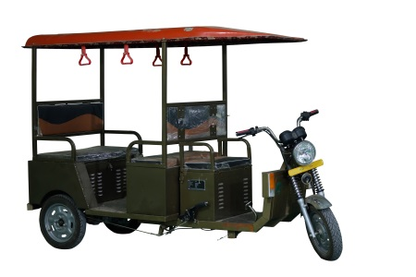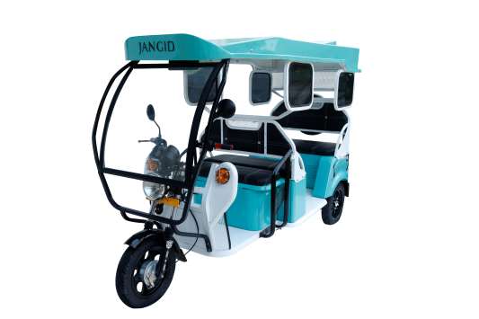

E Rickshaw Fabrication: In this project our team aim was to initiate Make in India voice in the field of E Rickshaw. Our project names were VAAYU and ADVANCE. We Develops all the parts by ourselves (Like chassis, frame, pattern, body).

- DEVELOPMENT OF CHARGING STATION:
Our project aim was to design and develop a charging station which will be used to charge the Electric vehicles. The design was approved by the management and the charging stations will be installed to Charging Pumps

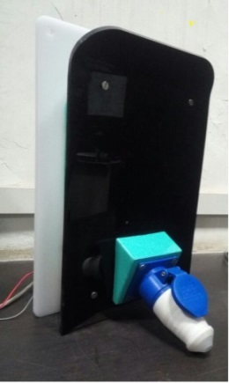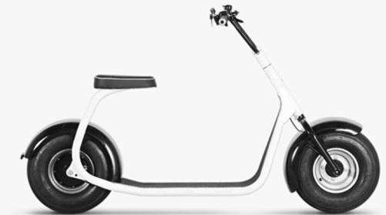

- E-CYCLE:
In this project design of E-cycle (BBT) was made. In response to the design various calculations related to torque, Gear ratio, battery run time, etc. were done.

JOB DESCRIPTION

- Rendering guidance to the small group activities in solving the quality problem and establishing Kaizens for continual improvement.

- Carry preventive maintenance, risk-based, condition-based maintenance and breakdown handling of plant.

- Quality inspection at shop floor, maintaining 7 QC tools and 5S.

- APQP , PPAP & Project Development.

ACADEMIC QUALIFICATION

- Graduation from Rajasthan University Jaipur. 2017.
- Diploma Industrial Training Institute in Automobile Engineering from Govt. College (Alwar) Rajasthan in 2012.
- 12th from Raj. Board of Secondary Education Rajasthan in the year 2014.

- 10th from Raj. Board of Secondary Education Rajasthan in the year 2009.

COMPUTER SKILLS

- R.S-C.I.T (Raj. State Certificate of Information Technology)
- ERP System
- Microsoft Office 2007, 2010

PERSONAL DOSSIER

Name : YOGENDRA JANGID
Father’s Name : Shri Devdut t Jangid
Date of Birth : 27 Aug, 1994
Nationality : INDIAN
Married Status : Unmarried
Permanent Address : V.P.O. Khairthal, Khatiwara mohalla, Ward no. - 6, Teh.
Kishangarh-bass, Distt. Alwar (Raj.) INDIA Pin- 301404

DECLARATION:
It is hereby informed that all the information given above by me is fully true to best of my knowledge.

(YOGENDRA JANGID)

