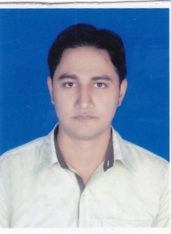
SHAHBAZ ALAM
Email:-Shahbaz9115@yahoo.com
Mobile No:- 8018954454 / 9334127083

CAREER OBJECTIVE

Desirous to work in a challenging environment with a team of work and creativity driven force meeting organizational goals as well as enduring personal growth.

EDUCATIONAL QUALIFICATION

- Completed B.Tech in Mechanical Engineering from Konark Institute of Science & Technology under
Biju Patnaik University Of Technology with a CGPA of 7.12 in the year 2016
- Completed 12th (CBSE) in Science from Patna Central School with 60.40% of marks in the year 2012
- Completed 10th (CBSE) from Patna Central School with a CGPA of 6.2 in the year 2010

TRAINING & ACCOMPLISHMENTS

- Master of CAD/CAM at CTTC (Central Tool Room and Training Centre), Bhubaneswar, from ( 7thJuly 2016 to 6thJanuary 2017)

- Advance Automobile Training on Volkswagen, Skoda and Audi vehicles at Bharat pvt. Industrial training institute Bhubaneswar, from 15th-22nd December 2014

IT SKILLS

- NX(UNIGRAPHICS)
- CATIA
- CREO
- MS OFFICE

PROJECTS UNDERTAKEN

- Project on “Design of Centrifugal Casting Experimental Setup for Fabrication of FGM” at Konark Institute of Science & Technology, Bhubaneswar.

- Project on “Manufacturing of Hand Injection Mould” at CTTC (Central Tool Room and Training Centre), Bhubaneswar.

- Attended One day Seminar On “Advances in Automobiles Engineering: BS III Engines”

EXTRA CURRICULAR ACTIVITIES

- Volunteered Freshers Party in 2nd year.
- Sports co-ordinator in annual school athletic

INTERESTS

- Travelling new places
- Creating new friends

PERSONAL DOSSIER

Date of Birth : 19/03/1995

Father’s Name : Mr.Naushad Alam

Address : Alamganj agarwal tola
Loharwaghat lane
Patna, Bihar
Pin:-800007

Passport no : L2906987

Nationality : Indian

Gender : Male

Languages Known : Urdu, Hindi, English

DECLARATION

I do hereby affirm that the above furnished information’s are true and correct to the best of my knowledge and belief and proof of which will be produced on demand.

Date: __/__/____

Place: SIGNATURE

