CURRICULUM VITAE
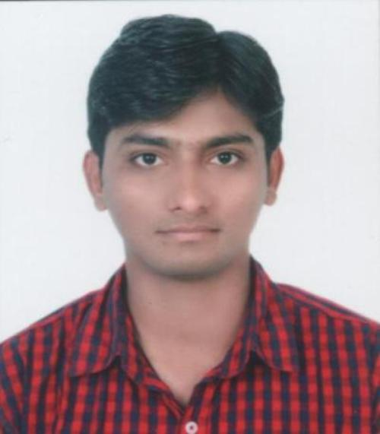
RAJAN KUMAR
S/O Shri. MUNNU CHOUDHARY
Sanjay Nagar Road No. - 4,
Postal Park Patna, Bihar - 800001
Email: - rajanshiv4151@gmail.com
Mob. : - +919758360907, +917260953728

CAREER OBJECTIVE

To justify my presence in the industry by contributing to it with best of my knowledge, dedication and team spirit and effectively utilize the skills and opportunities to enhance my performance.

EDUCATIONAL QUALIFICATION

B.Tech- Mechanical Engineering from Uttarakhand Technical University in 2016 with
67% Marks
Class XII- Adarsh Vikas Vidyalaya CBSE 2011 56 %
Class X - Adarsh Vikas Vidyalaya CBSE 2009 64 %

INPLANT TRAINING DETAILS

- NATIONAL THERMAL POWER CORPORATION ,
BARH, PATNA (BIHAR), (GOVT. OF INDIA):-
- Maintenance & operations of machines like boiler, turbine etc.

- INDIAN RAILWAYS CARRIAGE REPAIR WORKSHOP,
HARNAUT, PATNA (BIHAR), (GOVT. OF INDIA):-
- Maintenance & operations on non AC coaches, bogies, rail wheel etc.
- UTTARAKHAND TRANSPORT CORPORATION,
DEHRADUN, (UTTARAKHAND), (GOVT. OF UTTARAKHAND):-
- Training was regarding as major repair & maintenance work as well as assembly reconditioning work is performed.
- Good hands on experience on 6 cylinder diesel engine including assembling, disassembling & their maintenance.

ACADEMIC PROJECT
Parametric Optimization of SS-202 Alloy Steel in Turning Operation by Using Taguchi Method.
SOFTWARE SKILLS

- AutoCAD 2013 with grade “A”
- CATIA V5 R19 with grade “A”
- ANSYS 16.0 with grade “A”
- SOLID WORKS with grade “A”

PAPER PUBLISHED AND CONFERENCES

- Published On: - “International Journal of Scientific Progress and Research.”
ISSN: 2349-4689, Impact Factor – 3.963
Topic: - “Parametric Optimization of Heat Treated SS-202 Alloy Steel in
Turning Operation Using Taguchi Method.”
IJSPR- Issue-68, Volume-24, Number-04, S.No-35, June 2016,
Page- 180-182.
- Attended an International conference in Innovative Science and Technology held at Uttaranchal University, Dehradun (Uttarakhand).

PROFESSIONAL QUALIFICATION

- TOOL ROOM & TRAINING CENTRE , PATNA (BIHAR)
(GOVT. OF INDIA, MINISTRY OF MSME):-

- CNC Turning (Fanuc) with grade “A”
- 2 week duration
- Welding Simulator with grade “A”
- 1 week duration

- IDEAL INSTITUTE OF COMPUTER TECHNOLOGY, PATNA (BIHAR)
(REGD. UNDER MBKS, GOVT. OF BIHAR):-

- Diploma in computer application (DCA) with 64% marks.
- 6 month duration

EXTRA CURRICULAR ACTIVITIES
- Participate in (Entrepreneurship Awareness Camp) organized by DIT University, supported by “Dept. of Science & Tech. - National Implementing & Monitoring Agency for Training”.
- Active participate in cultural activities and technical fests.
- Participate in inter college event (The Survivor).
- Active participate in quiz & debate competitions.
- Active member of ECO-CLUB.
- Active blood donor.

SOFT SKILLS

Personal effectiveness, Presentation Skills, Adaptability, Communication Skills.

PERSONAL DETAILS
Date of Birth: - Feb.10, 1994
Gender : - Male
Nationality : - Indian
Languages : - English, Hindi
Hobbies : - Listening music, Read newspapers, Watching news channels & science fiction movies, Playing cricket, badminton & Adventurous travelling.

DECLARATION
I hereby declare that all the particulars given by me in this resume are to the best of my knowledge and belief, true and correct.

Place:- Patna
Date:- 09/01/2017 Rajan Kumar

