BIODATA
NAME: AMIT KUMAR MUKHERJEE. 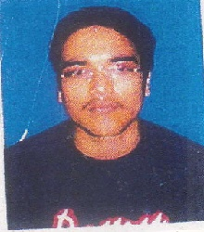
D.O.B.:17/11/1990
PERSONAL DETAILS
FATHER’S NAME: ASHIM KUMAR MUKHERJEE.
RESIDENTIAL ADDRESS: 53, J.N.LAHIRI ROAD, SERAMPORE,
HOOGHLY.PIN-712201
PHONE NO: 8274940438 / 8013386205.
E-mail ID: mukherjeeamit2012@gmail.com.
RELIGION: HINDUISM
NATIONALITY: INDIAN
MARITAL STATUS: SINGLE
GENDER: MALE
ACADEMIC QUALIFICATION

NAME OF EXAMINATION | YEAR OF PASSING | % OF MARKS
DIPLOMA IN LAND SARVEY | 2010 | 70.0%
HIGHER SECONDARY | 2010 | 57.0%
MADHYAMIK | 2007 | 47.0%
OTHERS

.
Experience: In STANDARD PHARMACEUTICALS LIMITED, as
Office Assent for 2 year, 6 Month in Komolaroy hospital
as Floor Manager.

AREA OF INTEREST: SWEMING.
LANGUAGES KNOWN: ENGLISH, BENGALI AND HINDI.

DATE:
PLACE: _____________.
Amit Kumar Mukherjee.
(AMIT KUMAR MUKHERJEE)

