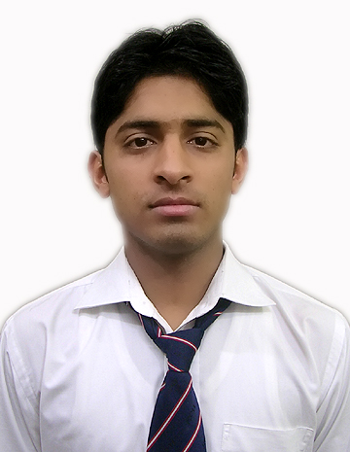
CURRICULUM VITAE

AKSHAT KUMAR
Cell:- +918006550877,
Email:- akshatkumar_0993@yahoo.co.in
Address:- C-224/1 “Vijay Vihar” Shubhash Nagar, Near Shiv Temple
Roorkee, Uttarakhand (INDIA) Pin code :- 247667

CAREER OBJECTIVE

To work in a challenging atmosphere by exhibiting my skills with utmost sincerity and dedication smart work for the growth of your esteemed organization along with mine.

ACADMIA
- Completed B.Tech (Automobile Engineering) from Graphic Era University, Dehradun in 2014 with secure 70.10% marks.
- Intermediate from A. S. Arya Saraswati Vidhya Mandir, Roorkee in 2010 with secure 60.20% marks.
- High School from S. G. R. R. Public School, Muzzafarnagar in 2008 with secure 63.60% marks.

CORE COMPETENCIES

- Good knowledge in field of Automobiles.
- Capacity to hard work.
- Good Communication Skills.
- Work in Challenging Atmosphere.
- Able to take initiative, willing and motivated to learn new technologies.

EXPERIENCE

I am working as a Quality Inspector in Quality Austria Central Asia Pvt Ltd at the Project location of Company in Victora Auto Pvt Ltd. Haridwar from last One Year.
Profile summary:-

- Gauges Handlings
- Manage line according to SOP(Standard Operating Procedure).
- Visualizations of Parts for final.
- Check quality of Parts for the finals dispatch.(PDI)

INDUSTRIAL TRAINING

- I have successfully done my 45 days training in Krishna Maruti Ltd, Manesar (Gurgaon).

Project Title : Assembly Process in Production
Organization : Krishna Maruti Limited (Manesar, Gurgaon)
Designation : Trainee
Period : 6 Weeks

Key Learnings
- The pivotal role of automation in rapid assembly of Car Seating.
- How robots provide stimulated scenario for factory workers and manufacturing methods.

ACADEMIC PROJECT

- I have completed my final year project on “Fabrication of Four Leg Walking machine” that is based on the “Theo Jansen Mechanism”. The purpose of this project is to contribute to the area of fabrication of four leg walking machine with single degree of freedom of an individual leg. The leg mechanism is to be considered efficient especially when walking on rough terrains. This project is also used for Surveillance, Military application, Medical application, Home security system.

COMPUTER SKILLS

- Basics- MS Office (Word, PowerPoint).
- Environment - Windows XP/Window 7/Window 8
- Good understanding of the internet and related Technology.

HOBBIES

- Listen Music
- Cooking
- Playing Caram
- Travelling

EXTRA CURRICULAR ACTIVITIES

- Completed Professional designing course in AutoCAD.
- Good knowledge of Siemens NX CAD.
- Participated in 3 days Industrial Visit to Ashok Leyland in Rudrapur and Tata Motors in Pantnagar.

STRENGTHS
.
- I am a Hardworking & Helpful person.
- I am a team player and can adapt to changing conditions with ease.

PERSONAL DETAILS

Father’s Name : Mr. Sunder Lal
Mother Name : Mrs. Poonam Date of Birth : 26th Sept, 1993
Sex : Male
Nationality : Indian
Languages Known : Hindi & English
Marital Status : Single

PERSONAL DETAILS

I hereby declare that all the above information is mentioned by me are true to the best of my knowledge.

Date:
Place: (AKSHAT KUMAR)

