ROHIT KUMAR MAHAKUD
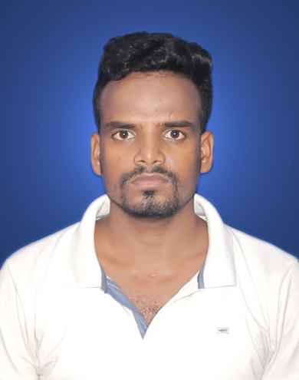
B.Tech-Mechanical Engineering

rohitkrmahakud@gmail.com

+91-7352441418, +91-7992318166

CAREER OBJECTIVE

To excel in my field through hard work, research, skills and perseverance. To serve my parents, and my country with the best of my abilities.

TECHNICAL COMPETENCIES
- Catia from CTTC Bhubaneswar.

- Auto-Cad from IDTR Jamshedpur.

PERSONAL COMPETENCIES

- Interactive.

- Leadership skill.

- Passionate.

ACADEMIC QUALIFICATION

Course/ Subject | Year Of | Institute | University/Board | CGPA/Marks
 | Passing |  |  | (%)
Bachelor of | 2013-2017 | NM Institute of Engineering&Technology, Bhubansewar,Odisha. | BPUT | 7.49
Technology
(Mechanical)
Intermediate | 2013 | Templecity Institute of Basic Science,Khurda,Odisha. | C.H.S.E | 59.33%
High School | 2011 | B D S L S Vidya Mandir high School Mosaboni,Jharkhand. | J.A.C | 56.6%

TRAINING & CERTIFICATION

- Summer Internship at TATA STEEL ,Jamshedpur in G- Blast Furnace Iron-making. as a Mechanical Engineer from (14 JUNE 2016- 05 JULY 2016)

- Vacation Training at CTTC,Bhubaneswar in ConventionalTurning, Conventional Milling and In-Plant Training in Production department from (01.03.2016 to 31.03.2016).
.
PROJECT

- PNEUMATIC CONTROL DEVICE

6th semester Mini-Project
- VAPOUR COMPRESSION REFRIGERATION SYSTEM
8th _{semester Major-Project}

HOBBIES

- ^{Carrom board}
- ^{workout/meditation}
- ^{sports}

EXTRACURRICULAR ACTIVITIES

- Active member in the BLOOD DONATION CAMP Organized by NMIET.
- Participated in SWACHH BHARAT ABHIYAAN organized by NMIET.
- Active participation in school and college cultural activities.
- Participated in Cultural Program held at NMIET.

PERSONAL PROFILE

Father’s Name | : | :Navdip Mahakud
Date of Birth | : | :26/01/1996
Language Known | : | :English, Hindi, Odia
Marital Status |  | :Single
Nationality/Religion |  | :Indian/Hindu
Permanent Address |  | :AT-Dangardiha,PO-B.Kutung,PS-Rajnagar,DIST-Seraikela Kharsawan
 |  | Jharkhand ,Pin-831002

DECLARATION:

I declare that the information and facts here in above are true and correct to the best of my knowledge and belief.

Place:Jamshedpur Rohit Kumar Mahakud

Date: Signature

