curriculam vitae
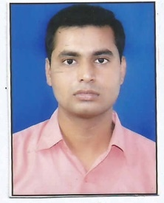
MO.- 9651690462/9839558160
ADD-634 Shiv Nagar
Maswanpur Kanpur
Pin-208019
Rambit254@gmail.com

SATYAM VERMA
OBJECTIVE:
To be associated with a firm,which provides career development opportunities and contributes in its progress through my knowledge and skill.

EDUCATIONAL QUALIFICATION:

- B.Tech. in mechanical engineering (2011-2015) from UPTU Lucknow with 74.00%aggregate.

- High school (2008) from UP board, Allahabad with 65.00%.

- Intermediate (2011) from UP board, Allahabad with70.00%.

Technical information:

- Completed four-week Industrial Training fromALIMCO Ltd.

Academic Projects:
Project Title: WEIGHT LIFTER TROLLEY with hydrolic system.
Duration : 45 days
.
EXPERENCE REPORT- ONE Year worked in Lhoia industrial private ltd.

Personal Details:

Father’s Name : Mr. SantoshVerma
Date of Birth : 9thjuly 1993
Nationality : Indian
Gender : Male
Marital Status : Single
Permanent Address: : 634- Shiv Nagar
Kanpur-208019
Languages Known : Hindi, English.
Hobbies : Playing Cricket and Listening music.

“I hereby declare that the above information's are true to best of my knowledge.”

Place:Kanpur (SATYAM VERAMA)

