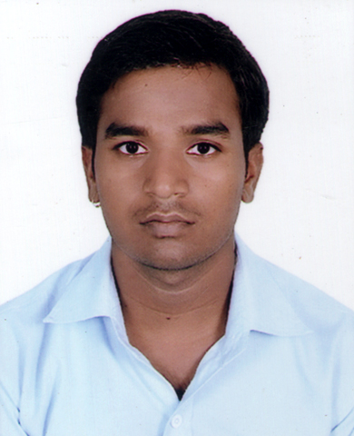

PHOTOGRPH
SANJAY SINGH PERMANENT ADDRESS:

VILL-MUNDELI, POST
Cell: +91-8941945286 CHARUBETA, NEAR-
SHUBHAM ICE FACTORY,
Email Id: sanjay30singh67@gmail.com KHATIMA, UTTRAKHAND
PIN CODE-262308

RESUME SUMMARY:

A throughout technical professional, I have completed B.TECH in MECHANICAL ENGINEERING and having a great interest in PRODUCTION.

CAREER OBJECTIVE:

A challenging & responsible job in a progressive and professionally managed organization where my professional & technical skills are effectively utilized in a way that contributes to the organizational growth coupled with personal growth within the organization.

PROFESSIONAL SKILLS:

- Strong determination.
- I have positive frame of mind towards everything. I have the ability to do any kind of work in any condition.

EDUCATIONAL QUALIFICATION:

COURSE | BOARD | PASSING YEAR | PERCENTAGE
SECONDARY | UTTRAKHAND BOARD | 2010 | 72
SENIOR SECONDARY | UTTRAKHAND BOARD | 2012 | 63.8

PROESSIONAL AND TECHNICAL QUALIFICATION

2012- 16: I have completed B.TECH from SHRI SIDDHI INAYAK INSTITUTE OF TECHNOLOGY, Bareilly.

Specialization– Mechanical Engineering
Aggregate Percentage- All Year

COURSE | COLLEGE | YEAR | UNIVERSITY | PERCENTAGE
B.TECH | SHRI SIDDHI VINAYAK INSTITUTE OF TECHNOLOGY | 2012-2016 | APJ AKTU | 65.6

INDUSTRIAL TRAINING , PROJECT AND VISIT:

TRAINING:-POLYPLEX CORPORATION LIMITED, U.S.NAGAR, UTTRAKHAND.
MAJOR PROJECT:-HYDRAULICALLY OPERATED RAILWAY BARRIER.
INDUSTRIAL VISIT:-
- RELIANCE ROSA POWER PLANT
- DIESEL SHED

MAJOR ACHIEVEMENT:

- 20,000 Rupees NMMS Scholarship from UTTRAKHAND Government.

COMPUTER SKILLS:

- Computer basic, M S Office (Word-pad and Power-point).
- Internet basic knowledge.

PROFESSIONAL DETAILS:

Father’s Name : Chhatrapal Singh
Mother’s Name : Vimla Devi
Date of birth : 10/07/1995
Sex : Male
Marital Status : Single
Languages : Hindi, English.

DECLARATION:

All information given above is true not carrying any false statement. It hereby declared that every statement given by me here is in best suited way.

DATE:

PLACE : KHATIMA SANJAY SINGH

