RESUME
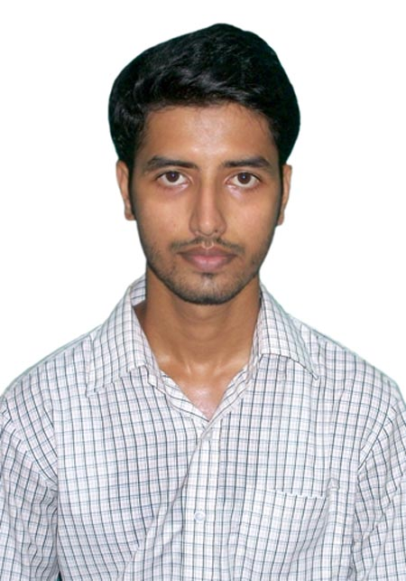

UDAY KANT MISHRA
House no.-281-282/14,
Gali no.-10,Gurgaon, India
Mob:+918470915844
E-mail: udaykantmishra98@gmail.com

CAREER OBJECTIVE

- “Seeking a position in a challenging environment that encourages continuous learning, provides exposure to new ideas and stimulates personal and professional growth. To be a part of the organization by imparting my knowledge, skills, experience and efforts so as to accomplish its common objectives.”

ACADEMIC QUALIFICATIONS

- B.Tech (Mechanical engg.) from SIET Dhenkanal ,Odisha in 2014.
- Intermediate (12th) from B.M.C. Rahika(BSE Board Patna)
- Senior Secondary School Exam (10th) from Raj High School Darbhanga(BSE Board Patna)

EXPERIENCE

- Company name: Hitech engineers,Manesar,gurgaon.
- Designation: QA engineer.
- Date of joining: 1st may 2014.
- Date of leaving: Presently working with Hitech engineers.

TECHNICAL

- PRO-E: one year experience of working on PRO-E software.
- CMM: knowledge of CMM
- Solid work: one year experience of working on solid work software.
- All type of documentation work relative to quality.
- Knowledge about profile projector, report making skill and relative analysis.
- Maintain SPC,PPAP,FMEA ,MSA etc.

TECHNICAL EXPOSURE

- Academic Project on:" journal bearing test rig".
- Seminar on "welding robot".
ACHIEVEMENT
- Reduce the total rejection quantity of plant by 5%.
- Reduce customer complain.
- Making good communication between plant personnel as well as customer.
- Actively participate in both internal and external audit.

USP

- Adaptive in nature.
- Leadership Quality.
- Sincere and Hardworking.

INTEREST

- Social activities.
- Attending technical exhibitions.

HOBBIES

- Playing outdoor games such as Badminton, Cricket.
- Reading newspapers and magazines.

- Father's Name : Baidya nath mishra
- DOB : 1 march, 1992
- Gender : Male
- Languages Known : English, Hindi, Maithili.
- Address : Kameshwari shayama mandir,
Raj campus,Lal bagh,darbhanga,
(Bihar).
Pin code: 846004.

DECLARATION

I hereby solemnly declare that information given above is true and complete to the best of my knowledge. If I will get a chance, I will try my best to work hard to prove myself for good work and result orientation.

Date:
Place: Uday kant mishra

