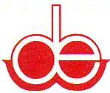
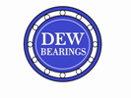
DELITE ENGINEERING WORKS
Manufacturer, Exporter & Supplier of
Needle rollers, Cylindrical rollers, Pins, Bearing Components, Textile Bearings, Ball & Roller Bearings, Special Engineering Products Since 1995.

SUBJECT: INTRODUCTION LETTER

Respected Sir/madam,

“DELITE ENGINEERING WORKS” is pleased to introduce itself as a leading manufacturer, exporter & supplier of needle rollers, cylindrical rollers, needle pins, cylindrical pins, bearing components, special engineering products, textile bearings, ball & roller bearings since 1995. We also manufacture stainless steel needle & cylindrical pins as per required grade in bulk quantities.

Our Company Product Portfolio:-
- Needle Rollers
- Cylindrical Rollers
- Needle & Cylindrical Pins
- Bearing Components
- Bearing Assemblies mainly for textile and automotive industries
- Thrust Roller Bearings
- Textile Bearings ( 328 & 2128)
- Ball and Roller Bearings ( Ball Bearings, Taper Roller Bearings, Spherical Roller Bearings)
- Spherical Plain Bearings
- Special Engineering Products

OUR PRODUCTS GALLERY

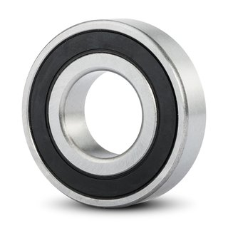

BALL BEARINGS
Type: 2RS
Range : 6000, 6200, 6300, 600, 620 Etc.

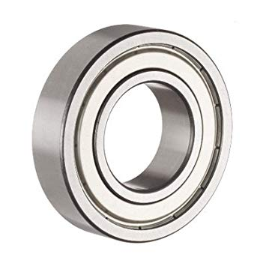

BALL BEARINGS
Type: ZZ
Range: 6000, 6200, 6300, 600, 620 Etc.

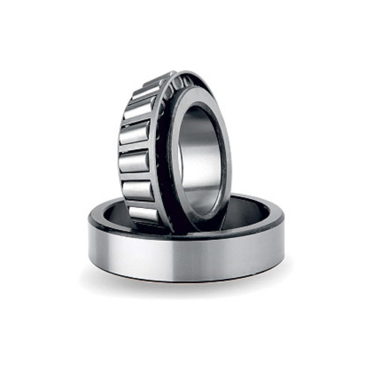

TAPER ROLLER BEARINGS
Range: 30200, 30300, 31300, 32000, 32200, 32300, 33000, 33100, 33200 Etc.

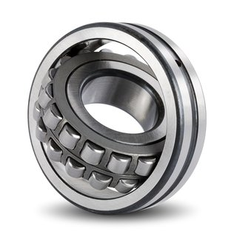

SPHERICAL ROLLER BEARINGS
Type: Steel Or Metal (Brass).
Range: 21300, 22200, 22300, 23000, 23100, 23200, 24000, 24100 Etc.

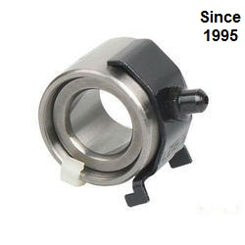
BOTTOM ROLLER BEARINGS
Range: 328, 2128, 323, 1128 Etc.

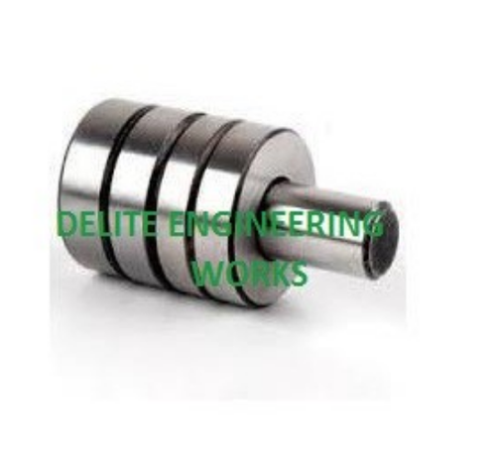

AUTOCONER BEARING SHAFT

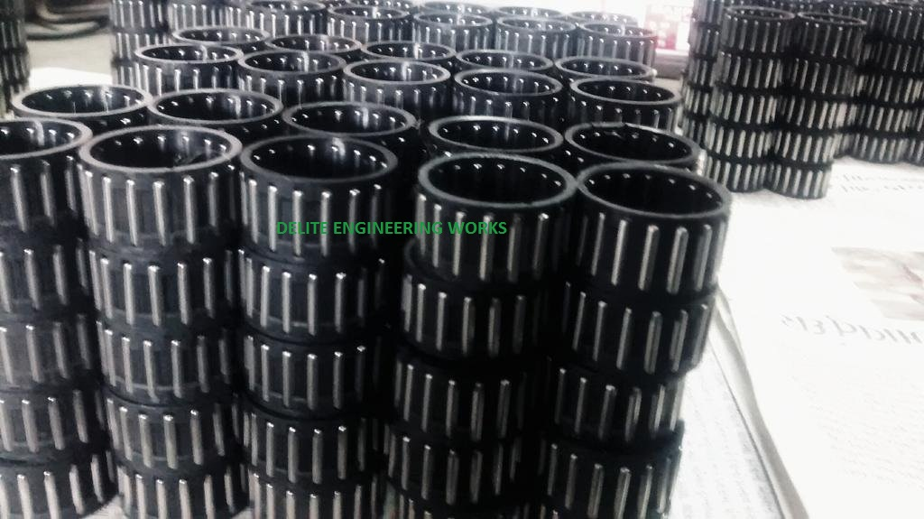

TEXTILE BEARING NYLON CAGE ASSEMBLIES
Range: 328(18), 2128(16) Etc.

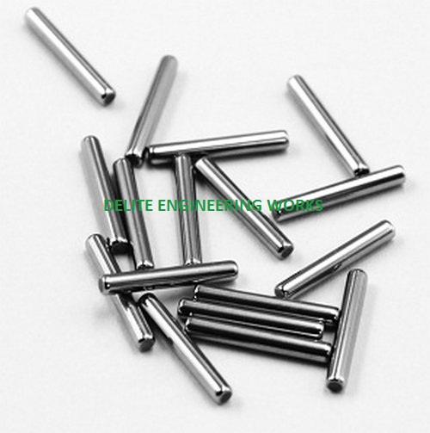

NEEDLE ROLLERS
Type: BP and BR.
Range: Diameter: 1.5 mm To 7 mm
Length: 6 mm To 50 mm

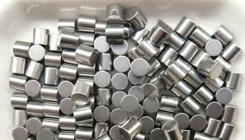

CYLINDRICAL ROLLERS
Type: BPM
Range: Diameter: 2.5 mm To 150 mm
Length: 5 mm To 150 mm

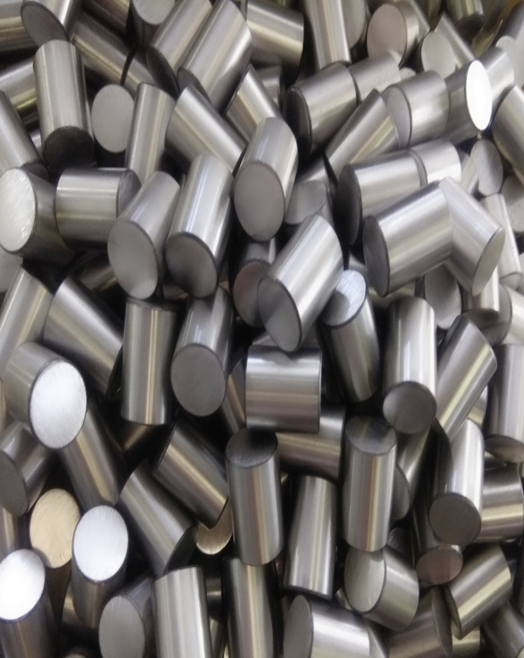

CYLINDRICAL ROLLERS
Type: BPM
Range: Diameter: 2.5 mm To 150 mm
Length: 5 mm To 150 mm

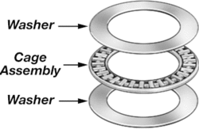

THRUST ROLLER BEARINGS
Range: ZF Series, 51100, 51200, 51300, 51400 Etc.

FACILITIES AVAILABLE IN PLANT

- CENTRELESS GRINDER – 04 MACHINES
- DUPLEX MACHINE – 02 MACHINES
- POLISHING DRUM – 02
- HAMMER DRUM – 01
- CUTTING MACHINE – 03 MACHINES
- HARDNESS TESTER – 02
- MICROSCOPE – 01
- HEAT TREATMENT FURNACE – 01
- MECHANICAL COMPARATOR MACHINE – 01

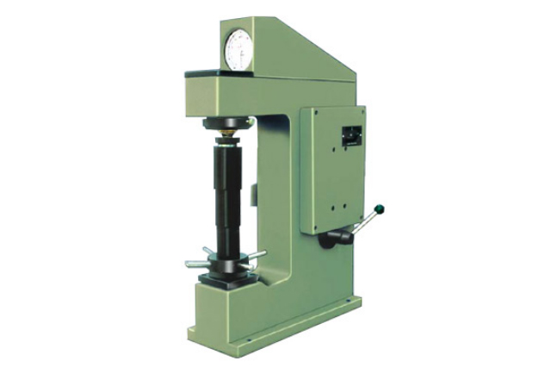

HARDNESS TESTER

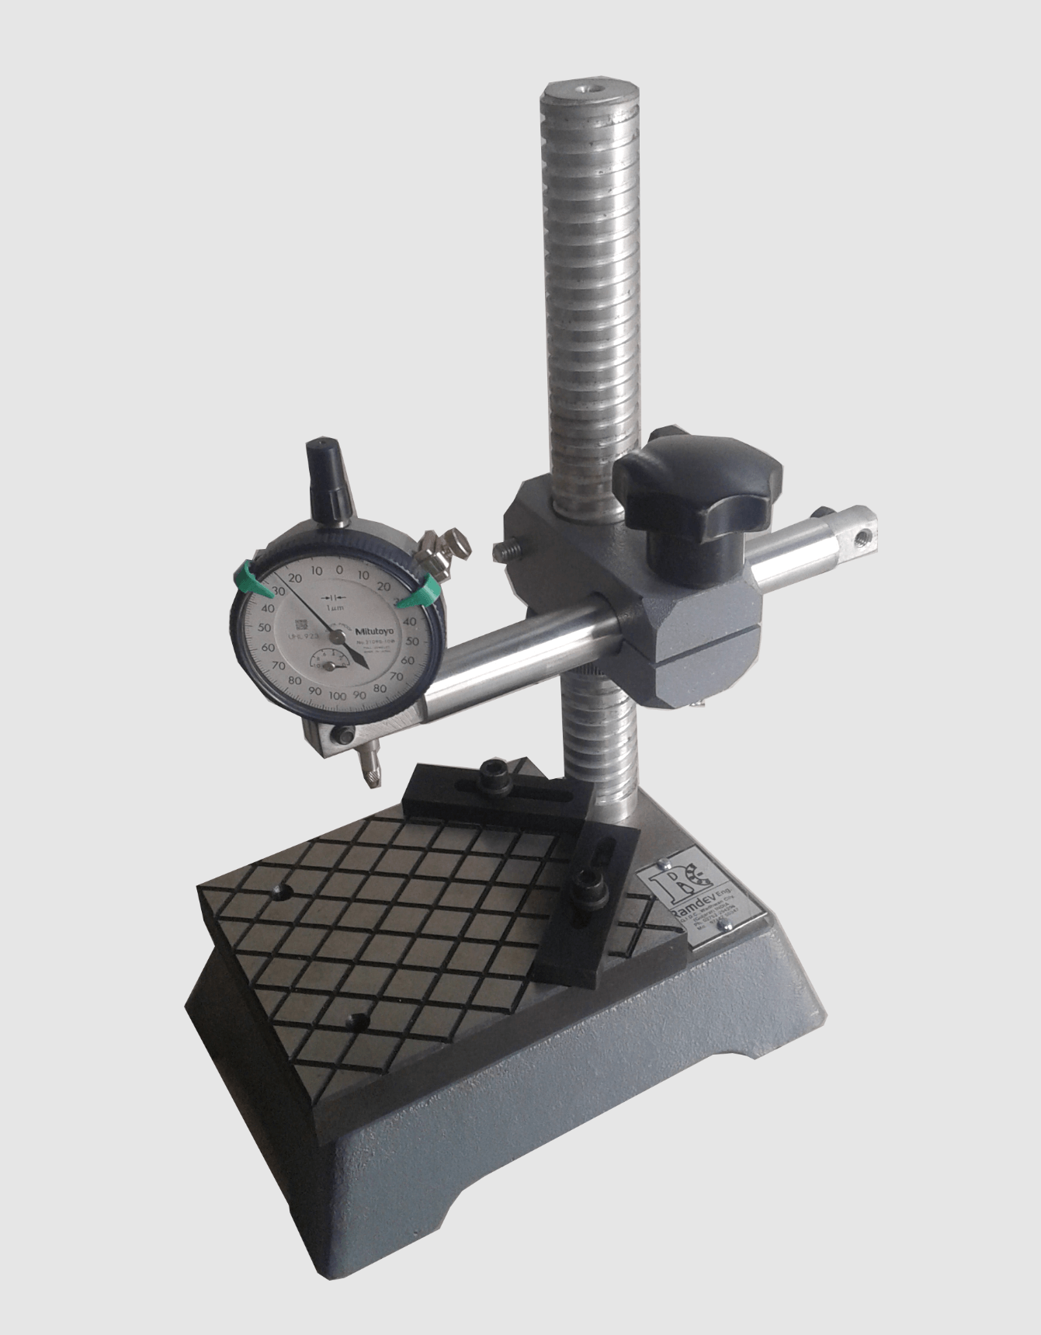

DIAL COMPARATOR STAND

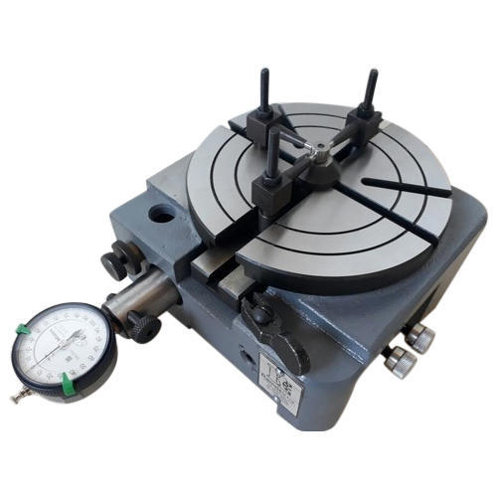

MECHANICAL COMPARATOR

Company works on the below principle that,
‘Quality is much more important to us than Quantity.’

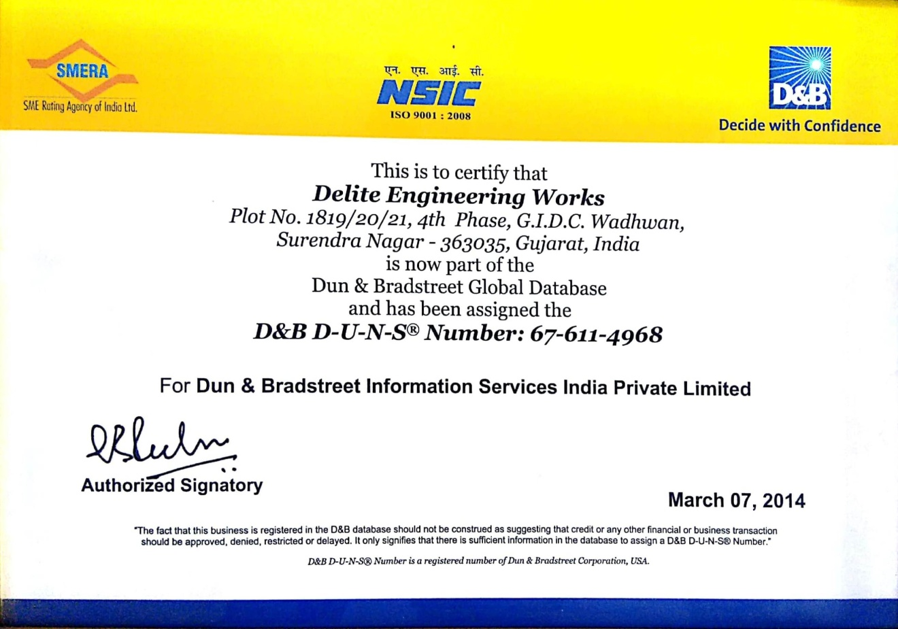

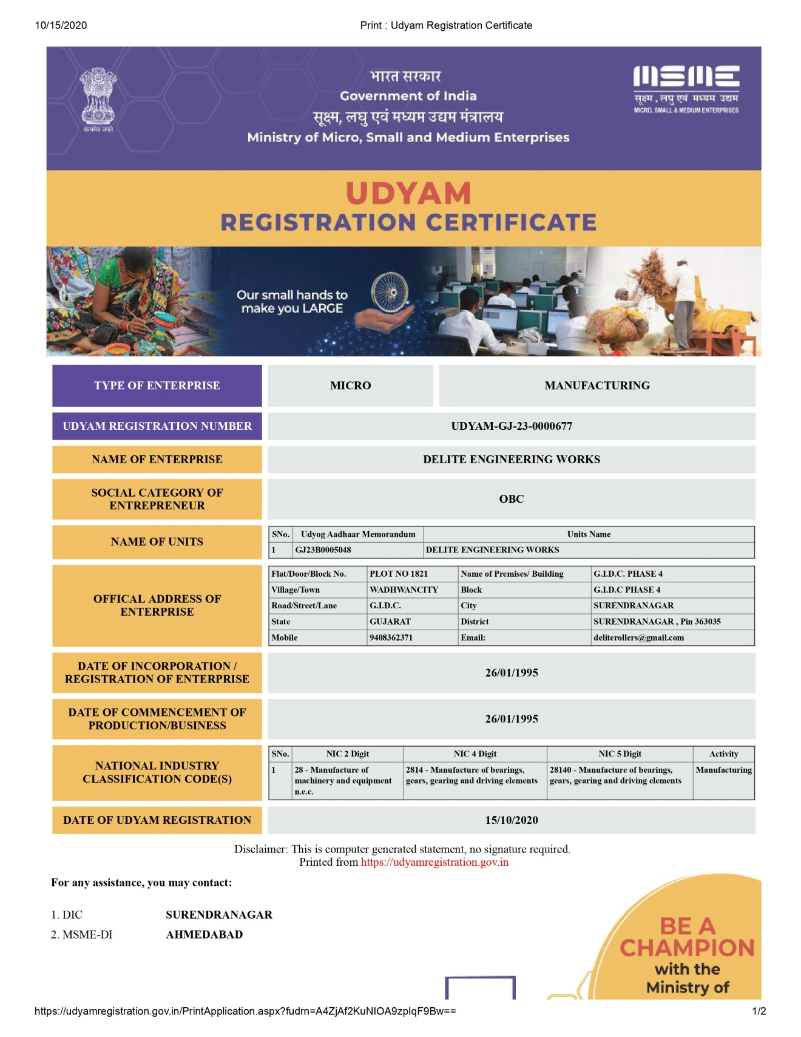

The standard material used in manufacturing above mentioned products are BEARING STEEL AS PER SAE 52100 or EN-31. Depending on the quality we are capable of producing rollers made out of S2 tool steel, stainless steel AISI 420, AISI 302 & AISI 316.

We had been in bearing industry since 1995. We are used to sell bearing rollers as well as bearing components in the name of ‘DELITE ENGINEERING WORKS’ and had established our brand name as ‘DEW’ for textile bearings, ball bearings, taper roller bearings, spherical roller bearings and engineering products.

On your valuable requirement, we are eager to work with your company.

CONTACT DETAILS

DELITE ENGINEERING WORKS

Company Postal Address: PLOT NO. 1821, G.I.D.C. phase 4, wadhwan, Surendranagar-363035, GUJARAT, India (ASIA).
Sales Office: “Rajyash RISE”, C-419, Beside Vishala Hotel, Nr. APMC Market, Vasna, Ahmedabad – 380007, Gujarat, India (ASIA).
CHIRAG L. SOLANKI : +91 9408362371 / 8460663891.
Web: www.deliteengineering.com

Thank you for checking my company profile and wish to have long-term business with your company.

