

**Devraj Singh**

**Field executive/ATL**

**devrajs274@gmail.com**

**+91-(894) 191-2067**

**SUMMARY**

**No any special in the carrer's but as I have observed that the life is a journey for the middle**

**class faimiles, i have worked only in 2 companys till life with fully dedication.**

**CAREER OBJECTIVE**

**The life is a journey**

**WORK EXPERIENCES**

**SSMS Service pvt LTD**

Feb 2018 - Present

Field executive/ATL

**PAST JOB :- Scientific Security Management Services Pvt. Ltd. Links -**

**http://www.ssmsonline.com/**

**JOB/POST ROLL :-**

On this organization our role was as FE ( field executive

**).**

A Field our roll was to as delivery of the shipmnets/orders/corier's and we had given the targets that

must be achieved. There will be personal as well as team targets for all. and finaly i had also

archived the our all task/tragets as per the company SOPs.

**CURRENTLY JOB :- Delhivery LTD - Links -**

**https://www.delhivery.com/**

**JOB/POST ROLL :-**

In this orgination our roll is as ATL ( Assistent Team Leader ).

As I am working in this orgination to do the our all office work mangement to downline the team

and as a working trains/guaids to downline the team of the all complince's archived as per the

company noom's/SOPs.

**Currently I am working on below all Operations tasks with the fully dedication and**

**achievement :-**

1

- Days Planing.

2

- Dispatches.

3

- Inbound.

4

- Outbound.

5

- Lastmile/Firstmile.

6

- Transportation.

**RESUMEMAKER.IN**

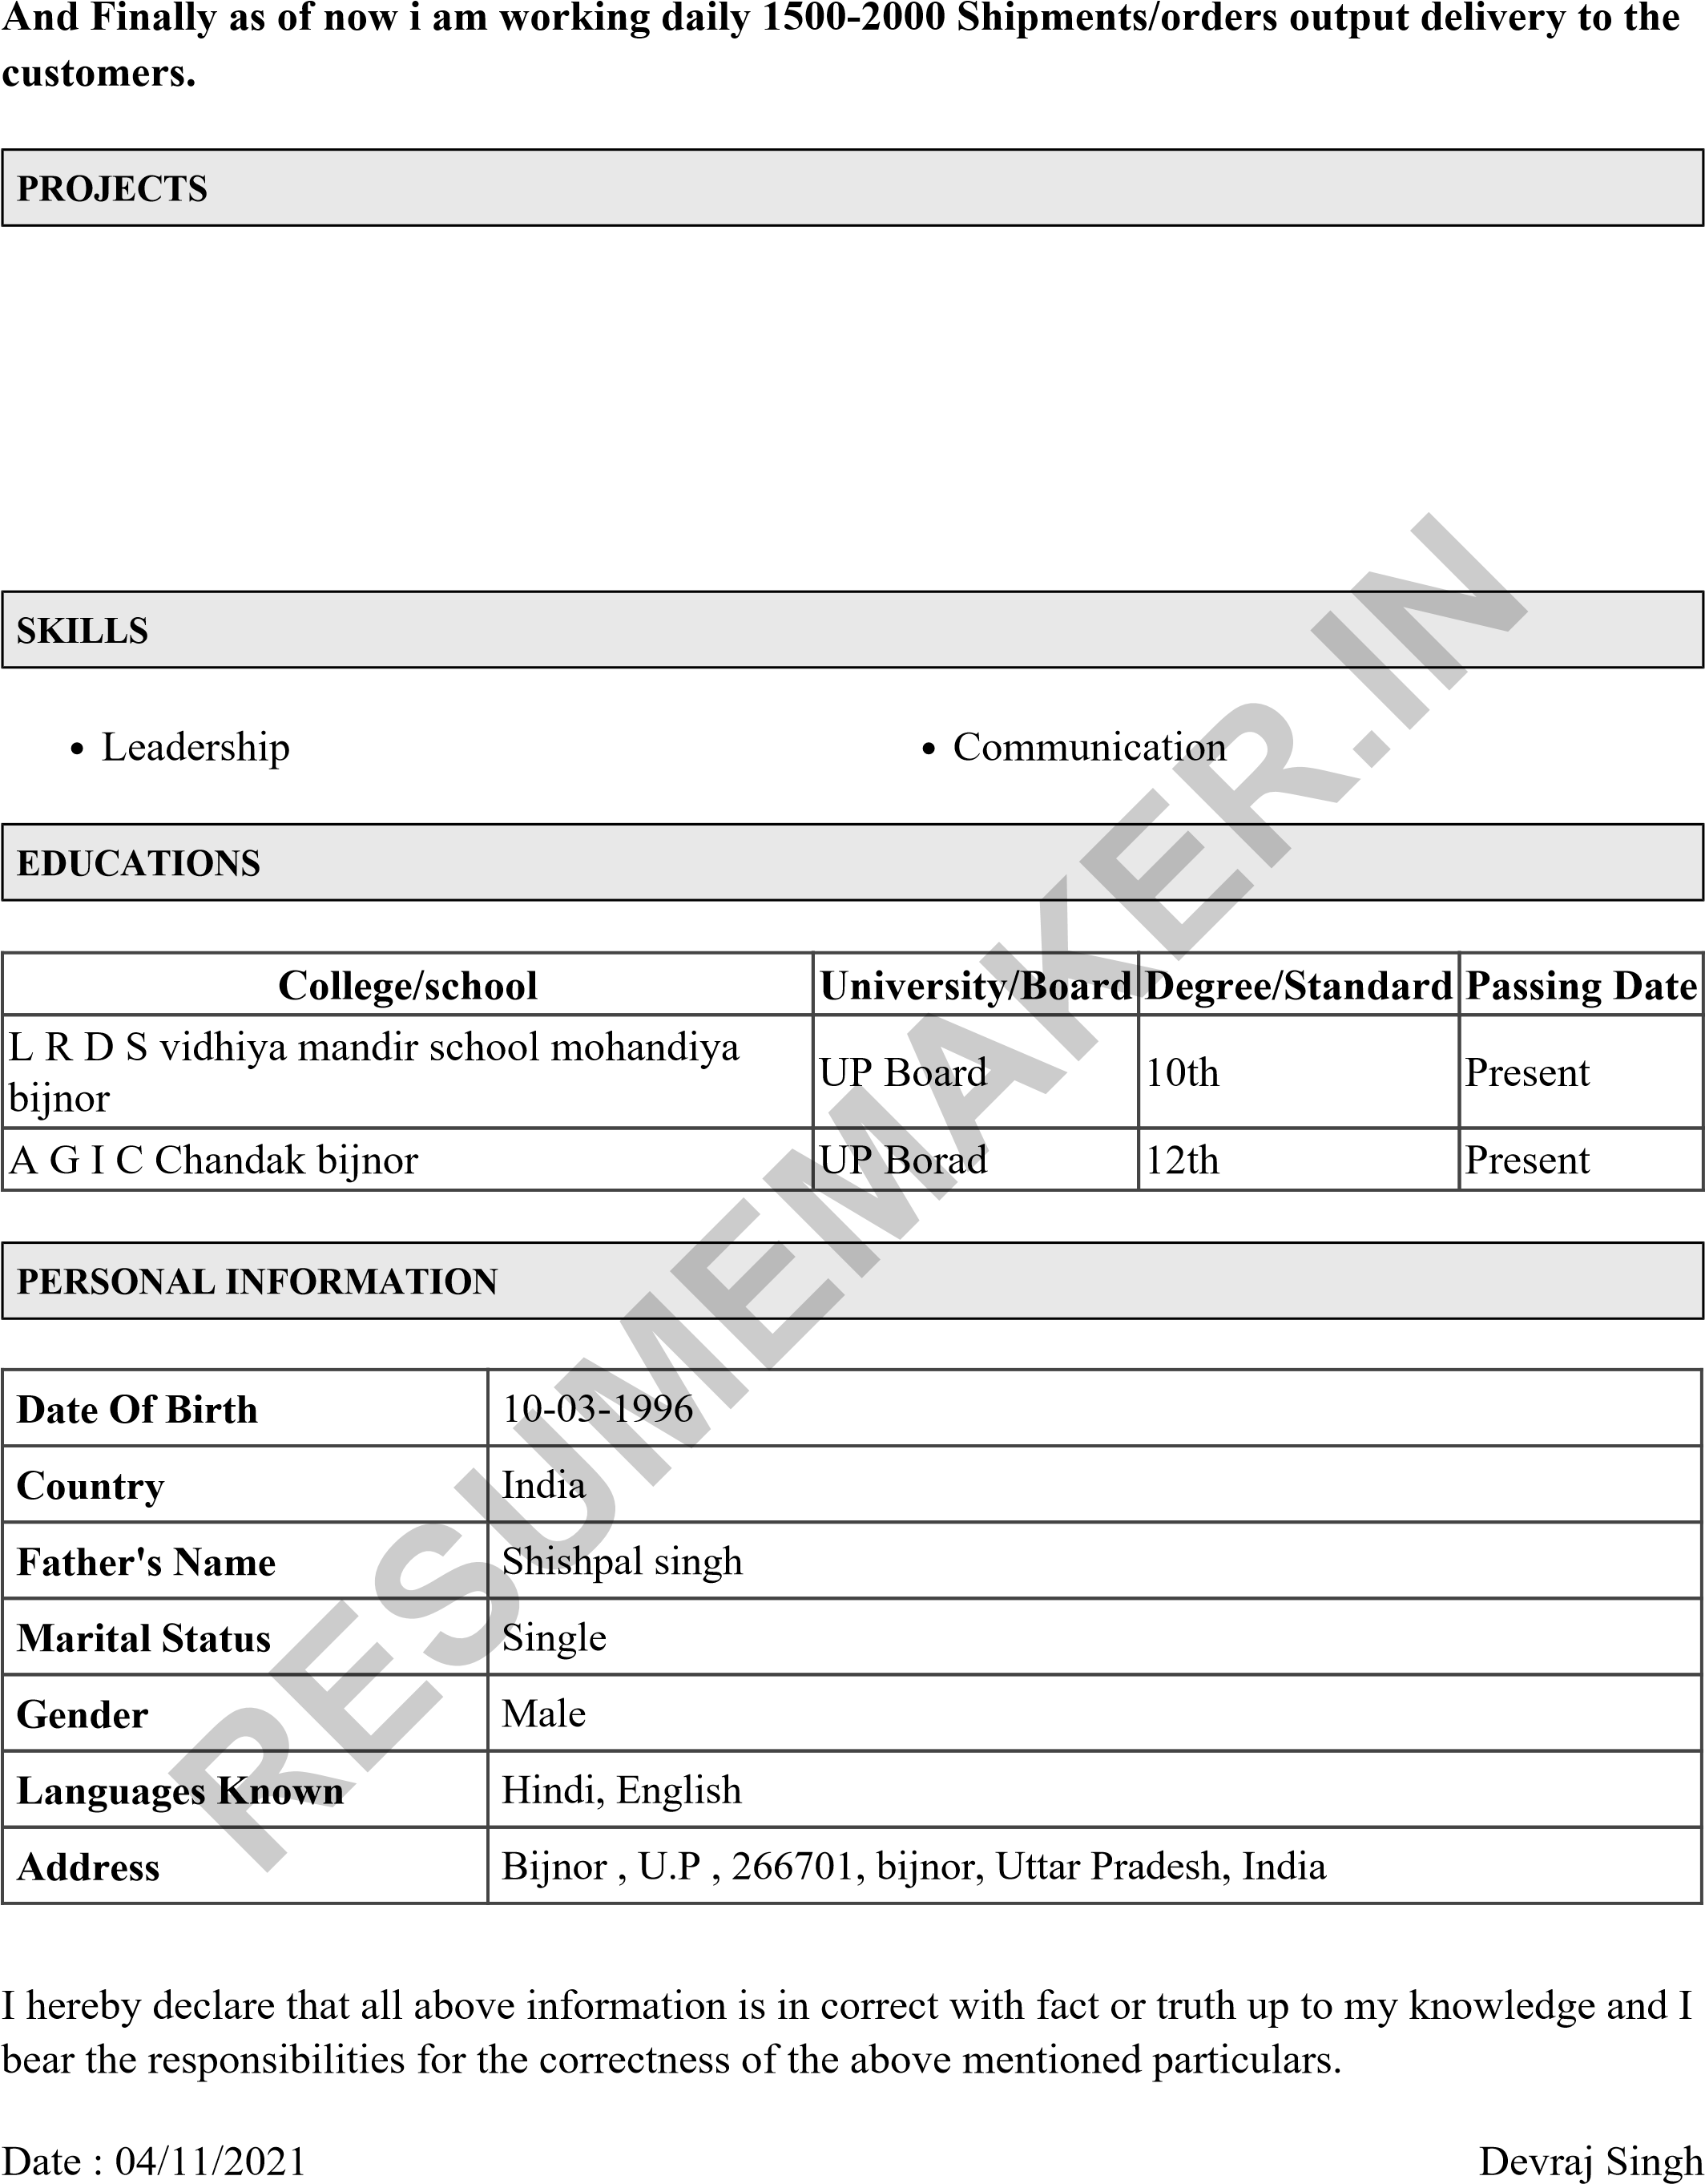**N/A**

**URL:** N/A

N/A

N/A