RESUME
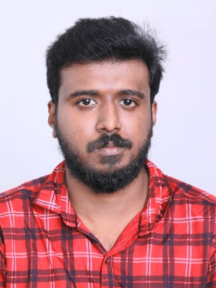
BIBIN JOSE

Karimbumannadi
Kudappanamoodu , Vellarada
Kudappanamoodu P O
Phone : 9645030472
Email : bibinjose1998@gmai.com

Objective

To pursue a highly rewarding career, seeking for a job in challenging and healthy work environment where I can utilize my skills and knowledge efficiently for organizational growth.

Educational Qualifications

Qualification | Institute | Board/ University | Mark Percentage | Year Of  Passing
SSLC | ST Johns HSS Undencode | Kerala State board | 62% | 2013
Mechanical Diploma | Union Christian Polytechnic College Kuttakode | Dote University | 67% | 2016

Strengths

- Ability to do work hard with almost sincerity and almost energetic and ready to adopt with the changing environment
- Strong will power, flexible and ability to learning quickly.
- Good communication

Hobbies

- Working with computer
- Reading
- Travelling

Work Experience

1 Year experience in KWANG SUNG BRAKE INDIA PVT LMTD
1 Year experience parts assistant at CHERAN AUTOMOBILES
2 Year experience service advisor at DIYA MOBIKES
1 year experience parts incharge at DIY MOBIKES

Personal Details

Father’s Name : Valsalan C
Mother’s Name : Punitha
Date of Birth : 13-03-1998
Languages known : English, Malayalam , Tamil and Hindi
Gender : Male
Marital Status : Single
Permanent Address : Karimbumannadi
Kudappanamoodu
Kudappanamoodu P O
Thiruvananthapuram Dist
Kerala Pin : 695505
Phone : 9645030472

Declaration

I hereby declare that all the above mentioned information is correct up to my knowledge and I bear responsibility for its correctness.

Place : Kudappanamoodu
Date : BIBIN JOSE

