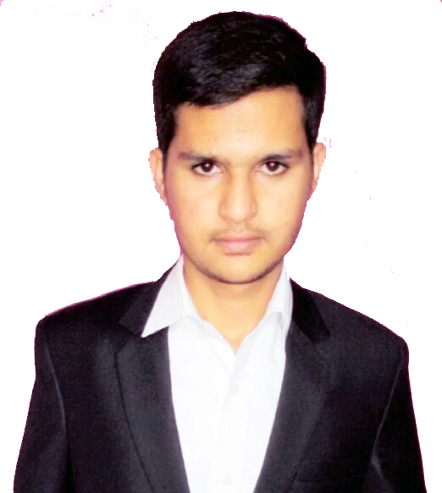

MOHAMMED

TAMEEM ANSARI

MECHANICAL ENGINEERING PROFESSIONAL

tameemansari@outlook.com +91 8892311646 linkedin.com/Tameem ansari

WHY The best thing that can define me is the sense of simplicity, can be easily spotted ME? among a group of youngsters, action oriented and driven by desire to admire,
Highly Trustworthy, possess excellent writing and communication skills, effective at Multitasking and risk taking, go getter, hard working and relentless.

VISION To work with higher challenges with determination and bring out a difference in
Whatever I do.

STRENGTHS Discreet and ethical.
Ability to communicate and motivate team members.
Flexibility and adaptability to new challenges.
Action oriented and analytical skills in problem solving.
Resourceful and punctual in completion of projects.

Sl.no | QUALIFICATION | INSTITUTE | UNIVERSITY | YEAR OF  PASSING | MARKS
1. | BE in Mechanical Engineering | C Byregowda Institute Of Technology, Kolar. | Visvesvaraya Technological University | 2016 | 74.809%
2. | PUC(PCMB) | Mahila samaja college,  Kolar. | State Board | 2012 | 75.33 %
3. | SSLC | BMS school,  kolar | State Board | 2010 | 70.56%
EDUCATION

SKILLS SOFTWARES KNOWN: Solid Edge ST2, ANSYS, Fluent and Gambit, SeeNC, C+. COMPUTER PROFICIENCY: MSOffice, Windows XP to 10, Adobe Photoshop. LANGUAGES KNOWN: English, Kannada, Hindi and Urdu.
PROJECT PROJECT TITLE: “Comparative study on heat treated Aluminum Bronze 2”

PROFILE PROJECT FIELD: Materials research and analysis.

TEAM NUMBER: FOUR.

MY DESIGNATION: Project Lead.

PROJECT SCOPE: Can be extended for PhD level researches.

DESCRIPTION: Aluminium bronzes are one of the alloys of copper and are universally known for their high strength and corrosion resistant properties hence are widely used in marine applications under higher compressive forces. In the current investigation we have chosen aluminium bronze grade 2 because of its optimum percentage of aluminium and its influence on different temperatures of annealing heat treatment on various mechanical characteristics are studied and compared with the untreated specimen and the best among them is discussed and concluded.

INVOLVES 1) Got training and certificate in CFD (FLUENT AND GAMBIT) BY CACS
& ACHIEVE- (Centre for Advanced Computer Studies) from PROTHERM institute with 99%.
-MENTS 2) was awarded with trophy and certificate for successfully completing PUC in 2012, by Merit graduates association trust, Kolar.
3) Coordinator and host of cultural activities of yanthrotsava (a techno fest) held at CBIT, 2015.
4) Participated in solid modeling competition conducted at T.Thimmaiah Institute of Technology, KGF.

PERSONAL Being in touch with new peoples and public speaking.
HOBBIES Different Cars info collection with their features.
Traveling and exploring.
Working out and Fitness.
I do often watch Science Channels in my spare time.

LET ME Be a part of your organization where I can utilize my fresh skills and enthusiasm and contribute the best of my ability for its success and growth.

DECLARE I do hereby ascertain that particulars of information and facts stated herein
Above are true, correct and complete to the best of my knowledge and belief.

PLACE: KOLAR

Mohammed Tameem ansari
2016
HIRE ME!

