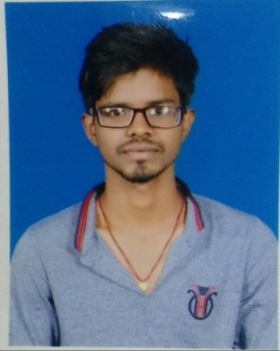

GHANSHYAM MAHTO

gmmahto28@gmail.com
Mobile: 9939689096
(Diploma: MECHANICAL ENGINEERING)
Objective:
I want to be a part of an organization which appreciates hard work and guides to a challenging position. I have confidence and enthusiasm in working as a team and achieve organization goals.

Computer skills:

Software : MS office
Operating system : Microsoft Windows
Educational Qualification:
- Diploma in Mechanical Engineering from STATE BOARD OF TECHNICAL EDUCATION, JHARKHAND with 65.70% in YEAR 2018.
- 12th from JAC BOARD with 64 % in THE YEAR 2015.
- 10th from JAC BOARD with 58 % in THE YEAR 2013.

Technical Academic Project:
- Project Name : Wind Energy.
- Description : The project was completed under my supervision and the
same was submitted as final project of the Diploma session.

Extra Activities.
- Control & Operation of lathe machine

Strength
- Ability to handle pressure work situation.
- Quick learner.
- Planning & organizing task.

Personal Detail:
Father’s Name : VISHWANATH MAHTO
Date of birth : 1st January 1998
Nationality : Indian
Religion : Hindu.
Sex : Male
Marital Status : Single
Languages Known : English, Hindi
Hobbies : Playing Cricket, Swimming.
Permanent Address : Vill: Turiyo Basti, Post: Bhandaridah, Bokaro, Jharkhand
829132.

Declaration:

I hereby declare that the information furnished above is true to the best of my knowledge.

Date:
Place: GHANSHYAM MAHTO

