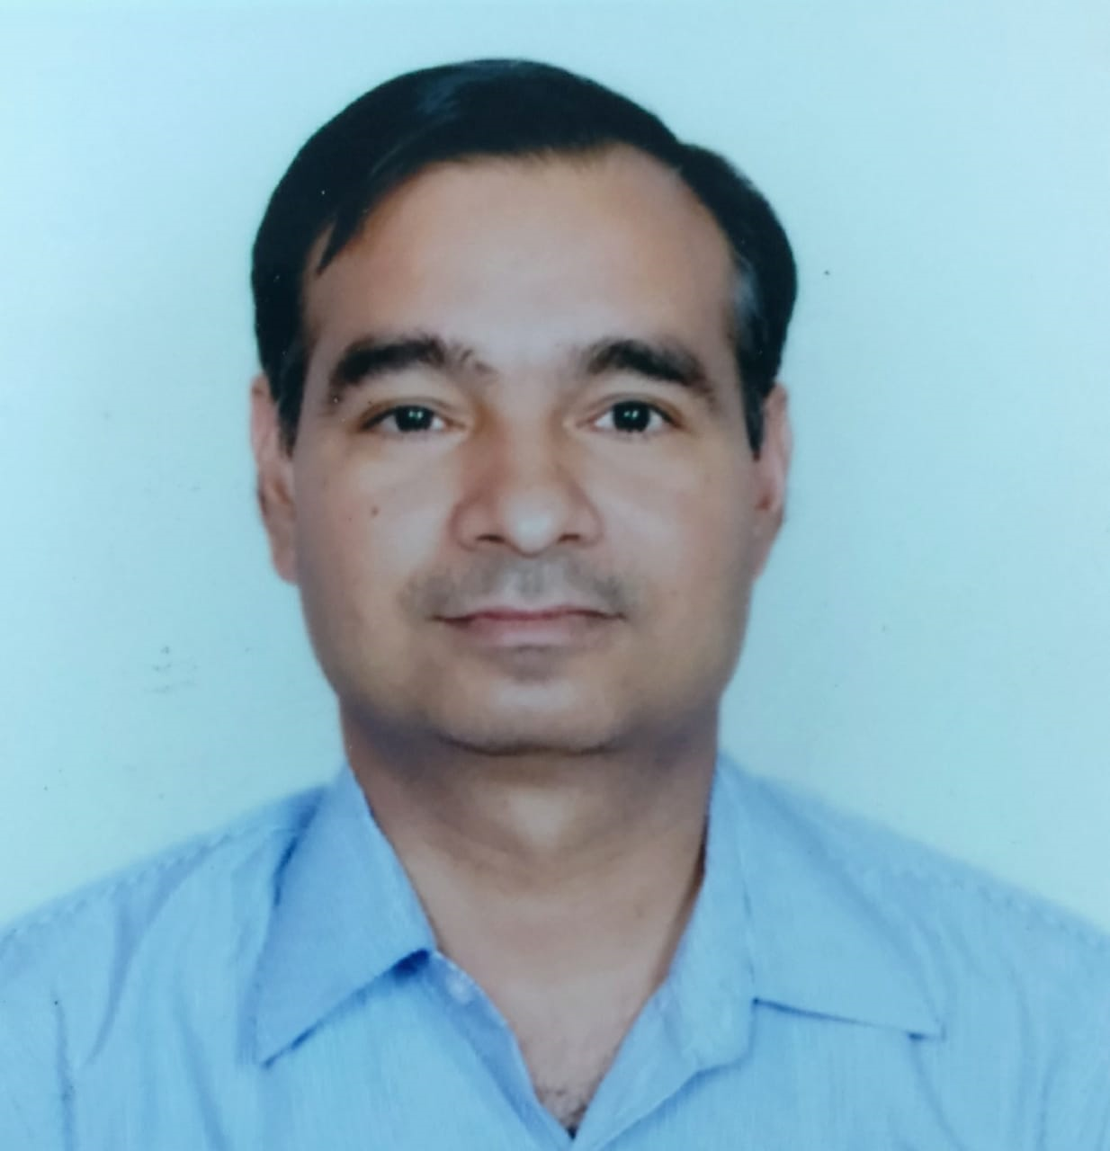
Anil Kumar Rohilla
Achievement-driven professional (Automotive/Machining and Manufacturing ) with experience in PPC (PMC), Supply chain & Material Management ,Stores & Dispatch Management, Logistics Management,Warehouse Management and Team Management; targeting senior level assignments with an organisation of high repute
Location Preference: PAN India

+919650033921
E-mail: rohillaanilkumar@gmail.com
Key Impact Areas |  | Soft Skills
 | Strategic Planning & Execution  Production Planning & Control  Stores and Dispatch  Logistics and Warehouse  Material & Inventory Management  Supply Chain Management  Cost Reduction/Optimization  Capacity Planning/ Enhancement  Process Enhancement  Team Building & Leadership |  | Communicator  Collaborator  Intuitive  Innovator  Leader  Problem-solver  Analytical  Team Builder
Career Timeline
Mar’09 – Feb’20

May’07 – Mar’09
Feb’20– Continue

Satyam Auto Components Pvt Ltd., Gurugram as an Assistant Manager
Apr’96 – Apr’07

Badve Engineering Ltd., Uttarakhand as Senior Engineer
Glass Equipment (I) Ltd., Bahadurgarh as an Engineer
KHVatec India Pvt Ltd., Greater Noida (U.P.) as a Deputy Manager (HOD) PPC, Stores and Dispatch
Executive Profile  - Professional offering rich experience in Production Planning & Control, Stores and Material Management (Supply Chain), Dispatch ,Customer Coordination, Logistics ,Warehouse & Compliance and Team Management  - Professional excellence in Demand Planning, Sales Forecasting, Supply Network Planning, Dispatch planning, Logistics Planning, Inventory Control Management  - Expertise in managing inventory functions to curtail inventory-holding expenses and ensuring adherence to the minimum inventory level to minimize wastage  - Exhibited leadership in assessing the performance of the suppliers based on various percentage for rejections, timely delivery,  - Highly skilled in managing logistics, warehouse, transportation, and customer services while monitoring compliance with laws  - Comprehensive experience in devising significant solutions, managing day-to-day for making utilization of man, method & materials | - Successfully managed TS, ISO-9000, ISO-14000, 5S, Safety & Kaizen activities in Dept. and implementation of SAP in company (MM & PP Module)  - Excellent relationship management skills with proven capabilities in defining problems, solving issues and mentoring motivated teams/workforce  Education  - 2005: MBA in Operations Management from IGNOU  - 1996: Engineering In Production from Haryana Technical Education Board, Haryana  - 1992: 12th from SDM Public School, CBSE, Sonipat  Technical Skills  - MS Office, MES, ERP and SAP (MM,PP,SD Module)
Professional Experience
Since Feb'20 with M/S KHVatec India Pvt. Ltd., Greater Noida (U.P.)
KHVatec is a Korea-based company (MNC) principally engaged in the manufacture and sale of aluminum casting products. The Company manufacturing metel LCD brackets for Samsung India. It is leading company with latest technology in LCD brackets manufacturing. It has Aluminium Die Casting,HPDC ,Press, CNC and Painting facility.
Roles and Responsibility:
- Process planning and Production Performance Management – Quarterly/Monthly/Weekly/Daily Production plan with respect to customer requirement/forecast and actual performance analysis
- Process Capacity analysis – Production capacity of machines/Line and process analysis
- Inventory Management and control – Monthly Physical Inventory and reconciliation, Daily Input and output Management of every Machine/ process
- Procurement management - Warehouse management (Raw material, BOP, Product and By-Product Scrap)
Material Inbound verification, Document verification, Purchase order & Invoice verification.Migo (GRN),RGP,NRGP
FIFO, Bin card, maximum and minimum maintain ABC analysis.Job work, 3PL , SPD Management, Shortage report
- Customer and supplier Coordination
- Dispatch Planning and Sales Planning of FG product customer wise against Customer requirement and forecast
- Leading daily Morning/Production meeting
- Presentation of Weekly and Monthly report to Top Management
- SAP and MES Management –Material Master,BOM, Routing, Production Version, Production Plan,MRP, LTP, Demand Management, Material Transfer, Production Performance, Material Management, purchase order,

Mar'09 – Feb’20 with M/S Satyam Auto Components Pvt. Ltd., IMT Manesar Gurugram
A Hero group Company, engaged in Auto mobile sector. The products are complete frame body assembly, frame body parts & fuel tank complete & its parts for Hero MotoCorp Ltd. The company has turnover of 400 Crores per year. Company has press shop & weld shop for manufacturing the product.
Growth Path:
Mar'09 - Dec'13 as Senior Engineer
Jan'14 -Feb 2020 as an Assistant Manager

Key Result Areas:
- Managing all activities of production planning and control, Dispatch & logistics and leading the team for PPC and Dispatch; planning production, job work & dispatch as per Hero MotoCorp Ltd. ( Gurugram, Dharuhera, Neemrana & Halol Plant )
- Preparing and issuing daily/ weekly/ monthly basis planning as per customer; managing planning of Production line as per plan/ capacity; issue of material /BOP stores to Production line, supervising daily/ weekly/ monthly output report plan v/s production/ sale and analysis; preparing MIS Report & Presentation
- Directing Inventory Control Management & reconciliation of job work items; auditing physical inventory of the plant
- Acting as Member of AET (Area Effectiveness Team) and managing Planning, Dispatch, Production with different KPIs (Key Performance indicators); maintaining the discipline and competence level in the department and managing the TS, ISO-9000, ISO-14000, 5S, Safety & Kaizen activities in department
- Customer Coordination
- Formulating standard operating procedures for new processes / equipment for ensuring environment, health & safety aspects; rendering customer solutions on time delivery
- Leading, mentoring & monitoring the performance of team members to ensure efficiency in process operations
- Focussing on optimisation of process parameters; initiating process improvements for achieving bottom line objectives & productivity targets
- Responsible for MRP, Plan order, Production Order open & close, Production confirmation, BOM, Routing, production version etc in SAP (PP Module)

May'07 - Mar'09 with M/ s Badve Engineering Ltd., Uttarakhand as Senior Engineer
Company belongs to Badve group who engaged in Auto mobile sector. It is one of the leading vendors of BAJAJ AUTO LTD. Company manufactures Auto parts for BAJAJ & TATA. The products are complete silencer assembly, side stand assy, center stand assy, gear change assy, brake lever assy & lamp shed assy for BAJAJ two wheelers (XCD and PLATINA model bikes). For TATA it makes four wheelers Tata Ace parts with silencer assy. Company also manufacturing DVD player’s body for LG. with Company turnover 100 crores & group turnover 600 crores.
Key Result Areas:
- Managed all activities of Production Planning and Control (internal & external) & Stores and lead the team
- Planned as per Bajaj Auto Ltd. & Tata Motors Ltd. for production and job related work and managed TPM & Kaizen activities in department; generated shortage report for next 3 days of material for production&assembly
- Prepared and issued daily/ weekly/ monthly basis planning as per BAL & Tata; issued BOP components from stores to production line & assembly line as per plan
- Followed up for activities for critical components with purchase; managed daily/weekly/monthly output report plan v/s production
- Supervised Inventory Control & Management by maintaining of reorder level/ safety stock; implemented SAP in company (PP Module)
- Acted as Member of AET (Area Effectiveness Team) – Planning, Dispatch, Production with different KPIs
- Updated BOM, Routing, Production Confirmation in SAP and prepared MIS Report & Presentation; maintained the discipline and competence level in the department

Apr'96 - Apr'07 with Glass Equipment (I) Ltd., Bahadurgarh as an Engineer
M/S Glass Equipment(India) Ltd. Bahadurgarh (Haryana) is ISO-9001 Company.It engaged in Manufacturing and maintenance of Glass forming machines up to 12 sections with SG, DG and TG Mechanical and Electronics timing control system. It is an Engg division of HNG Bahadurgarh belongs to Somany Group.
Key Result Areas:
- Facilitated organizational growth by managing production plan & control activities starting from raw material to finishing goods inspection; gathered input of material for workshop; managed job movement Controlling as per process sheet
- Reported to Manager about progress of project and feedback; studied again about job operations before final inspection
- Directed inventory control; coordinated with each department for daily progress; calculated machine as well as operators efficiency in turning shop, machine shop, CNC shop and radial drilling section
- Supervised the cycle time study, costing of in-house jobs, method study, MIS and so on
- Prepared monthly report for management like rejection report, efficiency report, machine utilization report and so on

Trainings

# Training attend on time Management, Planning & Organizing, 5S, Safety & Kaizen at Maruti Center for Excellence (MACE)
# 6 months in-plant training at Jay Yushin Ltd.,Gurugram in 1995
# 6 months in-plant training at Dominant Offset Ltd., Gurugram in 1994

Personal Details
Date of Birth: August 07, 1976, Langauges Known : English & Hindi
Present Address: G-638 , Alpha II, Greater Noida (U.P.)
Permanent Address : 8/525, Street No. 1, Dayanand Nagar, Near New Najafgarh Road, Bahadurgarh – 124507 (Haryana)

Place:

Date: (Anil Kumar Rohilla)

