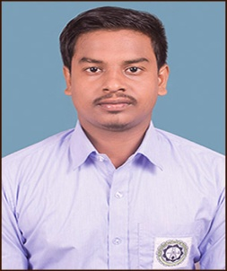
CURRICULUM VITAE

NAME : SUMANGAL BISWAS
CONTACT NO : 7076502262
EMAIL ID : sumangalbiswas93@gmail.com

OBJECTIVE :
Challenging and utilizing my abilities developed through my experience and education with an opportunity for career growth based on my merits and promote the growth of the organization.

ACADEMIC QUALIFICATION :

COURSE | BOARD / UNIVERSITY | NAME OF THE INSTITUTION | % OF MARKS
DIPLOMA IN ELECTRICAL  ENGINEERING | WBSCTE | MURSHIDABAD INSTITUTE OF TECHNOLOGY | 1st-69.5  2nd-76.0  3^{rd_}74.8  4th-69.3  5th- 69.7  6th- 74.0
12TH | WBCHSE |  | 71.2
10TH | WBBSE |  | 64
COMPUTOR SKILLS : CITA
TRAINING : INDUSTRIAL SKILLS FOR ELECTRICAL ENGINEERS PART -3 AT TPSDI
WORK EXPERIENCE : CONTINUING WORKING AS TESTING ENGINEER IN JBS PVT LDT OF 132 KV & 220 KV SUBSTATION IN RAJASTHAN.
HOBBIES : READING BOOKS, PLAYING CRICKET

PERSONAL DETAILS:
FATHER’S NAME : SUDHIR BISWAS
ADDRESS :
VILL- KHIDIRPUR COLONY
P.O- BARUIPARA
P.S - HARIHARPARA
DIST- MURSHIDABAD
PIN- 742165
STATE- WEST BENGAL
DATE OF BIRTH : 09/04/1996
GENDER : MALE
NATIONALITY :INDIAN
MARITAL STATUS : UNMARRIED
LANGUAGE KNOWN :BENGALI,HINDI,ENGLISH

DECLARATIONS:
I hereby declare that the innovations furnished above is the best of my knowledge.
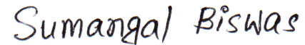

SIGNATURE OF CANDIDATE
DATE : 22/01/2021
PLACE : WEST BENGAL ,MURSHIDABAD

