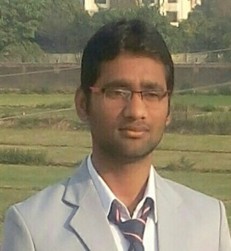
RESUME

HARE RAM SINGH
Mob No-7349943850
Email:-hareramsingh401@gmail.com
Address: Rispana pul Haridwar by pass Road,Near Minakshi Wedding Point,Dehradun(U.K).

CAREER OBJECTIVE:-
- To serve in reputed organization that can utilize my capabilities and skills and being quick earner and always ready to accept challenges for my organization.
ACADEMIC QUALIFICATION:-
Qualification | Univercity/Board | Institute/School | Passing Year | % Age
Diploma(Mechanical Engg.) | UBTER | Shree Dev Bhoomi Institute of Education Science&Tecnology Dehradun. | 2016 | 75.8%
Intermediate(12th) | Bihar Board | K.M.Y.J.K.V.P.College Kamlabari Jainagar(Madhubani) | 2014 | 64%
Matriculation(10th) | Bihar Board | Anup High School Bhatsimari | 2011 | 69%

- High school passed from BSEB Board in 2011 with 69%.
- Intermediate passed from BSEB Board in 2014 with 64%.
- Diploma passed from UBTER Dehradun in 2016 with 80%.
PRFESSIONAL QUALIFICATION:-
- Basic Knowledge of mechanical engg..
- Basic Knowledge of computer.
- Basic Knowledge of Auto cad.
WORK EXPERIENCE:-
- Fresher

PERSONAL DETAILS:-
Father`s name: Mr. Khushi Lal Singh.
Date of Birth: 08-04-1995.
Sex: Male.
Marital status: Unmariied.
Nationality: Indian.
Languages known: Hindi,English,Bhojpuri,Maithili.
Permanent Add: Vill-malhanma,Post-Bhatsimar,Via-Rajnagar,Dist-Madhubani(Bihar),Pin code:847235.
DECLARATION:-
I hereby declare that all the statement made in this format are true and correct to the best of my knowledge and belief.

