MR. AKASH SHARMA
660/20 Prem Nagar, Jail Road, Rohtak
akkiakash0922@gmail.com 9418922488
DOB 10/05/1995

Objective To obtain a challenging position in a high quality engineering environment where my resourceful experience and academic skills will add value to organizational operations.

Experience Supreme Pvt Ltd, Khushkhera, Bhiwadi
In Process Quality Engineer

2016 - 2017

I worked there as an In Process Quality Engineer and my Key Responsibilities were as follows:-
- Do Job Setup Approval of all the Injection Moulding Machines as the shift starts
- Make FPA Report of the Component setup that is going to be produced after Job Setup
- Do Hourly monitoring of the Components being manufactured upon shop ﬂoor as per SOP
- Monitor Any Change in 4M (Man, Machine, Material and Method) and take necessary actions
- Raw Material Veriﬁcation as per Speciﬁcation
- Hands on Instruments such as Slip Gauge, Height Gauge, Proﬁle Projector, Puppy Dial, etc.

YAZAKI INDIA PVT LTD, Bhiwadi
Production Engineer
I worked as an Production Engineer and my Key Responsibilities were:‐
- Responsible for the Daily Production as per Planning and achieve Productivity and Eﬃciency Targets

2017 - 2018

- Responsible for Producing required components as per the Process Work Flow and Standard Operating procedures
- Responsible for selecting and deputing Man Power as per their skill level
- Conduct On Joining Training and record and monitor the capability of each operator
- Monitor and act for Rejection Control upon the shop ﬂoor due to Improper Handling and inappropriate procedure
- Maintain 5S and discipline at the shop ﬂoor during the shift
- Upskill the Operators by providing knowledge of documents and other necessary things such as Daily Check sheet, Reference Sample, Drop Parts Category, Daily Rejection quantity, Critical Stations, etc
- KAIZEN - Continuous Improvement

Elin Electronics Pvt Ltd Ghaziabad
Senior Quality Engineer
January 2019 - Till Date

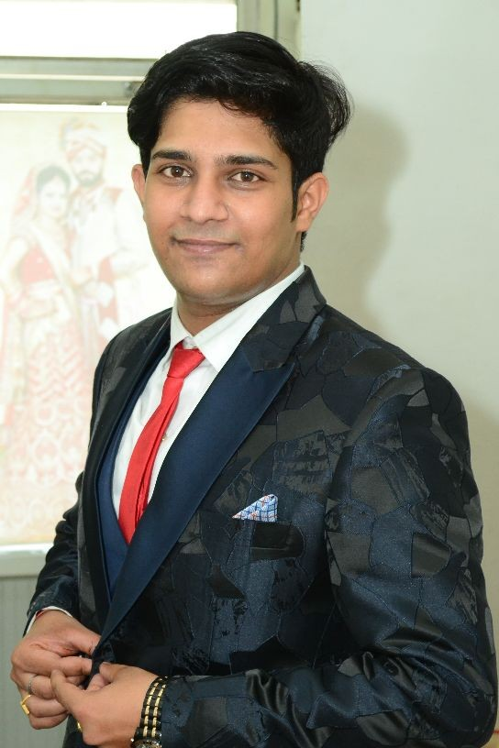I worked there as an Senior Process Quality Engineer and my Key Responsibilities were as follows:-

- Do Job Setup Approval of all the Critical Stages as the shift starts
- Make FPA Report of the Component setup that is going to be produced after Job Setup
- Do Hourly monitoring of the Components being manufactured upon shop

ﬂoor as per SOP
- Monitor Any Change in 4M (Man, Machine, Material and Method) and take necessary actions
- Raw Material Veriﬁcation as per Speciﬁcation
- Hands on Instruments such as Slip Gauge, Height Gauge, Proﬁle Projector, Puppy Dial, Quickoscope, Ford Cup, UTM Machine,etc.
- Prepare Monthly MIS report and share with Management
- Poke yoke Monitoring and Validation
- Prepare Monthly Basis Rejection Data Report and share action plan as per requirememt
- Conduct QGFI Audit at the Final Inspection stage
- Process Capability Study
- Handles Customer Complaints and Queries and share CAPA
- Prepare 8D-Corrective Action/Preventive Action Report and Share Improvement Plan
- Conduct PQCS audit as per Control Plan
- Kaizen Implemention on the Shop Floor
- Prepare Work Instructions/Standard Operating Procedures
- D-3 Analysis and Corrective action report

Education
maharishi Dayanand University,rohtak
B.Tech Mechanical 2013-2017 — 53%

Skills LEADERSHIP
IN PROCESS QUALITY CONTROL AS PER CUSTOMER SATISFACTION SPC PLAN
HANDS ON INSTRUMENTS SUCH AS PROFILE PROJECTOR, HEIGHT GAUGE, SLIP GAUGE, QUICKOSCOPE, ETC
4M CHANGE MONITORING AND CONTROL AND VALIDATION QGFI AUDIT
PQCS AUDIT PFMEA
POKE YOKE MONITORING AND VALIDATION JOB SETUP APPROVAL
PARTICIPATE IN CFT MEETINGS
PREPARE MONTHLY REJECTION DATA TREND AND PREPARE ACTION PLAN PREPARE DEFECT WISE PARETO
PROCESS CAPABILITY STUDY

Projects

TO CONTROL DEFECTS DUE TO CHANGE IN PROCESS PARAMETERS OF INJECTION MOULDING MACHINES
My project was basically based upon controlling defects in Injection Moulding Machines due to any sudden change in Machine parameters such as Temperature of Heat Exchanger Units and Air Pressure Supply and Water Supply in the Mould for Cooling

Interests Reading Magazines related to Automobile sector
Listening Music
Playing Basket Ball
Play Outdoor with my Pet Named - Odin

Language English - Fluent , Hindi - Fluent

Achievements &
Awards
Activities
Best Science Project Award in school while in 10th Class
2nd Prize for Drawing Competition in 10th Class
Jogging Running
Yoga and Pranayaam Trekking
Camping Travelling
Declaration
I hereby declare that the information given above is all true to my senses, So please to Consider if interested in my work proﬁle
Signature:
Mr. Akash Sharma

