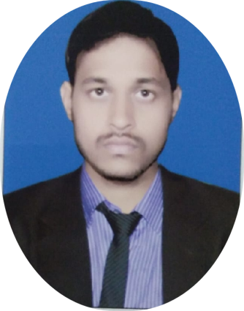

C/o-chamari mistri,at-rajendra pattelbiha, po-Rs gaya, ps- Kotwali Bihar
823001
Ak2209426@gmail.com
9334858979
Amit Prakash

Job
PROFESSIONAL PROFILE
An exceptional leader who is able to develop and motivated . Others to achieve targets. I can demonstrate a strong ability to manage projects from conception to success full completion. A proactive individual with a logical approach to challenges, I perform effectively even within a highly pressurised working environment.

OBJECTIVE. :
l am a responsible person.i am doing any work carefully.to secure a challenging position where I can effectively contribute my skills as professional,possessing competent mechanical skills, and application of knowledge for the continuous development of the industry.

Experience vico forging pvt Ltd(steel manufacturing company )
2/1/2018
EXPERIENCE _ 3 year vico forging Pvt.ltd as a maintenance engineer cnc mechanic, vmc mechanic operating and maintenance engineer

Subjects _ mechanic maintenance engineer, and mechanic operating, CNC mechanic operating, VMC mechanic operating HMC mechanic operating and maintenance engineer
Present working- vico forge pvt Ltd (vapi GIDE) this company my position maintenance engineer ,design this company products engine part, transmission part and steering part ,colling Taber, vaccum pump, cnc mechanic,
vmc mechanic, hmc mechanic maintenance and mechanic operating,and, air compressor Hyduril mechanic, power press mechanic, milling and AutoCAD, solid work fabrication

Education 10th
T moddinter school, BSEB
2011
Mark_ 69.0%

+2 science
Mirza Galib college, BSE
2013
Mark_ 63.60%

B.tech
MIT's engineering college rayagada (Odisha)
B-tech (mechanical engineering)
2014 - 2018
Mark- 72.5%

SUMMER TRAINING I have done my 1'st 30 days Successfully completed my summer training in
Hyderabad press. at Jk paper mill Ltd , Jk pur , Rayagada,odisha.

B.E (FINAL YEAR) PROJECT :
I have done my project mechanical engineering (2014-18) has successfully completed their major project on " GO KART " under Biju Patnaik university of technology (BPUT)

Software skills : word , excel,access , power point , email & catia,autocad .

Technical skills: Good knowledge in designing using data
software,word,excel,access,powerpoint & email and catia software.
CENTRAL TOOL ROOM TRAINING CENTRE : ( CATIA SOFTWARE) >
A govt.of India society I have done my course tha catia software in chandak industrial area in Bhubaneswar . Tha course comprises the following subjects are 1 conventional machining . 2 Introduction to CAD / CAM/CAE. 3 part design. 4 Generative surface design . 5 Assembly design
.6 Kinematic simulation . 7 Drafting & detailing . Has successfully completed the course from 23/02/2018 to 22/03/2018 date of award : 22/03/2018 .

Languages: Speak: English and Hindi. Write: English and Hindi

Publications
INTERNATIONAL CONFERENCES
Amit Prakash , of the " improve zeeta electrical and electronics Pvt Ltd.part using desirability function approach " globe trends and challenges in design , manufacturing and production of all India manufacturing technology .

Profile > confidences
>Positive attitude
>Ability to fit in any environment
>Hard working nature and motivation skills

Personal information
> Name. : Amit Prakash
>Date of birth. : 15/05/1996
>Gender. : Male
>Father's Name: Ashok Kumar
>Mother's Name: Meena Devi
>Nationality. : Indian
>Marital status. :Un married

Declaration I do hereby declare that the particulars of information and facts stated here
in above are true , correct and complete to the best of my knowledge and
belief.

Signature

Amit Prakash

