RESUME
Personal Detalls
Name | Kaushal kumar | 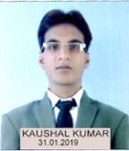
Father name | Ram Autar
Mother name | Rita Devi
Address | Vill- kashopur Pachokhara, Post Lalpur Naudiha, District Mirzapur, Pincod 231001
Mobile number | 8353956113,9794488683
Emai id | Skkaushalkumar8796@gmail.com
Educational Qualifications

Sr No | Degree | Year | Board | Percentage
1 | High school | 2012 | Up board | 61.3%
2 | Intermediate | 2014 | Up board | 74%
3 | Polytechnic | 2018 | Sobhith university | 61.2%
Heareby Declare That Infoemation Provided Above is Teur ti The Best of my knowledge.
Date singnechar

I

