A.RUPACHANDARAN
DIPLOMA MECHANICAL ENGINEERING

Objective

Seeking a challenging career to apply my knowledge and skills in learning and growing environment with the aim to attain organizational goals.

Educational Qualification

DME - Ranipet Institute of Technology. Walajapet,Tamilnadu,India
Period - (2015) Percentage (73%)

HSC - Govt Boys Hr School. Walajapet,Tamilnadu,India.
Period - (2012) Percentage (41%)

S.S.L.C - Govt Boys Hr School. Walajapet,Tamilnadu,India.
Period - (2010) Percentage (64%)

Work Experience

ABI-SHOWATEC INDIA PRIVATE LIMITED,Pulivalam Village & Post,Via Banavaram,Vellore Dist, Tamil Nadu, India.
Mar 2019 to Mar 2020

Role: Quality Assurance – (CMM lab).

BRAKES INDIA LIMITED, Sholingur, Tamil Nadu, India.
Dec 2017 to Dec 2018

Role: Production - M/c Shop, TPM, Welding, Assembly.

RENAULT NISSAN AUTO INDIA LIMITED, Oragadam, Tamil Nadu, India.
4 month

Role: Production - Body Shop Welding.

GREAVES COTTON LTD, Ranipet, Tamil Nadu, India.
Sep 2015 to Aug 2016
Role; Production – Vmc,Cnc

Role: M/c Shop, VMC Operator, Tpm.

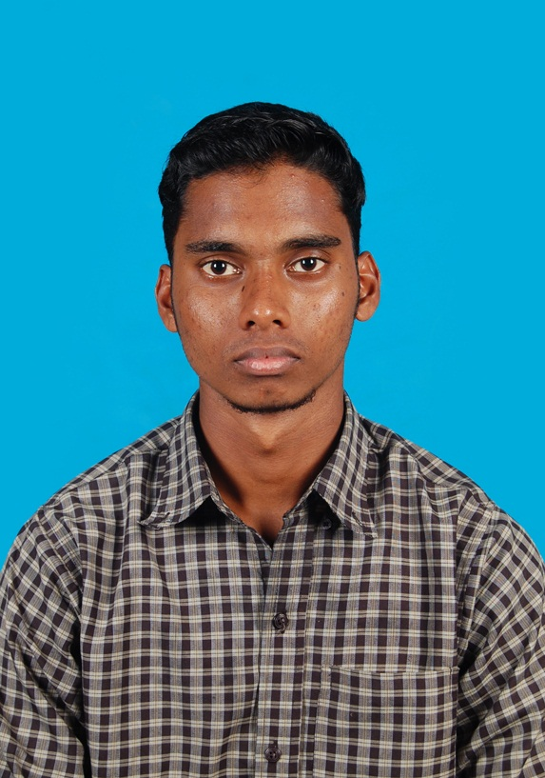

Contact

No.16, Vallalar Street, Sivananda Nagar,
Thiruvalam, Katpadi, Vellore, Tamilnadu, India.
Pin Number- 632515

Contact Details: - 9171219285,9894889680

Mail ID :-rupachandaran@gmail.com

Other Info

Language

- Tamil
- English

Computer Skills

- Basic System
- MS Office

Area Of Interest

- Manufacturing
- Maintenance
- Tpm

Personal Skills
- Possess Good relation building and inter personal skill.
- Good in Communication Skill.
- Learning any kind of process quickly.
- Good team working.
Personal Profile

Father Name : S.Arulmozhivarman
Mother Name : A.Lakshmi
Date Of Birth : 26-04-1994
Gender : Male
Marital Status : Unmarried
Religion : Hindu
Nationality : Indian
Driving Licenses : TN23 20160010103 (Exp.date : 24/11/2036)
Passport Number : P6416512 (Exp.date : 26/12/2026)
Declaration

I hereby declare that the above mentioned information is true to the best of my knowledge.

Place : Signature
Date : (A.RUPACHANDRAN)

