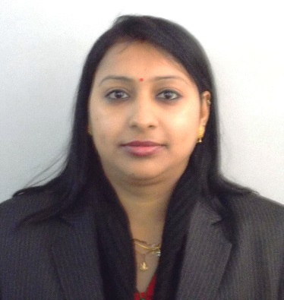
manisha_nexgen@rediffmail.com

EXPERTISE

Manish Kaur

House No. 893, Ward No. 8, Mehrauli, New Delhi.
+91- 9540042384, 9582669137

Accomplished Customer Relationship Manager.
OBJECTIVE
Seeking challenging assignments in an organization of repute which provides me avenues for professional learning and makes good use of my technical skills and encourages individual growth.
PROFILE
- A dynamic & result-oriented professional with over 13 years of experience as Customer Relationship Manager (CRM). Currently spearheading Customer Relations with Frontier Auto world. (Dealership of Volkswagen Cars) in Gurgaon. Reporting to Managing Director.
- Excellent Relationship Management skills, articulate, combine strong business acumen with the ability to conceive profitable and efficient solutions utilizing technology. Industrious, thrives on challenges while working effectively with all levels of management and the people therein.
- Highly analytical & detail oriented in approach, with strong ability to adapt and handle risks, operating outside comfort zone. Dedicated individual with a reputation for consistently going beyond what is required and using personal high standards to achieve results.
- Self-motivated professional with creative, vibrant and fresh ideas, positive attitude, high level of energy, perseverance and the ability to perform in stressful and demanding situations.
- Well-developed communication skills with reputation of unwavering accuracy, credibility and integrity.
ACHIEVEMENTS

- Awarded twice by Volkswagen as the best CRM in the North Zone.
- Awarded twice within six months for all round performance and sincerity by M&M.
Customer Service Operations . Cross Functional Cordination . Client Relationship Management. Team Management . Communication Skills . Report Preparation.

CORE COMPENTENCIES
PROFESSIONAL EXPERIENCE

M/S RING ROAD HONDA (Honda Dealership) Gurgaon Apr ‘08 – May ‘10
Asst Customer Relations Manager

VOLKSWAGEN GURGAON (Volkswagen Dealership) Jun ’10 – till date
Customer Relations Manager

HCL TECHNOLOGIES LTD, BPO Services, Noida Mar ‘07 – Mar ‘08
Sr. Customer Relations Executive

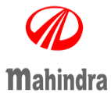
M/S NEXGENSOLUTION TEHNOLOGIES (P) LTD , (Mahindra dealership) Ranchi Mar ‘05-Mar’07
Customer Relation Manger-Service
M/S JAIN UDYOG LTD, (Mahindra Dealership) Jamshedpur Aug ‘03 – Feb ‘05 Executive Assistance Reporting to M.D
JOB RESPONSIBILITIES

- Handling and maintaining all databases of customers and handling all grievances and problems of the Customers.
- Responsible for keeping healthy relationship with Customers keeping into account their opinion and also keeping into account the Welfare & Goodwill of the dealer.
- Dexterous with service related activities both manually and computerized and handling PDI & Pre-Sale, free service & Warranty Claim along with all correspondences.
- Well aware of policies and procedure from the portal and arrange to provide training to the service supervisor & advisors.
- Conversant with customer satisfaction index and procuring all the activities as well monitoring time to time development of service advisor, service supervisor, & technicians for improvement of ranking of the CSI and maintain the quality to the same.
- Taking care of claims settlement like goodwill and Loaner car claims and also claiming the same in dealer portal.
- Arranging Events for customers to increase the level of customer satisfaction.
- Maintaining appointment schedule of MD, with travel plan and preparing Minutes of Meeting, client handling.

TRANINGS
- Dealer Management Software for all type dealership activities organized by Dealer & by the franchise at dealer point for 15 days and time to time revision for new / add version.
- Dealer Portal Training for all the dealer activities online, organized by Mahindra & Mahindra Ltd. at Patna.
- CRM training at Kolkata organized by Mahindra & Mahindra Ltd (MILE)
- STA training attended at M&M Ltd., R.S.O. Ranchi for their Scheme-Scorpio total Armor & Scorpio shield for one day and also one day at dealer point revision for the same.
- CRM training conducted by HONDA in Greater Noida.
- Certification training held at Gurgaon by Volkswagen for CRM’s
- CRM conclave held at Pune and Plant visit in VW Pune
EDUCATIONAL QUALIFICATIONS

Graduation 2006 Ranchi University, Ranchi
Diploma in Computer Application (DCA) New Tech Point, Jamshedpur

PERSONAL DETAILS
Date of Birth: 22nd February 1985
Marital status: Married
Permanent Address: Zone No. 1, House No. 292, Telco Colony, Jamshedpur, Jharkhand.

