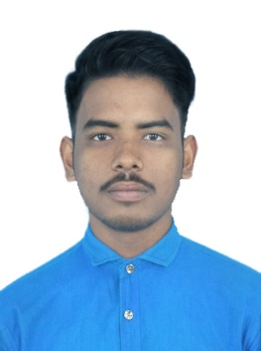
CURRICULUM VITAE

Personal Details
Name- Paresh Roy Nationality- Indian
Father Name- Nikhil Roy Sex-Male
Marital Status- Single Language Known- English,Hindi,Bengali
Date Of Birth-19 , April , 1998
Present Address -
vill-Shikarpur, P.o-B.S.Asram, p.s-Chakdaha,Dist-Nadia
Pin-741248 Mobile No-7047724231,
Email-pareshroy@gmail.com 8436337285,
Academic | Results
Name Of Examination | Institution | Board/University | Year | Result
Secondary | Shikarpur Vivekananda High School | W B B S E | 2014 | 45.0%
Higher Secondary | Shikarpur Vivekananda High School | W B C H S E | 2016 | 53.5%
I T I,  (SURVEYOR) | ITI , Kalyani (govt) | N C V T | 2015 | 73.0%
DIPLOMA IN (SURVEY ENGENERING) GAYESPUR GOVERNMENT POLYTECHNIC.
Computer And Technical Skill
1,Operating system- windows 10/8/7/vista
2, Microsoft – office ,word ,access , power point
3, Internet Knowledge- browsing web page, online transactions,
Download and uploading
PARESH ROY

