CURRICULUM VITAE
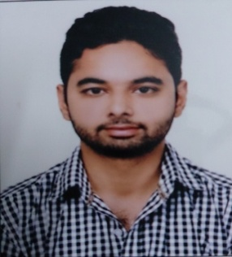
RAGHAV PURI

H.NO:130 white enclave, backside green field,
Majitha road
Distt.- Amritsar.
State- punjab
Contact No. 9417419972
Email: praghav9024@yahoo.in

MECHANICAL ENGINEERING
CAREER OBJECTIVE:

To work for the organisation where i can utilise my potential, skill and fulfil the requirement by being an integral part of an organisation. Besides that, try to upgrade myself, for enhancing the working environment to achieve the goal for development. I am very keen to learn the new techniques in industry.

EDUCATIONAL QUALIFICATIONS: Marks obtained in previous classes
Class | Percentage | Board
B.Tech (Mechanical Eng.) | 70% | PTU
+2 | 53% | PSEB
10th | 64% | PSEB

PROFESSIONAL SKILL
- knowledge in AutoCAD and PRO-E
- Good knowledge of operating system (OS).
- Basic knowledge of power point, excel, Ms word, Ms dos

KEY SKILLS
Excellent verbal and written communication, proactive nature, ability to listen other patiently, sincerity and punctuality, hard working attitude.

TRAINING
- Two Months Training in SAHIL ALLOYS & MACHINE TOOLS PVT.LTD. Batala (A CNC LATHE MACHINE Manufacturing).
- Attended 6 Months Training in NAHAR TEXTILE INDUSTRIES (OSWAL DENIM) LALRU in the ERECTION OF STUNTER MACHINE.

EXTRA CURRICULAR ACTIVITIES
- I have participated in shotokan karate, cricket events at Inter school level and district level.

STRENGTH
Passionate to work, Leadership skills, Adaptability, Energetic, Cooperative.

PERSONAL INFORMATION
Father’s Name : Shri Sudhir Kumar Puri
D.O.B : 13-03-1990
Marital Status : Single
Nationality : Indian
Language Known : English, Hindi, Punjabi

HOBBIES
To work on creative things and listening music.

DECLARATION
I hereby declare that the above mention information is true to best of my knowledge.

Raghav Puri
Signature

