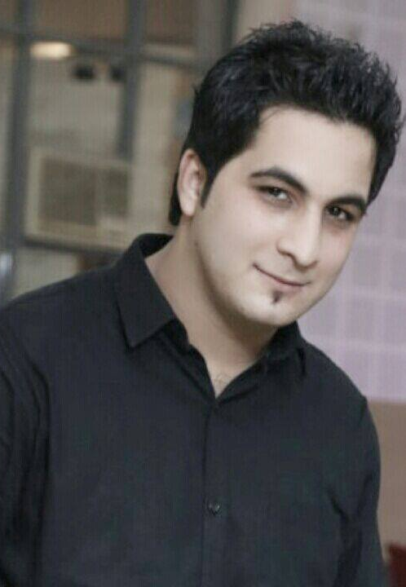  NAME:HIMANSHU ANEJA  Positive mind-set and pro-active attitude, self-starter.  E- mail  Himanshuaneja2000@gmail.com  Contact Number  Mob: +919017400442  : +918930400442  Permanent Address  780/23 D.L.F Colony  Rohtak, Haryana  India  Personal Data  S/O Sh. Ramesh Aneja ,  Date of Birth : 1st April,1993  Gender : Male  Nationality : Indian  Current CTC : INR 40000 | PROFESSIONAL SYNOPSIS  A dynamic professional with nearly 6 years of experience in Quality department as Senior Engineer.  Career Profile  - Bachelors of Engineering in ‘Mechanical’  - Worked as Quality Engineer in Nageshwar Auto Industries, Rohtak (April 2014 to June 2016)  - Working as Senior Engineer (Quality) in Bhagwan Precision Pvt. Ltd. , (July2016 to May 2019)  - Working as Assistant manager (Quality) in Dynamic Transmission Ltd. , (June2019 to Till now)  BHAGWAN PRECISION (P) LTD (ROHTAS GROUP)  In the Automotive Industries, Bhagwan Precision Pvt. Ltd. Is a TS 16949 & ISO 14001 Certified company. This company is manufacturer of all type of turned component & Hydraulic components like as Lowering seat & Spool Assy. Hydraulic Sleeve & Spool control valve, Isolator valve, Response bodies, Shafts etc.  The company is catering to Mahindra & Mahindra Ltd. , TAFE Access Ltd , Hero Moto Corp Ltd. , Escorts India (P) Ltd. , Punjab Tractor, Ognibene Power Spa etc.  Responsibilities:  - Manage departmental activities of customer quality and final inspection. Addressing customer concerns and reports.  - Rejection recording, monitoring, analysis root cause & verification and identify countermeasure, implementation & monitoring effectiveness (using 7QC tools).  - Preparation of dimension and visual inspection standards for final inspection.  - Daily working on rejection data to reduce the PPM by using suitable poka-yoke and kaizen.  - Responsible for new parts devlopment.  - Maintain the 5’s activities on shop floor.  - Daily shop floor red-bin meeting with Q.C staff for in house quality problems & customer complaints.  - Making MIS of every month and participate in MRM every month.

Education

Qualification | Marks obtained | Institution | Year
AISSCE  Board CBSE | 72.8% | ShikshaBharti Sr.  Sec. School | 2008
AISSCE  Board CBSE | 64% | ShikshaBharti Sr. Sec. School | 2010
B .Tech | 62% | MaharshiDayanandUniversity | 2010-2014

Project/Training
- Industrial Training :
Company Name: "Micro Turners"
Project: Quality Control on line process and final Inspection.
Description:Checking Hardness, measuring dimensions, applying Poka-yoke, maintaining 5’S, Controlling PPM levels.
- Summer Internship: June 2012 to Sep 2012
Company Name: Uno Minda (lighting-division), IMT Manesar, Gurgaon.
Project: Quality Inspection and Assembly department control.

- Industrial Training : Yellow Belt
Company Name: "Mahindra & Mahindra"
Project: Problem Solving Aproach through QC Story.

Computer/ IT skills

Operating Systems | Windows XP, Windows7, Windows 8
Software | ERP system ,MS Office, Ebiz Frame

Activities and Achievements
- Medals in National level baseball tournament.
- Participated in Quiz at school level.
- Participated in Fest in College as a volunteer.

KEY SKILLS & ATTRIBUTES
- Quality management, quality control, assurance, quality engineering.
- Process, incoming, receiving, in-process and online inspection.
- CAPA and Counter measure action.
- Can easily acclimatize with any kind of work environment.
- Work effectively with diverse groups of people.
- PPAP , APQP , Feasibility.
- Ambitious and committed to excellence.
- Layout Inspection & Dock Audits.
- Well versed with Eddy Current tester and Magna flux tester.
- Well-organized working methods and ability to report in a structured and concise format.
- Strong ability to organize and prioritize own work and to manage multiple tasks.

INSTUMENTS AND GAUGES

●Vernier caliper ●Micrometer ●Height Gauge ●Standard pin
●Dial Gauge ●Push pull gauge ●Filler gauge● Roughness Tester
●Profile projector ●Counter Tracer ●AIR PRESSURE GAUGE ●Cylindricity Tester etc.

Hobbies and Interests
- Interacting with people.
- Playing and watching Baseball.
- Playing Billiards.

Languages Known
Proficiency in Languages: English and Hindi.

Declaration
I hereby declare that the above particulars furnished by me are true to the best of my knowledge and belief. I assure, if I given a chance, will execute my work to the fullest satisfaction of my superiors.

DATE:

PLACE:

