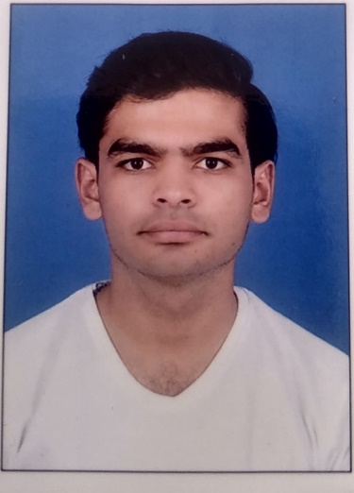

* 33KV GIS, 220KV switchyard (AIS), OLPC system, monitoring and operations on scada panel.
* Data Collection and analysis from Disturbance Recorded System.
* Hands on experience of ABB made Load Shedding Systems, RTU Systems.

REFERENCE

Bhavin Thummar

*Reliance Industries Ltd*

P. +91 8140427725

E. bhavinthummar15@gmail.com

Efficient operation of power plant

Fault finding, troubleshooting and problem resolution.

Power restoration and Load shedding

Quick and correct decision maker

Protection co-ordination

* Operation of energy management systems (Load Shedding, Power Balance, Efficiency, S/S Monitoring and Scada).
* Handling partial power failure and many other emergency in field as well as from panel.
* Maintenance of various electrical equipment including hazardous protected areas.
* Have expertise of Electrical schematic and logical drawing analysis.
* Efficient operation of gas and steam turbine.
* Good debugging and troubleshooting skill.
* Good communication and teamwork skill.

PRO SKILLS

Panel Operator & Field Executive

Skills

* Operation of six GTGs (GE base frame 9) of 124.54 Mw power capacity each, G60 relay base protection system, EX2100 base AVR system, MLJ type synch facility, and shaft voltage grounding system.
* Operation of two Man base STG of 27 Mw capacity each, Jeumont base AVR and GE base protection relay.
* Operations and maintenance of power, distribution, current, potential transformers up to 174MVA capacity, trafo protection panel T60 base relay system and overall protection.
* Operations and maintenance job on 230V to 220KV voltage System (AIS & GIS), up to 160KVA base UPS and battery chargers of 125 and 220v DC.
* Issuing and accept work permit by following safety standards and follow LOTO procedures as per Electrical safety procedures.
* Handing preventive maintenance and major plant shutdown, abnormal and emergency condition (breakout), isolation, normalization, startups, shutdown and troubleshooting activity.
* Commissioning experience of 220kV switchyard, 33kV substation and gas turbine modification.

Reliance Industries Ltd

Reliance Industries Ltd

*Jul 2014 - Present*

Field Executive

*Jul 2014 - Present*

Panel Operator

EXPERIENCE

*The institution of Engineers*

*2017*

**Electrical Engineer**

EDUCATION

[dixitramoliya135@gmail.com](mailto:dixitramoliya135@gmail.com)

+91 9904902904

+91 8160186492

Jamnagar, Gujarat, India

CONTACT

**PROFESSIONAL STATEMENT**

**I have 6 years of experience in Power Plants, which includes working on electrical equipment of gas turbine, steam turbine, motors, transformers and switch gears AIS - GIS (230V- 220kV). I am always ready to take challenges and convert them into betterment for the organization.**

Dixit Ramoliya