RESUME

PARTHA DEY

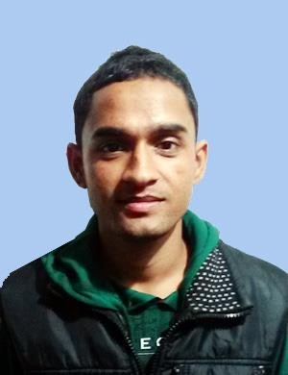
VILL-SHIBOGRAM P.S-MAYURESWAR DIST-BIRBHUM PIN-731245
WEST BENGAL

MOBOLE-8768598072/8618981534 E-mail:parthadey337@gmaill.com

OBJECTIVE:

To work in an organization where I can serve the organization by me knowledge and interpersonal skills for the development of organization as well as to develop my knowledge.

PERSONAL PROFILE:

NAME :- PARTHA DEY

FATHER’S NAME :- ANANTA DEY

PERMANENT ADDRESS :- VILL-SHIBOGRAM

:- POST-BEGUNIA

:- DIST-BIRBHUM

:- PIN-731245

:- WEST BENGAL

DATE OF BIRTH :- 01.06.1996

SEX :- MALE

NATIONALITY :- INDIAN

RELIGION :- HINDU

MATIRAL STATUS :- UNMARRIED

EDUCATIONAL QUALIFICATION

Name of Examination | Board/Council | Name of the School | Year of Passing | Persent of marks
Madhyamik | W.B.B.S.E | Kanutia J.C High School | 2012 | 60%
H.S | W.B.C.H.S.E | Sainthia High school | 2014 | 62.8%

TECHNICAL QUALIFICATION

DEPARTMENT OF MECHANICAL ENGINEERING (DIPLOMA)

Name of the Institute | Semester No | Council | Grade point | Average
BASANTIKA INSTITUTE OF ENGINEERING & TECHNOLOGY | 1st 2nd 3rd 4th 5th  6th | W.B.S.C.T.E | 7.2  7.2  7.4  8.2  6.7  6.8 | 69.2

WORK EXPRINCE :-

JBM GROUP COMPANY (NEEL METTAL PRODUCT LTD), BANGALORE.

WORK EXPRINCE 6 MONTH’S IN QUALITY DEPARTMENT.

SHIVAM AUTOTECH LIMITED (HERO GROUP),VEMGAL INDUSTRIAL AREA

KOLAR, KARNATAKA 563 102.

IM WORKING 2 YEARS IN S.A.P (SYSTEM APPLICATION PRODUCT) & CNC

MACHINE OPERATING OF PRODUCTION ENGINEERING DEPARTMENT (NPD).

HOBBY:-Playing Cricket, Interesting story & Adventure.

All the above information is true the best of my knowledge and belief

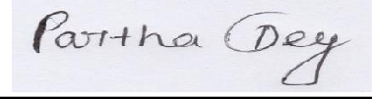
Place:-.................................................... ..

Date:-.................................................... Signature

