- ROHIT KUMAR MAHAKUD
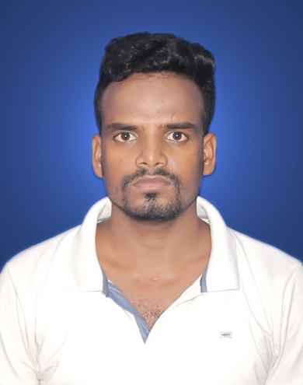
B.Tech-Mechanical Engineering

rohitkrmahakud@gmail.com

+91-7352441418, +91-7992318166

CAREER OBJECTIVE

To excel in my field through hard work, research, skills and perseverance. To serve my parents, and my country with the best of my abilities.

PERSONAL COMPETENCIES
- Interactive

- Leadership skill.

- Passionate.

ACADEMIC QUALIFICATION

Course/ Subject | Year Of | Institute | University/Board | CGPA/Marks
 | Passing |  |  | (%)
Bachelor of | 2013-2017 | NM Institute of Engineering&Technology, Bhubansewar,Odisha. | BPUT | 7.49 CGPA
Technology
(Mechanical)
Intermediate | 2013 | Templecity Institute of Basic Science,Khurda,Odisha. | C.H.S.E | 59.33%
High School | 2011 | B D S L S Vidya Mandir high School Mosaboni,Jharkhand. | J.A.C | 56.6%

TRAINING & CERTIFICATION

- Summer Internship at TATA STEEL,Jamshedpur in G- Blast Furnace Iron-making. as a Mechanical Engineer from (14.06.2016 to 05.07.2016)

- Vacation Training at CTTC,Bhubaneswar in ConventionalTurning, Conventional Milling and In-Plant Training in Production department from (01.03.2016 to 31.03.2016).

EXPERIENCE CERIFICATON

- Auto Assembly P.D.I Quality Department in 1Year 5 Months experience (GAT) From Lifelong India Pvt Ltd. Haridwar(U.K).
- 7 Quality control tools & 5S.
- RGP,NRGP,PDI Report, QGFI audit & Daily Rejection Data file fillup.
- Visual/functional/Dimension Inspection checks & Rework.
- SAP Working VL01N,MMBE,MB1B,MD04,CO11N,QA32 etc.
- Basic Computer knowledge in Ms-word, Excel, Power point etc.

PROJECT
- VAPOUR COMPRESSION REFRIGERATION SYSTEM
- 8th _{semester Major-Project}

HOBBIES
- ^{workout/meditation}
- ^{sports}

EXTRACURRICULAR ACTIVITIES
- Participated in SWACHH BHARAT ABHIYAAN Organized by NMIET.
- Active participation in school and college cultural activities.
- Participated in Cultural Program held at NMIET.
- Participated in Cricket Tournament Organized by Lifelong.

PERSONAL PROFILE

Father’s Name | : | :Navdip Mahakud
Date of Birth | : | :26/01/1996
Language Known | : | :English,Hindi,Odia
Marital Status |  | :Single
Nationality/Religion |  | :Indian/Hindu
Permanent Address |  | :AT-Dangardiha,PO-B.Kutung,PS-Rajnagar,DIST-Seraikela Kharsawan
 |  | Jharkhand ,Pin-831002

DECLARATION:

I declare that the information and facts here in above are true and correct to the best of my knowledge and belief.

Place: Jamshedpur Rohit Kumar Mahakud
Date: Signature

