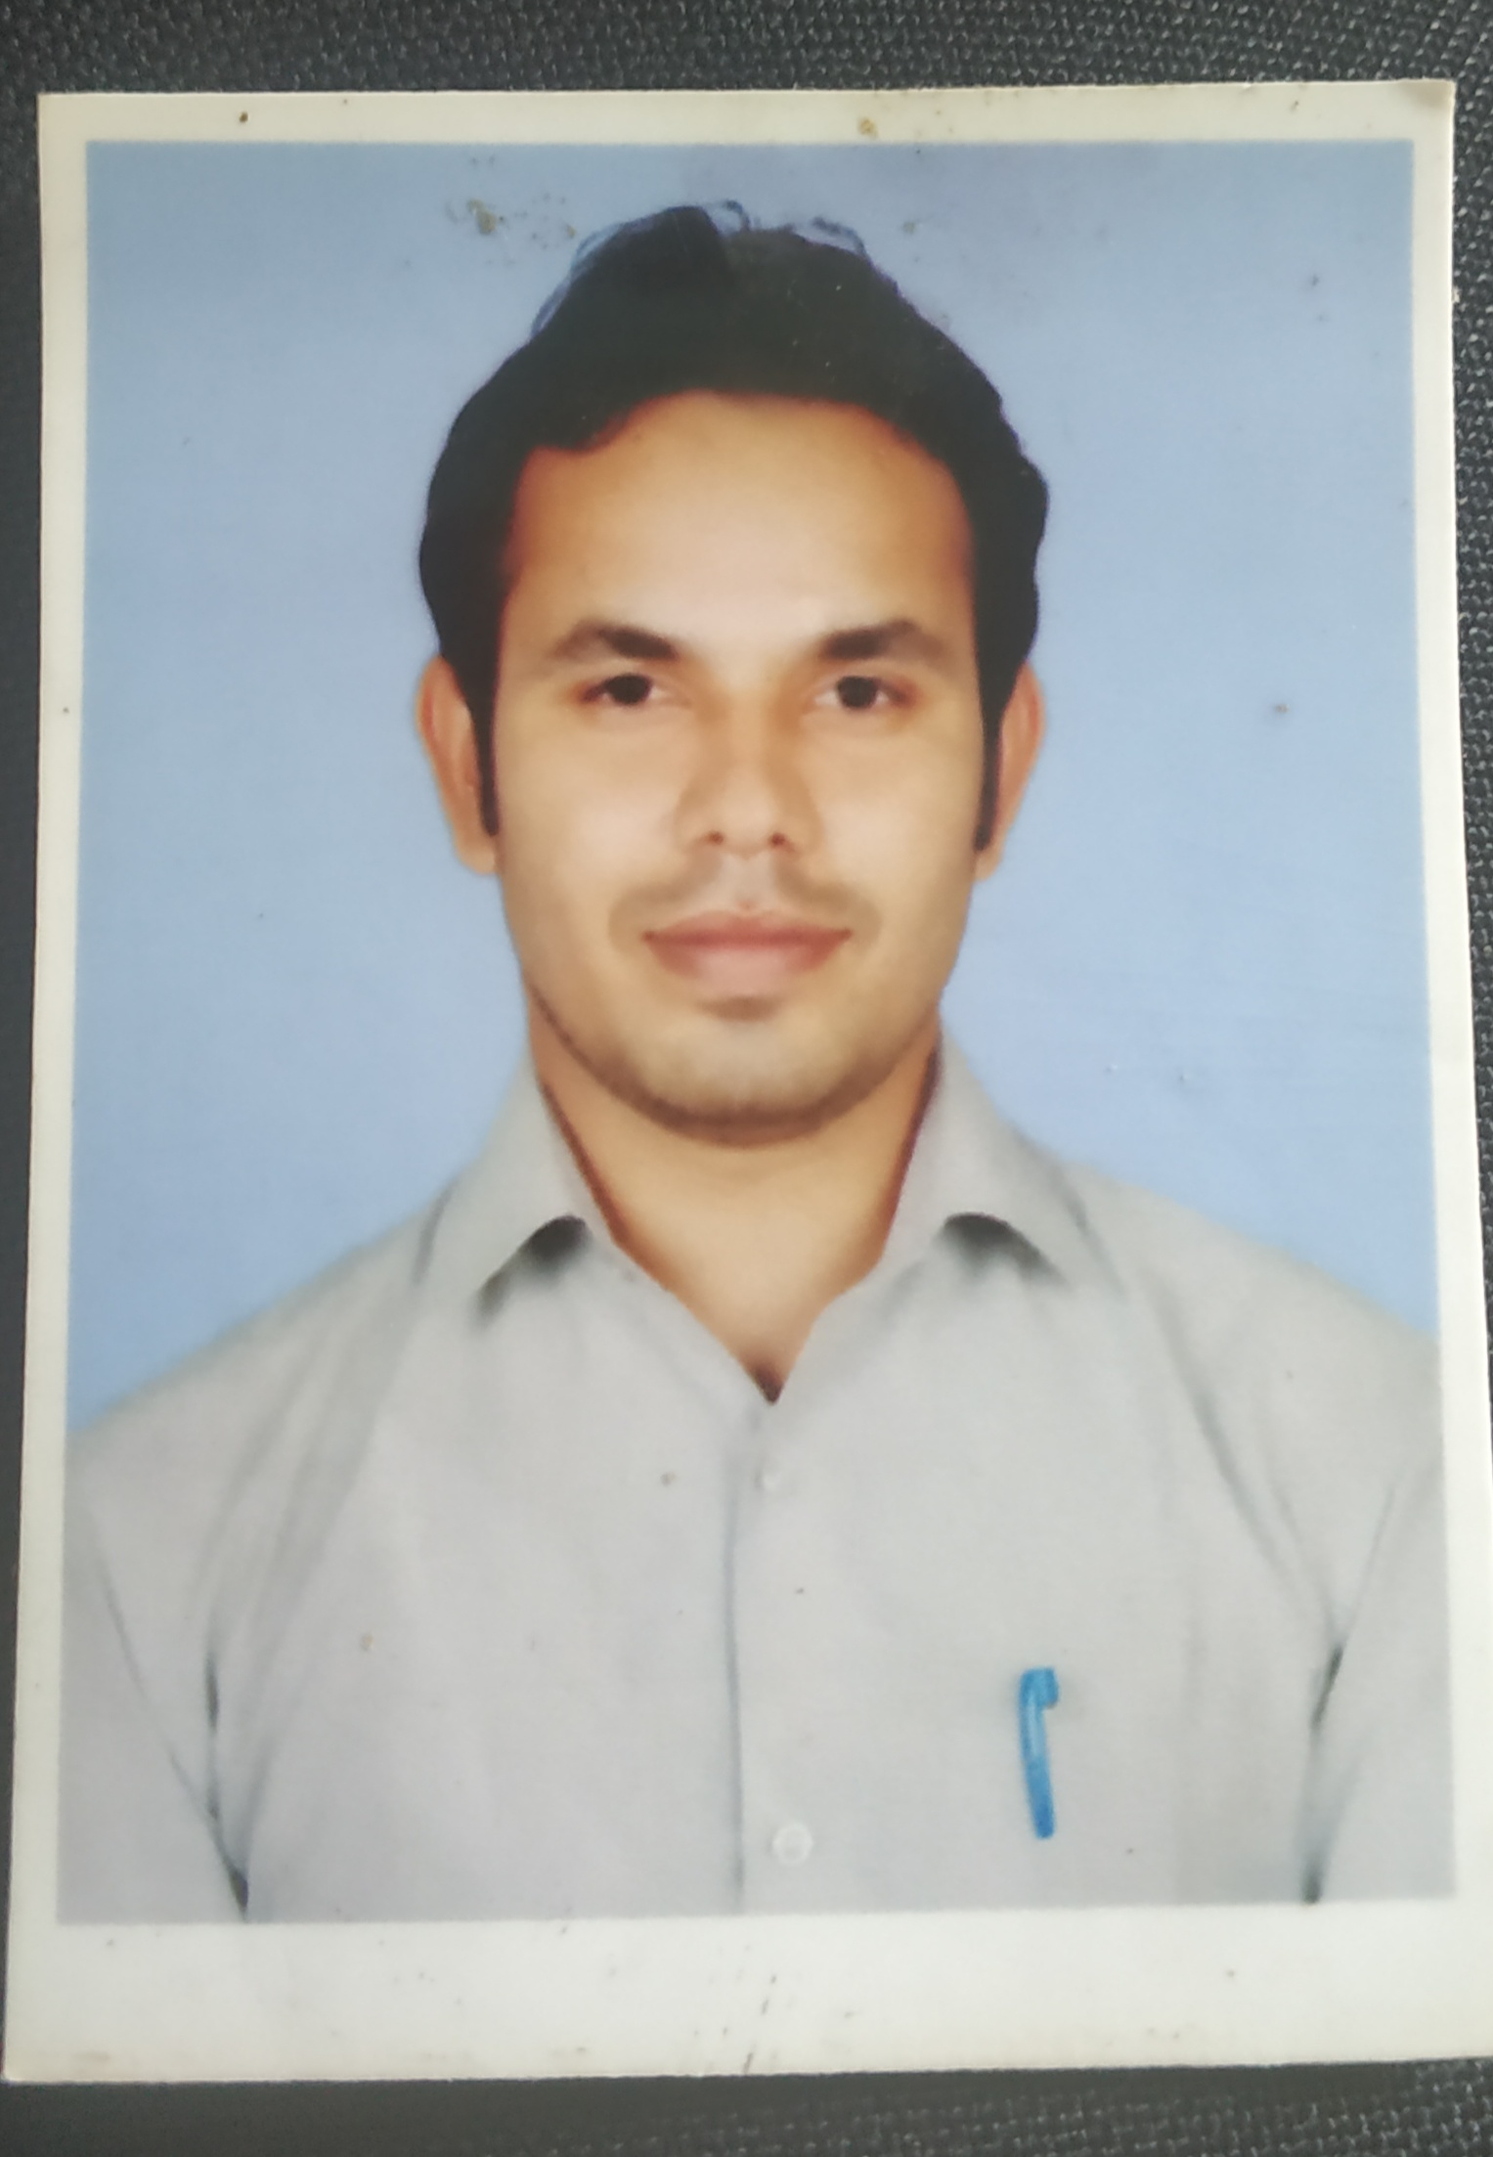
Curriculum - Vitae
Pintu Kumar
V.P.O Sutana,
Distt.-Panipat
Panipat-132103
Contact No. – 9991147446,7397766574
Email – pintudhiman48@gmail.com
_____________________________________________________________

Career Objective:

A challenging opportunity that synthesizes my knowledge & skills to join a high motivates and professional organization to gain knowledge and achieve excellence with utilizing my experience for the growth of the organization

Educational Qualifications:
- HIGH SCHOOL:Passed In year 2008 from H.S.B.E Board
- SECONADRY SCHOOL: Passed IN March 2014 From H.S.B.E Board.
- DIPLOMA ( Electrical Engineer): Completed from Haryana State Technical Board Education in 2012 from Govt. College Polytechnic Sonipat

Career History: (Total 5.10Years Experience as a Service Engineer)
- Near about 3 Years’ experience in Micromatic Machine Tools Pvt. Ltd. from 16 June 2014 to 14 April,2017 as a Service Engineer.
- 1 Year experience in Hi-Tech Gears Ltd. from April 2013 to May 2014 as a Junior Engineer.
- Currently working in Lakshmi Machine Works Limited from 12 June,2017 to till date as a Service Engineer.
Company Profile:
- Lakshmi Machine Works (LMW) was founded in 1962. It is engaged in the manufacture of textile machinery, machine tools and foundry products. LMW commands a 60% market share in the domestic textile spinning machinery industry.
- Machine tools division: In 1988 it started new plant to manufacture CNC machine tools in technical collaboration with Mori Seiki Company of Japan. It has portfolio of products that includes CNC lathes, vertical machining centers, drill tap center and horizontal machining center.During 2009, the company added to its formidable manufacturing resources, a new plant to produce detailed components for aerospace industry mainly focused on Engine, Structural and Landing gear parts. With sophisticated facilities and extensive experience it actively contributes to make its customers competitive.LMW has global presence in developing countries as well as in Europe.
Job Profile:
- Responsible for attending breakdowns of machines which are CNC Turning machine of LMW Designer, VMC Machines.
- Responsible for service, AMC contract renewals, repairs and service business of CNC Machines for direct Customers.
- Responsible for Commissioning of Turning Center, VMC Trouble shoots the problems raised at the time of Commissioning.
- Developing routine and Preventive Maintenance schedules time to time for increase machine up time & equipment reliability.
- Responsible for attending the customer calls directly which are in AMC.
- Responsible for spare management of LMW Designer CNC turning machines.
- Handling of CNC Machine & various control systems Fanuc and Siemens.

Other Skills:
- Basic knowledge of computer.
- Excel, MS Word.
Professional Strengths:
- Hardworking, honest, punctual & dedicated towards work.
- Positive & practical approach towards life.
- Willingness to learn new & interesting things quickly.
Hobbies:

- Playing Cricket,Badminton
- Listening Music
- Reading Novels
Language Proficiency:
- Hindi
- English
Personal Details:

- Name : Pintu Kumar
- Father’s Name : Mr. Ram Niwas
- Date of Birth : 20 June 1993
- Marital Status : Married
- Sex : Male

I declare that the above information are true and correct to the best of my knowledge & belief.
Place: Panipat
Date : (PINTU KUMAR)

