RESUME
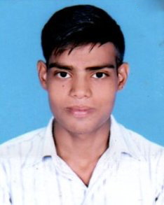
AMAN SHARMA
MOH. TARO WALA BAGH NEAR MALHAR TALKIES
SHAHJAHANPUR U.P 242001
MOBILE NO. 6390062957
E-mail:-dp738880@gmail.com
CAREER OBJECTIVE

To build career in a growing organization, where I can get the opportunities to prove my abilities by accepting challenges, fulfilling the organizational goal and climb the career ladder through continuous learning and commitment.

ACADEMIC QUALIFICATION
- 10th Passed from U.P Board 2014
- 12th Passed from U.P Board 2016

OTHER QUALIFICATION
- DIPLOMA IN MACHANICAL ENGINERING
PERSONAL SKILL
- Honesty
- Accepting Challenges
PERSONAL PROFILE
- Father’s Name Late Mr.Vinod Kumar
- Date of Birth 31.05.1999
- Sex Male
- Marital Status Unmarried
- Language Known Hindi & English
- Nationality Indian

DECLARATION
I solemnly declare that all the above information is correct to the best of my knowledge and belief.

Date:-
Place:- AMAN SHARMA

