Career Objective

Looking for a fresher job as a Mechanical Engineer where I can give my best work to employer with my knowledge and hard work and also, I can learn new things to improve my knowledge & Growth.

Education

2015 - LDRP Institute of Technology & Research, Gandhinagar, Gujarat
2019 Kadi Sarva Vishwavidyalaya University, Gandhinagar, Gujarat
B.E. Mechanical Engineering
CPI-6.80/10
CGPA-7.04/10
Year of Passing-2019

2013 - The H.B. Kapadia New High School, Ahmedabad, Gujarat
2015 The Gujarat Secondary and Higher Secondary Education Board
HSC
Percentage-58.76
Year of Passing-2015

2001 - The H.B. Kapadia New High School, Ahmedabad, Gujarat
2013 Gujarat Secondary and Higher Secondary Education Board
SSC
Percentage-75
Year of Passing-2013

INDUSTRIAL EXPOSURE

- 15 Days Internship at CHEM PROCESS SYSTEMS PVT. LTD.

CHEM PROCESS SYSTEMS PVT. LTD. is in the field of manufacturing of Heat-Exchanger like Condenser and Ejector. During my Internship I work in Production Department and I learnt about Design and Production of Condenser and Ejector. I also gain knowledge about different types of Metals, Valves, Welding techniques and different types of tests like DP test, Radiography test, Destructive test, Hydrostatic test during my Internship.

Project

- Design & Development of Smart-Bot

Smart-Bot is a robotic car with intelligent senses. It is one type of AGV which is currently used in the industry for transportation of materials and finish products in the factory without human driver. Particularly we made this robotic car accident proof in one direction with the use of ultrasonic sensor. It is work as per programme. We use microcontroller named Arduino for controlling of this Smart-Bot.

- Study of Fire Tube Boiler

In this project I study about fire tube boiler’s design, it’s manufacturing procedure different welding technique, different types of tests like DP

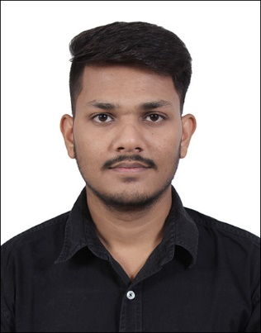

Mrugesh Vaghela
Mechanical Engineer

Personal Information

Address
C/80 Riddhi Siddhi Apartment
Near Tulip Bungalows
Thaltej, Ahmedabad
Pin code-380059
Gujarat, India

Phone
9558960856

E-mail
1997mrugesh@gmail.com

Date of birth
01/09/1997

LinkedIn

www.linkedin.com/in/mrugesh1997

Language Known

English
Hindi
Gujarati

Hobbies

Watching Movies
Reading

test, Destructive test, Pneumatic test and also learn about different IBR
Rules and regulations. I also learn about different boiler accessories during this project.

- Contactless Eddy Braking System

This is one type of braking system. This is a contactless brake. This is a frictionless brake. In this project with help of the magnetic field brake is applied. Magnetic field is generated in magnetic coil with eddy current. This type of brake is very useful in Tram, Roller coaster.

Technical Skills

- Computer Programme

AutoCAD
SOLIDWORKS
MS Office

Strength

- Hard working
- Honesty
- Team Working

Certificates

- Internship Certificate
- Autodesk Certified Professional: AutoCAD®
- SOLIDWORKS Course Completion Certificate
- AutoCAD Course Completion Certificate
- Robogenesis HEXABOTZ Robot Workshop Participation Certificate
- XENESIS 2018 Robo War Coordinator Certificate

