RESUME
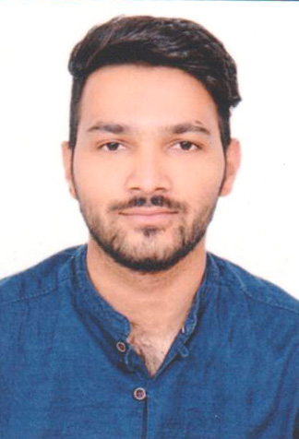

Address :
House no. 21, Green Estate Colony,
A2Z Builders, Muzaffarnagar
Pin- 251001
Mob. No.- 9759697778
NITIN KUMAR
Email : nitinpal7778@gmail.com

CAREER OBJECTIVE :
- A responsible and challenging position that will allow me to explore my ability, skill and sense of dedication towards my duties with a sole aim of see the progress of the company.
EDUCATIONAL QUALIFICATION :
  - High School from U.P.Board, Allahabad in 2012.
  - Intermediate from U.P.Board, Allahabad in 2014.
  - Completed B.Tech. (Mechanical) (Final year) from Galgotias University in 2019
TECHNICAL SKILLS :
    - C & C++ (Basic knowledge)
    - Auto Cad (Basic knowledge)
    - M.S. Office & Internet
    - Catia V5 (Intermediate knowledge)
TRAINING :
  - Name of Employer : 510 Army Base work Shop
  - Duration : 11th June 2018 to 7th July 2018
  - Name of Project : Study of Hydraulic Circuit on 17M MAST VEH.
  - Name of Employer : TVS Srichakra Limited.
  - Duration : June 2017 to July 2017
  - Name of Project : Stock preparation.
SEMINAR :
- Name of Employer : National Power Training Institute (Delhi)
- Duration : 29 Oct. 2017 to 31 Oct. 2017
- Name of Project : Conventional Power Generation And Management.
STRENGTH :
    - Positive Attitude
    - Confidence
    - Honesty
    - Hard working.
HOBBIES :
    - Interacting with people.
    - Reading books & Newspapers.
PERSONAL PROFILE :-
Father's Name : Sh. Subhash Chand
Date of Birth : 12.09.1996
Nationality : Indian
Marital Status : Unmarried
Gender : Male
Language known : Hindi & English
DECLARATION :
I hereby declare that all the information given above is true and correct to the best of my knowledge and belief.

Date:

Place: [Nitin Kumar]

