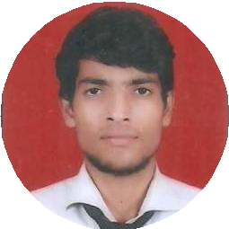

1640201@coet.in
Yogesh Sharma
To work In an organization in are responsible position where my technical and management skills should been enhanced and should be implemented for organization's growth.
8527184801
H No- 19/350 Trilok Puri Delhi 110091, India
16 June, 1997

SKILLS
Basic of Solid Works

EDUCATION

B.Tech

Mahatma Gandhi Mission's College of Engg & Technology(AKTU)
07/2016 – 06/2019 Courses

Mechanical Engineering

Diploma
G.B.Pant Institute of technology(B.T.E)
07/2013 – 06/2016
Courses

Diploma in Automobile Engineering

72.82%

77.48%

ACADEMIC
Basic of PTC Creo

Govt. Boys senior Secondary School (C.B.S.E)
06/2011 – 06/2012
Ansys
Courses

Matriculation

84.68%

CNC Milling & Lathe programming

LANGUAGES

English
Full Professional Proﬁciency

Hindi
Native or Bilingual Proﬁciency

INTEREST

Automobile
PROJECTS

Pedal operated hacksaw
Design and developed hacksaw machine run by pedal which helps diﬀerently abled people to run machine by their own.

Fabrication of Automatic Baby Cradle
Design and developed automatic baby cradle which helps mothers and diﬀerently abled parents to take care of babies while they are working.
Added sensor (sound sensor) which detects baby’s cry and start by itself.

INDUSTRIAL TRAINING

DTC Workshop Okhla New Delhi
DTC Central Workshop

Mahatma Ghandhi College of Engg & Technology Noida
Software Training Creo, Ansys

