RESUME
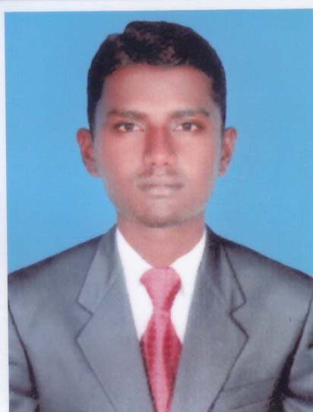
S. ABDULKADHER
S/o,A. SulthanMydeen
179/22E, Syed gurukkalPallivaasal Street,
Tenkasi,
TirunelveliDist, Tamilnadu. Emailid:abdulkadher1994@gmail.com
Post - 627 811 Contact No:+91 9043258376

CAREER OBJECTIVE:
Aspiring for a career that will help me to explore myself fully and realize my potential.To utilize my skills thereby contributing towards the growth and development of the company I belong to along with mytechnical and personal skills.
EDUCATIONAL QUALIFICATION:

COURSE | INSTITUTE NAME | YEAR OF PASSING | PERCENTAGE OF MARKS
DME | Everest Polytechnic College Kadayanallur | 2013 | 69.54%
XII | Government Boys Higher Secondary School, Kadayanallur | 2011 | 62.75%
X | M.M. Higher Secondary School, Idaikal | 2009 | 74.60%

COMPUTER SKILLS:

- COURSES COMPLETED:

  - Diploma in AUTOCAD (2D AND 3D)
Version:2014

  - Course on CREO (PRO-E)
Version: 2.0

  - Course on REVIT MEP
Version: 2013

- INSTITUTE NAME:

- CADD CENTRE, Tenkasi

- WORKING PLATFORM:

  - Microsoft WINDOWS

PROJECT WORK:

- TITLE:

- Modeling of Alternator Testing Machine

- DURATION:

- 2012-2013

EXPERIENCE:
- One year in Delphi TVS Diesel Systems Limited, Mannur, Kanchipuram Dt

- DESIGNATION : TRAINEE
- DEPARTMENT : FPD EXIT QUALITY (Heat Treatment)
- DATE OF JOINING : 2013
- DATE OF LEAVING : 2014

- Six Month In Vj Automotive Pvt Ltd,Coimbatore

- DESIGNATION : Quality Checker
- DEPARTMENT : FPD
- DATE OF JOINING : 2014
- DATE OF LEAVING : 2015

- One year in Oppo Mobiles Pvt Ltd,Chennai

- DESIGNATION : PROMOTER
- DEPARTMENT : SALES
- DATE OF JOINING : 2015
- DATE OF LEAVING : 2016

Strength:

- Self Confidence & Human Relationship
- Can absorb things and learn quickly
- Problem solving skills

PERSONAL PROFILES:

Name : S. ABDULKADHER
Father’s Name : A. SulthanMydeen
Sex : Male
Date of Birth : 07-07-1994
Nationality : Indian
Religion : Muslim
Marital Status : Single
Languages Known : Tamil&English
Address : S/o.A. SulthanMydeen 179/22E, Syed GurukkalPallivaasal Street,
Tenkasi.
Post – 627 811.
TirunelveliDist, TN
Contact Number : +91 9043258376,7676814771

DECLARATION

I hereby declare that all the information’s furnished above are true and correct to the best of my knowledge and belief.

DATE : 31/05/2016 Yours sincerely,

PLACE: VEMAGAL,KARNATAKA (S. Abdul Kadher)

