**CAREER OBJECTIVE**

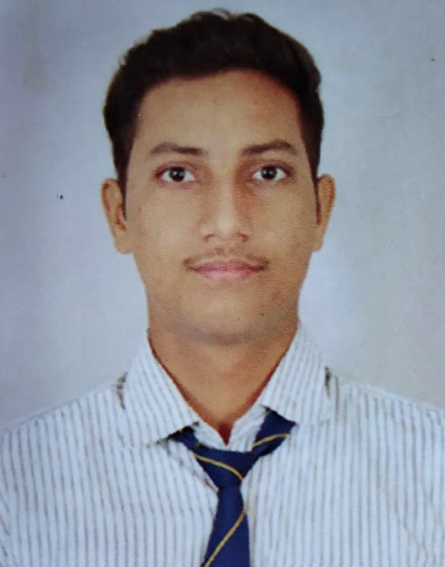

***PERMANENT ADDRESS:***119 SAILENDHAR ROAD  
*P.O: LILUAH*

*DIST: HOWRAH*

*PIN: 711204*

***DATE OF BIRTH:***

*30-06-1996*

***FATHER’S NAME:***

*SUNIL KUMAR SINGH*

***GENDER:***

*MALE*

***NATIONALITY:***

*INDIAN*

***RELIGION***

*HINDU*

***CASTE***

*GENERAL*

***LANGUAGE’S KNOWN***

|  |  |  |  |
| --- | --- | --- | --- |
| *LANG.* | *READ* | *WRITE* | *SPEAK* |
| *HINDI* | *YES* | *YES* | *YES* |
| *ENGLISH* | *YES* | *YES* | *YES* |
| *BENGALI* | *YES* | *YES* | *YES* |

To gain employment with an organization that offers me consistently positive atmosphere to learn and implement new technologies for the betterment of the organization, use my skills in the best possible way for achieving the organization’s goal and solve problems in an effective as well as creative manner in a challenging manner.

**PROFESSIONAL QUALIFICATION**

|  |  |  |  |
| --- | --- | --- | --- |
| ***Examination*** | ***Board*** | ***Marks*** | ***Division*** |
| 10th (Metric) | WBBSE | 65% | 1ST |
| 12th (H.S) | WBCHSE | 43% | 2ND |

* Diploma in Mechanical Engineering with 7.5(Distinction)   
 Grade Point Average.  
  
  
  
CURRENT EMPLOYER:-

**WORK EXPERIENCE**

Organization: ESSEL PROPACK LIMITED, VAPI

Department: MENTAINENCE.

Designation: process & production engineer

Duration: 1stOctober 2017 to march 2019 (1.7 year)

**COMPANY PROFILE**

ESSEL PROPACK LTD. Is a MNC top most packing company. Its manufacturing laminated & plastic tubes in five areas like beauty & cosmetic, pharma & heath, food,home &oral .It’s also manufacturing caps & closures. The company have many types HSL & LSL tubing machines and also have injection molding machine, laminator machine, blown film machines &Flexo Printing machines.

Essel Propack is the world’s largest manufacturing with units operating across country such as USA,Germany, Egypt, china Russia & India.

**JOB PROFILE & RESPONSIBILITIES**

* Handle break down machines during shift.

* Knowledge about printing machines, gears & roller setting.

* Knowledge of ABL & PBL laminate, tubes parts & also of LDPE, HDPE & LLDPE.

* Knowledge about process of printing.

* Knowledge of solve troubleshooting in printing machine & tube machine.

*Acts as a project leader for new machine installing & development.

* Fallow all activities of preventive maintenance.

* Maintain safety of man machine & material.

* Fallow guidelines of all manage system of work practice HMP & GMP.

**COMPUTER PROFENCIENCY**

*Certification in AutoCAD 2D.  
* Practical knowledge of working in Microsoft Office.

*Proficient in working with Windows Vista/XP/7/8.1/10, Linux.

*Sound knowledge of Adobe Photoshop.

**CORE COMPETENCIES**

*E.g.: Managerial, Communication Skills &Analytical Skills.

* Honest, Hardworking and optimist.

* Willingness to learn new things&Positive Thinker.  
* Disciplined & good etiquette.

* Knowledge of various types of printing machines, its procedure, technical specification

*Knowledge of SAP System, 7 new & old QC tools, kaizen, & R&D.

**STRENGTH**

*Flexibility and Adaptability to work in any environment.   
*Willingness to accept any challenge irrespective of its   
complexity.   
*Good team player and positive attitude.

**DECLAIMER**

I **ABHISHEK KUMAR SINGH,** elucidatethat all the above given information are factual and are best known to me.

PLACE:- Kolkata ABHISHEK KUMAR SINGH

DATE :- 18/06/2019 REGARDS