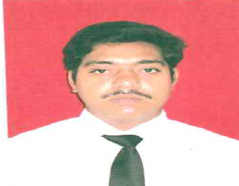
Resume
RAVI RANJAN KUMAR

Contact- 09693808014

Email-itsmeravimba37@gmail.com
Objective

Seeking a good position in an organization . I am also looking for a challenging environment that would provide me opportunities to utilized and enhance my skill sets. To be a successful Business Man in the Business world and to serve the Nation’s Peoples

Educational Qualification

QUALIFICATION | BOARD/UNIV. | PASSING YEAR | DIVISION | PERCENT
M.B.A(full Time)  Specialization  Major-Human Resource &  Minor-finance | NALANDA COLLEGE ,M.U BODH-GAYA  APPROVED BY AICTE (UGC) | 2014 | 1ST | 75.28  (DISTINCTION)
BACHLOR OF BUSINESS MANAGEMENT(BBM) | NALANDA COLLEGE M.U BODH-GAYA | 2011 | 1ST | 72.50
I.SC(BIOLOGY) | B.S.E.B PATNA | 2008 | 2ND | 51.50
MATRICULATION | B.S.E.B PATNA | 2006 | 2ND | 44.50

COMPUTER PROFICIENCY:

- ADCA-IN Nalanda International Institute of Technology
- CFA –In Wizard Tech, Bihar sharif

Work Experience
- ATS INFRASTRUCTURE PVT.LTD. AS PF TRAINEE IN HR DEPARTMENT

- Project work in ITC on Consumer Behavior
- Summer training at BCCL- DHANBAD a subsidiary of coal india limited
- Industrial visit at Nalanda Dairy Project
Hobby
Interacting with people & reading magazines

Personal Details

- Name : Ravi Ranjan kumar
- Father’s Name : Arjun Sharma
- Date Of Birth : 12/08/1990
- Nationality : Indian
- Sex : Male
- Marital Status : Unmarried
- Permanent Address : S/o:-Arjun Sharma
AT- MOGALKUAN( Baulipar)
P.o+P.s :- Sohsarai
Distt :-Nalanda (Bihar)
Pin Code :-803118
- Alternate Email : itsmeravi1990@gmail.com
Declaration
I consider myself familiar with Mainframe aspects. I am confident of ability to work in a team. I hereby declare that the information furnished above is true to the best of my knowledge.

Place :-Bihar sharif Ravi Ranjan Kumar

Date :-..………………

