RESUME
Rajeev Gaurav 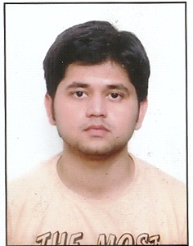
L-30 sai mandir gali near beni
sweets laxmi nagar new delhi-110092
Mob-7531918894,8377044721
E-mail:-rajeevgaurav291@gmail.com
Objective:
Objective:

To work in a challenging and dynamic environment to keep value to myself and simultaneously contribute to the growth and success of the organization, I represent.

Educational qualification:

Degree/  Course | University/  Board | Year of  Passing | Aggregate/Percentage
BE  (mechanical) | RGPV Bhopal | 2015 | 78.24
XIIth | BIHAR  Board | 2011 | 69.8
Xth | CBSE | 2009 | 63.8

Workshop/Training :
Have good hand experience in cad software i.e Auto cad and Catia, Industrial management skills such as TPM,TQM,SIX SIGMA,Lean manufacturing,5.S,ISO,TS,APQP,Have good hand experience of office software such as excel and power point,Have knowledge of image processing I ROBOTICS done from NIT(maulana azad national institute of technology), Bhopal ,Have soft skill certificate by clearing NCVT(national council for vocational training) exam.

Practical exposure:
Minor training- Bhilai steel plant(sail),bhilai chattisgarh

Major training- Madhya Pradesh power generating
corporation Limited(mppgcl), sarni M.P
Minor project- Antilock and regenerative braking system
Major project- Five wheel arrangement in four wheeler
Experience- One year(June 2015 to May 2016) in sonali auto pvt ltd(mahindra and mahindra) has to cross examine the vehicle for their preventive at the service centre of “Before and After”
Personal profile:

Name : Rajeev gaurav
Father’s Name : Mr. Anil kumar
Date of Birth : 29/10/1994
Marital Status : Unmarried
Sex : Male
Nationality : Indian
Hobbies : Making Friends,reading novels,watching inspiration videos and comedy shows
Languages Known : English & Hindi
Strength : Confidence, Leadership skills, Problem solving attitude
Skills : Good Communication skills, Result oriented approach, Easy going with people,ability to work in divers work environment

DECLARATION:

I am Rajeev gaurav hereby declare that the knowledge provided above is true to the best of my knowledge and believe.

Date :

Place: New Delhi Rajeev gaurav

