RESUME
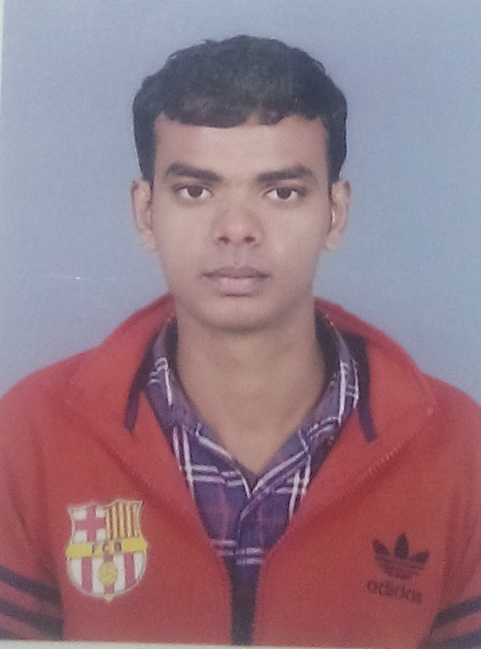

RAHUL KUMAR
Housing Bord Sec-6 House No-337
Dharuhera Rewari pin code -123106 (Haryana )
Contact Num : 9569865106
Email: rahulrajgku@gmail.com

OBJECTIVE
Seeking an entry level job position in a reputed engineering firm in order to build a long term career by investing the best of my technical knowledge & educational qualifications and to serve the organization with an outstanding output
CURRENT IMPLLOYEE (1 Aug 2016)
COMPANY NAME – AMTEK AUTO LIMTED (VISON)
COMPNY PROFILE- An ISO/TS Certified group and leading manufacturer of flywheel , Nissan Maruti Suzuki,Toyta,Magna, J C B,New Holand,Ford etc. we are also leading of Vendor company Maruti Suzuki, manufacturing Nissan etc
JOB PROFILE
Department : Production
Designation- Production Engineer
- Production on daily / monthly basis according to customer schedule / requirement.
-  Programming and setting on CNC and VMC machine.
-  I have good command on CNC and VMC programming and setting.
-  Lead Profile and Profile Projector.
-  Manpower and shift handling.
-  To ensure the execution of Production Plan.
-  To monitor the daily check sheet.
-  To make awareness regarding 5S and conduct 5S audit time to time.
-  To plan the corrective action against each loss to increase the production.
-  Preparation of Standard Operating Procedure / work instruction sheet of every process.
-  Maintain culture of Kaizen, Managing (Man, Machine, Material, Method & Environment)

WORKED EXPERIENCE
- One year worked with Krishna Ishazaki Auto limted
Binola ,Gurgaon Haryana
- Planning of Production on daily / monthly basis according to customer schedule
- Manpower and shift handling.
- To monitor the daily check sheet
PROFESSIONAL QULIFACTION
B-Tech(Mechanical)
- Guru kashi University Bhatinda Punjab Affiliated from UGC Delhi Secured 75 % marks in the year (2012-2016)

SCHOLASTIC
Intermediate (PCM)
- Bihar Board in 2012 and Passed with 67% Marks
High school
- Bihar Board in 2010and passed with (58)% Marks
TRANING
- 6 month Industrial Training in Krishna Ishazaki Auto Limted ,Binola in Gurgaon
- 4 month programming on CNC ,VMC and Auto Cad Training
- 1week skill Development training in Amtek Auto LTd
- 45 days Vocational training in Indian Railway ,Samastipur
ACHIVEMENTS
- Participated in various cultural & technical events of my college and school.
- Member of Royal Mechanical Club.
- Member of Cross Functional Team for KAIZEN, 5S, Safety Management etc.
- Team Leader of 5 S implementation Team.
- Co-ordinator of Safety Management Team.
- Achive the 1st Award For Kaizen in our palnt.
SKILLS
- Communication skills with positive attitude which enables grasp the new atmosphere.
- Ability to work and perform
- Elementary knowledge of mechanical design software’s AutoCAD 2010
- MS Office
PERSONAL DOSSIER
Names : Rahul kumar
Father’s name : Shambhu Prasad Yadav
Permanent Address : Vill- Kamargama ,Ps-Kalyanpur, Dist-
Samastipur ,Pin-847301,(Bihar)
Date of Birth : 12-10-1995
Gender : Male
Religion : Hindu
Nationality :Indian
Marital Status :Unmarried
Linguististcs Ability :Hindi,English

DECLERATION:-
I hereby declare that all the statements made in this resume are true, complete and correct to the best of my knowledge and belief.
Date:
Place:
Rahul kumar

